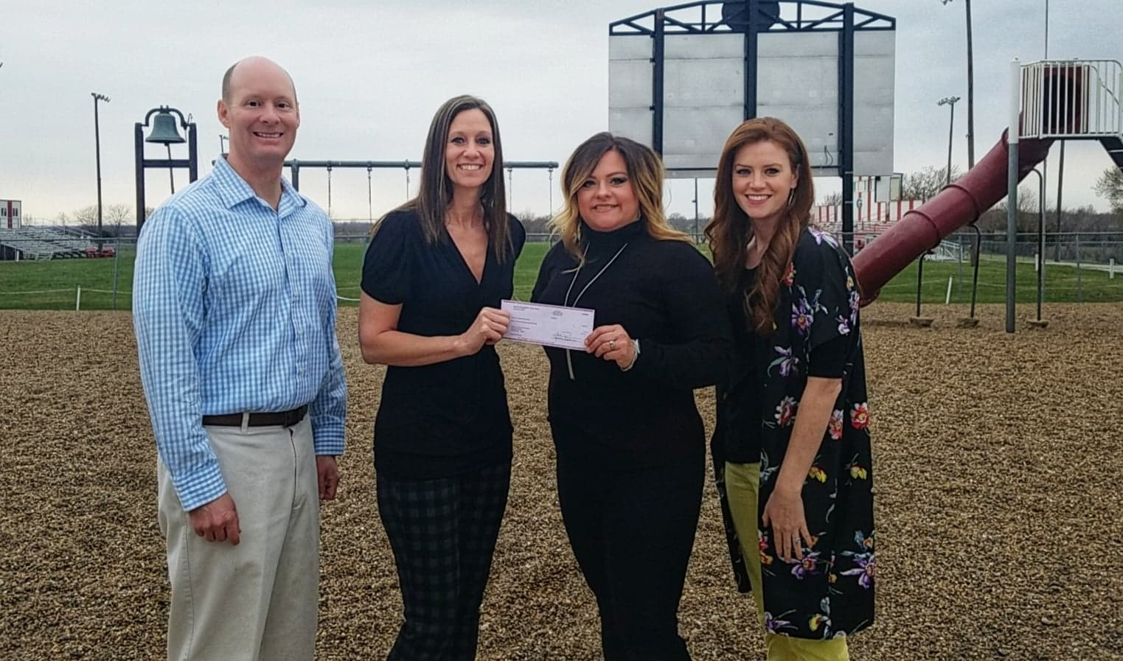

Access ii gives the gift of inclusive play

Access II Independent Living Center met with Gallatin R-5 School District staff in April to present Covel D. Searcy Elementary School with a check for $11,000. The funds will be used to purchase accessible playground equipment, including a swing set, interactive play wall, or “hide out” and construction is set to begin this summer. The inclusive play equipment will allow students with disabilities more opportunity to play with their peers. The equipment is designed for children of all abilities.

**Enabling News**

# Access II

# Independent Living Center

**June 2019 Volume 82**

The Enabling News is a quarterly newsletter written and produced by the staff at Access II ILC for our staff members, consumers, and the communities we serve. For future content submissions, ideas, or questions please contact:

Jessica Adkins : Marketing Director

[jadkins@accessii.org](mailto:jadkins@accessii.org)

*Pictured above from left to right: Superintendent Dr. Bryan Copple, Access II Executive Director Heather Swymeler, Covel D. Searcy Principal Nicole Thogmartin, Access II Marketing & Development Director Jessica Adkins*

Access II Independent Living Center

101 Industrial Parkway

Gallatin, MO 64640

Toll Free:

888-663-2423

P:660-663-2423

F:660-663-2517

access@accessii.org

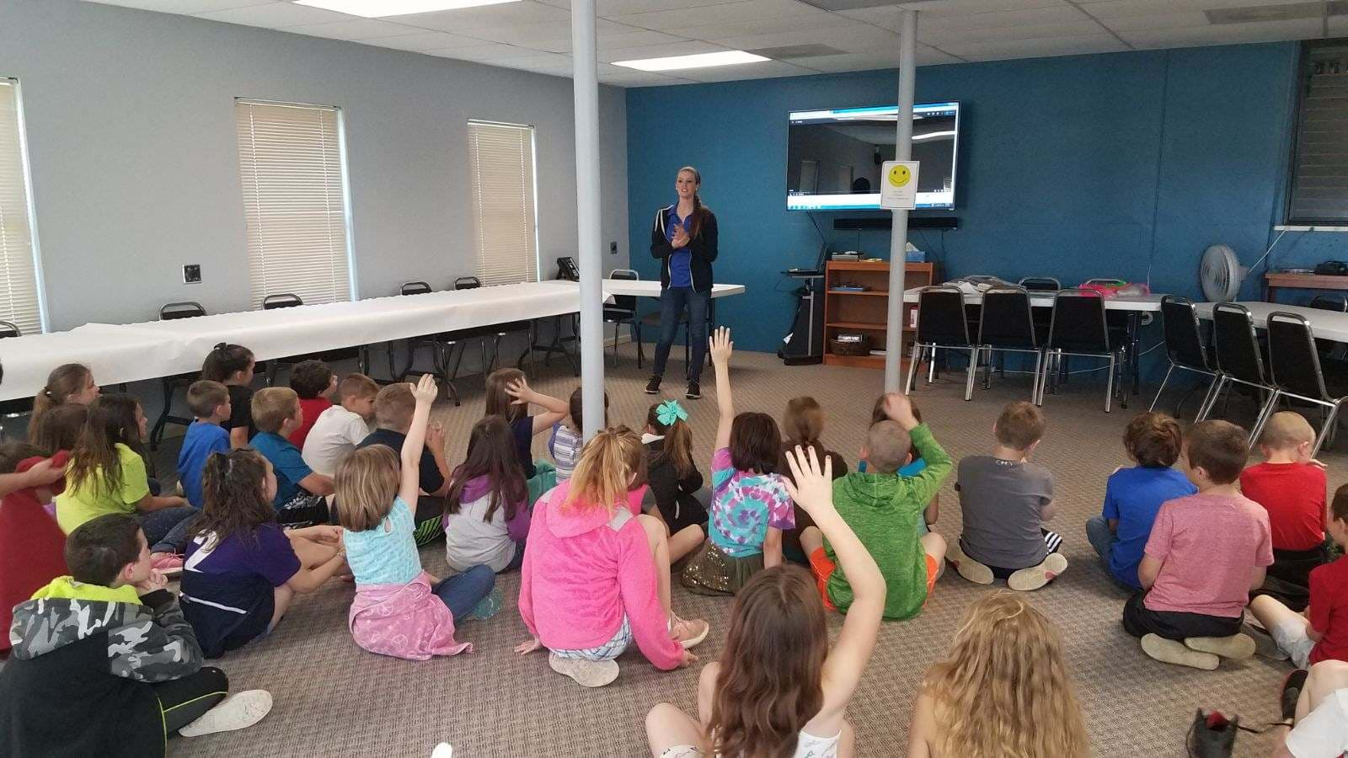

*Pictured above: Students answer questions about a disability etiquette video and give examples of what they should, and should not do in particular situations.*

Second grade students get a glimpse of living life with a disability

Access II hosted second grade students from Covel D. Searcy Elementary School on May 15th for a day designed to help them have a better understanding of disabilities and disability etiquette, in a fun and unique way. Students rotated through several different stations including tactile learning, wheelchair races, germ busters, accessible vans, a “blind lunch” and more.

Gallatin R-5 was not the only school district selected to receive funding to add inclusive pieces to their playgrounds. The North Daviess R-III School District also received $1,366 in funding for their playground, totaling $12,366 that Access II gifted to local school playgrounds.

All elementary schools were sent applications in which they had to explain their proposed projects and the amount of funding they were requesting from the Access II Accessible Playground Fund. Access II will follow up with both schools next Fall to ensure the equipment has been installed, and to see how students are making use of their new play areas.

Have equipment to donate?

We accept donations of gently used equipment. We do not accept hospital beds or broken equipment. If you have equipment to donate please contact Ayron at 660-663-2423 ext. 230

Are you in need of equipment?

Please call our office at 660-663-2423 to find out more about our durable medical equipment (DME) loan program.

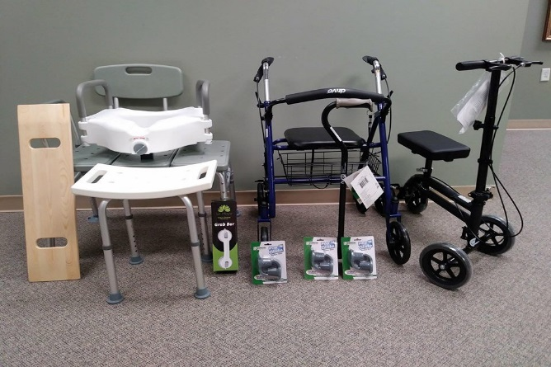

Second Grade Learning Day is an annual event that typically happens in May. This year the Trenton DAWGS (Disabled Athletes with Grundy Support) lent their time and taught students the game of bocce ball, which is a sport they play during Special Olympics meets.

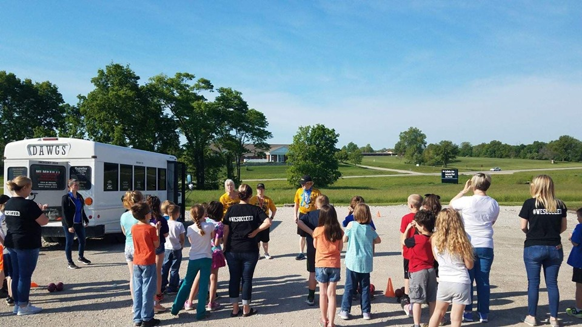

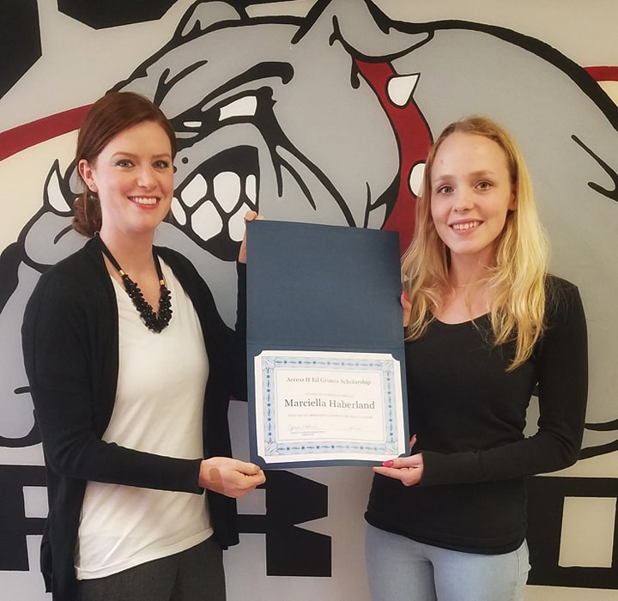

*Pictured above from left to right: Access II Marketing & Development Director, Jessica Adkins, and Marciella Haberland*

Access II presented Marciella Haberland, Gallatin High School Senior, with the Ed "Eddie" Grimes Scholarship on May 9th.

The $500 scholarship will be used towards expenses for Marciella next year at North Central Missouri College where she will be studying to become a special education teacher.

Access II presents 2019 “Eddie” grimes scholarship

*Photo caption*

*Pictured above: Second graders from Covel D. Searcy Elementary school learn how to play bocce ball.*

JOIN OUR TEAM

ACCESS II IS CURRENTLY ACCEPTING APPLICATIONS FOR:

In-Home Aide

Please submit resumes to Deena McCallon at [dmccallon@accessii.org](mailto:dmccallon@accessii.org)

or call 660-663-2423 ext. 233 for more information on how to apply

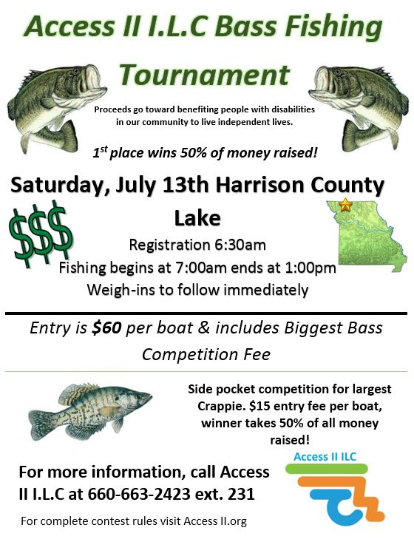

Access II welcomes new staff member Charla Ratliff as a contract RN.

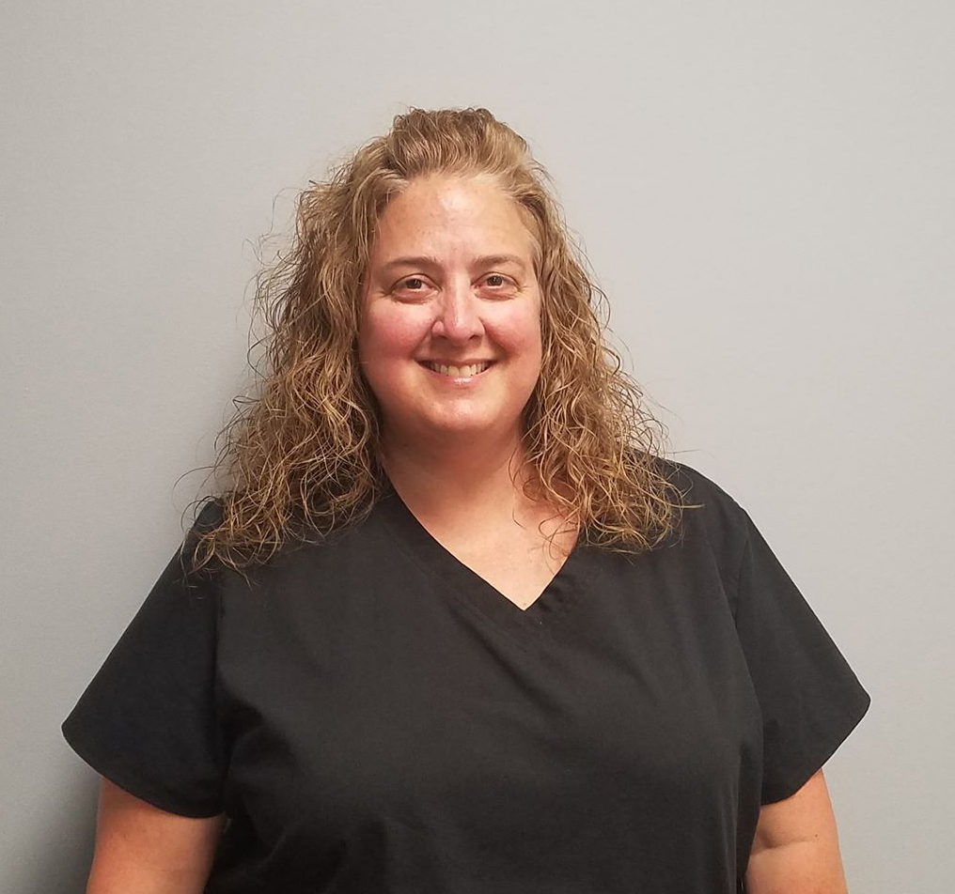

Charla will be completing medication set-ups and general health evaluations for our consumers.

We are happy to have her on our team!

Access II is now creating graphics to go along with our PSA’s.

Look for these monthly on our Facebook page and share with your friends and family.

The Access II Spring Bass Fishing Tournament set for June 1st was cancelled due to dangerously high water at Harrison County Lake and flooding near the Bethany area.

The tournament has been rescheduled for Saturday, July 13th at Harrison County Lake.

In addition to the cash prize, Royals tickets, and gift cards will be offered to second and third place.

Fishing Tournament rescheduled for JUly 13th

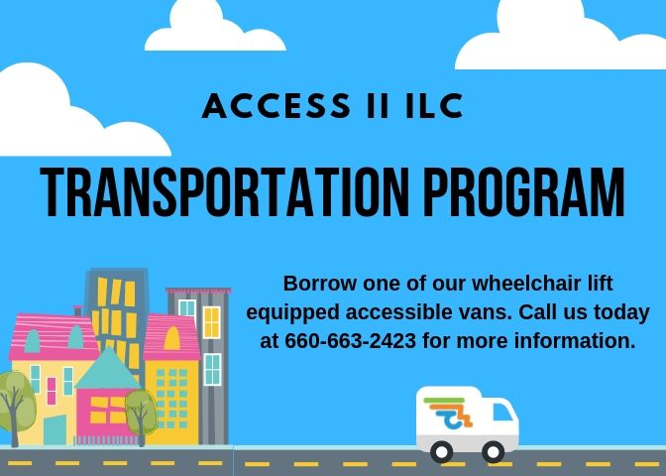

*Pictured above: Graphic image describing Access II’s transportation program*

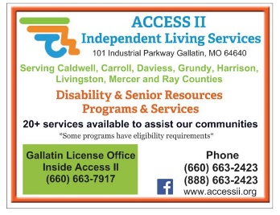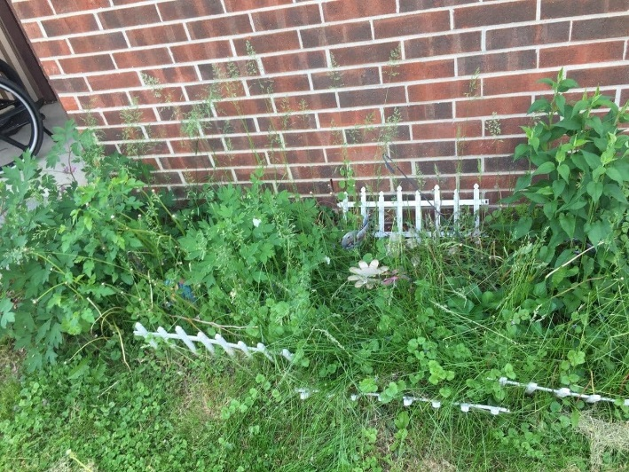

STAFF LENDS A HELPING HAND

The Helping Hands Committee is back in action, and is taking applications for small projects consumers may need assistance with that cannot be provided through regular service programs. This is one way we are hoping to improve the lives of the people we serve.

The Helping Hands Committee put this flower garden back in order, and planted bulbs for one of our consumers who struggles with this task due to their physical disabilities.

For more information on this program or to request an application please give us a call at 660-663-2423. Projects will be evaluated on a case by case basis.

*Access II magnets are available at the office! Stop by and pick up yours today.*

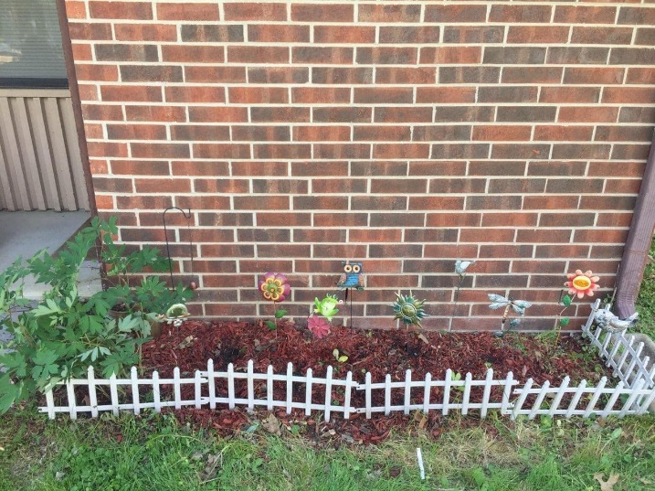

*Pictured above: Flower bed before*

**Access II**

**FOOD**

**PANTRY**

Access II has a small food pantry for our consumers in need. The pantry contains non-perishable food items and hygiene products.

Please call 660-663-2423 the office if you are in need, or stop by the office.

*Pictured above: Flower bed after*

ACCESS II PARTNERS WITH COMMUNITY TO PROVIDE CLASSES IN GALLATIN

Access II hosted a crock pot cooking class April 4th in partnership with Community Action Partnership of North Central Missouri. CAPNCM provided a free crock pot and cook book to all who attended. Participants got to sample a 5 ingredient recipe and one person went home with all of the ingredients for the meal.

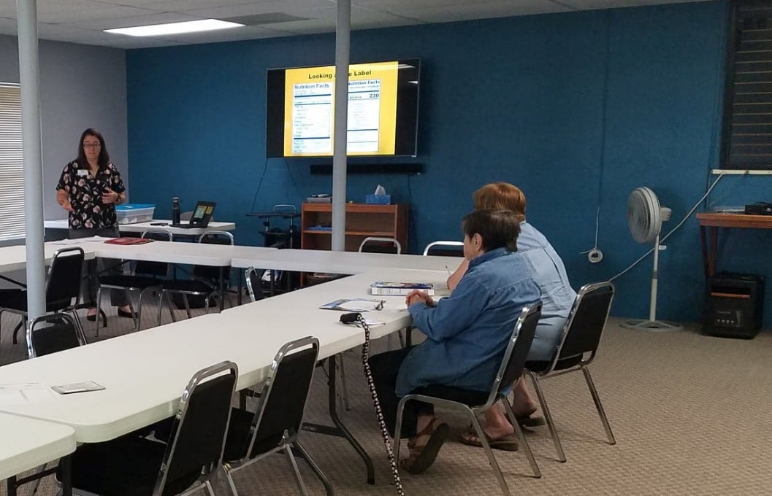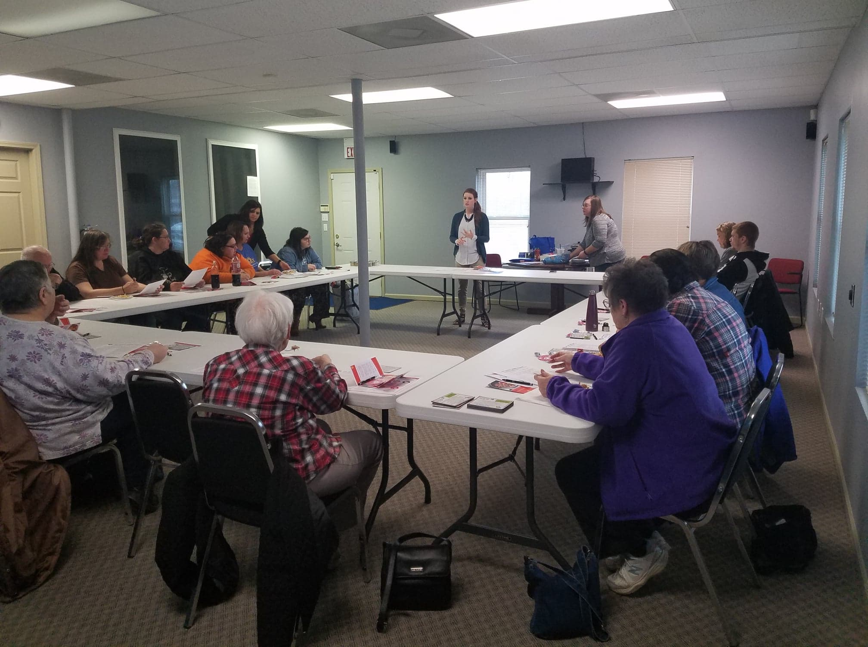

**TIPS FOR EATING HEALTHY WITH DIABETES**

**1. Think Whole**

Use brown rice and whole wheat pasta. Look for 100% whole wheat flour and breads, and other whole grains like oats and barley.

**2. Fill Up!**

Aim for at least 8 grams of fiber per meal, especially when you eat carbohydrate-rich foods. It will help manage your blood sugar, keep you feeling full, and be good for your heart health. That's extra important because diabetes makes heart disease more likely.

**3. Check the Fine Print**

Does your recipe spell out what the calories, carbs, fiber, and fat are? That info comes in handy. Then all you have to do is stick to the suggested serving size and you'll know exactly what you get.

On June 12th Access II partnered with University of Missouri Extension Registered Dietician, Sarah Wood, to offer a “Making a Healthy Plate with Diabetes” class. The class discussed topics such as making healthy food choices, identifying different types of sugars, and understanding nutrition labels.

*Pictured above: Class participants listen to a presentation on diabetes and healthy eating.*

*Photo caption*

*Pictured above: Class participants listen to a presentation on Access II programs while sampling a crock pot meal.*

Topics that were discussed were proper crock pot cooking, safety, and meal ideas. Access II staff presented on Access II programs and services while the participants ate.

Pictured to the right: Winning teams pose with their prizes.

Tournament Results

First Place Bass: Holder/Jones 7.75 lbs

Second Place Bass: Hall/Campbell 7.42 lbs

Third Place Bass: Sell/Dawson 6.64 lbs

Biggest Bass: Hall/Campbell 3.35

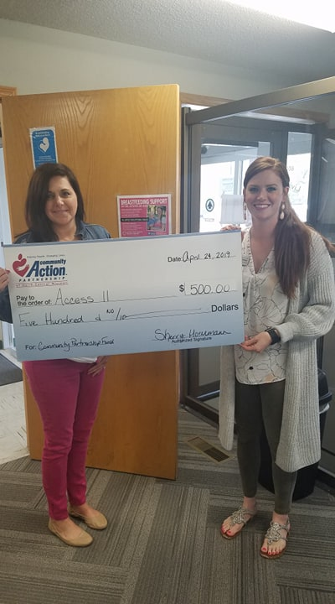

*Pictured above from left to right: Traci Fields, CAPNCM community organizer, and Jessica Adkins, Access II Marketing Director*

In April Access II received a $500 grant from CAPNCM’s Community Partnership Fund. The money will be used toward Access II’s accessible transportation program. The funds will help with maintenance of the two-wheel chair lift equipped vans, that are loaned out to the community.

The purpose of the transportation program is to provide increased transportation options for Access II consumers and people with disabilities in the community.

The use of the vans is limited to transportation within the state of Missouri, to and from medical or dental appointments, recreational use, or transportation to and from consumer training’s or seminars.

ACCESS II RECIEVES GRANT FOR TRANSPORTATION PROGRAM

Did you know Access II is a demonstration site for Missouri Assistive Technology?

If you need to try out a piece of equipment before buying it please give us a call at 660-663-2423 to see if we can assist you with a 6 week device loan.

For a catalog of devices, please visit https://at.mo.gov/device-loan/etc-catalog.html

2019 INCLUSIVE EMPLOYER AWARD

Access II Employment Specialist, Karla Garner, presented McDonald’s restaurant in Chillicothe, MO the Access II 2019 Inclusive Employer Award. They also received a certificate of recognition from the Missouri Rehabilitation Association for being nominated for Employer of the Year.

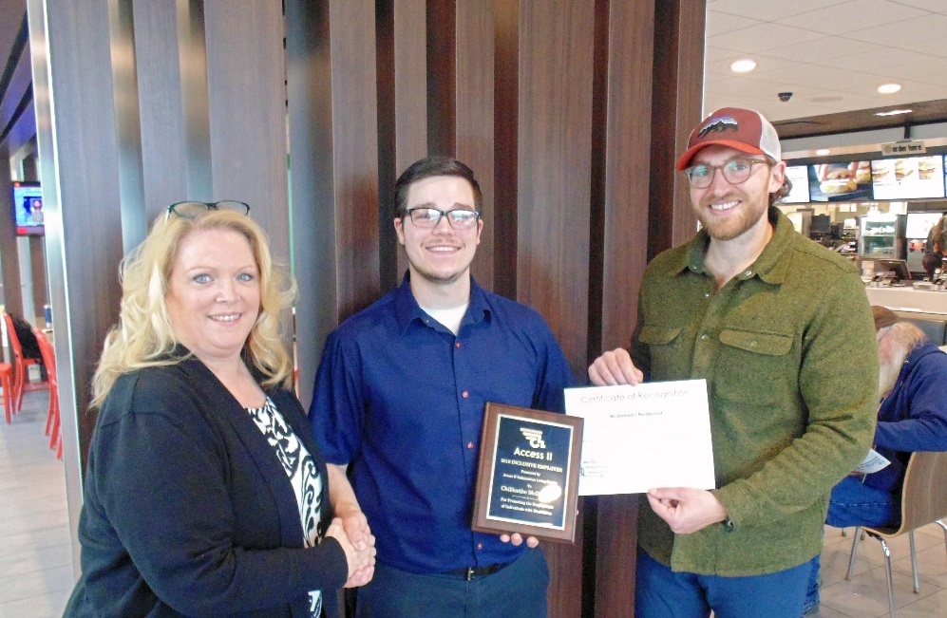

SENIOR TAX FUNDS PROVIDE NEW AVENUE FOR IN-HOME SERVICES

Access II was recently awarded funding from the Caldwell County and Daviess County Senior Citizens Tax funds. Access II will be utilizing these funds to provide in-home services to seniors 65 and older in Caldwell and Daviess Counties in need of assistance in their homes to remain independent.

This program is designed to meet the need of individuals who otherwise cannot qualify for service through existing Access II In-Home or CDS programs. There are a limited number of slots available per county, and service availability depends on current funding. For more information about this program call Jessica Adkins at 660-663-2423 ext. 231.

DID YOU KNOW?

June is national Alzheimer’s and Brain Awareness Month

6 early signs of Alzheimer’s

1. Memory Loss that disrupts daily life
2. Challenges in planning or solving problems
3. Difficulty completing daily tasks at home, work, or leisure
4. Confusion with time or place
5. Trouble understanding visual images or spatial patterns
6. New problems with words or speaking

*Pictured above from left to right: Karla Garner, Access II employment Specialist, CJ Myrick, and Ethan Essig, McDonald’s management.*

Karla presented both the plaque and certificate on May 10th. McDonald’s has employed several of Access II’s jobseekers, and has worked with our job coaches and staff to make sure individuals are successful and thriving in their positions.

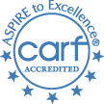

***STAFF***

**Executive Director**

Heather Swymeler

**Financial Director**

Amber Wells

**Marketing & Development**

**Director**

Jessica Adkins

**ILS/Employment Specialist**

Karla Garner

**LPN**

Sam Brewer

**ILS/CDS Case Manager**

Jen Grider

**Billing Specialist**

Staci Hamilton

**In-Home Scheduling Coordinator**

Deena McCallon

**Financial Assistant**

Ashley Chambers

**Administrative Assistant**

Ayron Wilson

***Board***

**President**

Stacey Maxwell

**Vice-President**

Lisa Bowles

**Treasurer**

David Lainhart

**Secretary**

Leslie Stanley

**Members**

Karen Bryant

**Brandy Gannan**

**Annie Gibson**

Tim Tadlock

Rob Zirfas

@accessii

https://www.facebook.com/accessii/

UPCOMING EVENTS AND OFFICE CLOSINGS:

* July 4– Independence Day– Office Closed
* July 13– Access II Bass Fishing Tournament
* July 7 – Access II’s 24th Founding Anniversary
* July 26 –29th Anniversary of signing of the ADA (American’s with Disabilities Act)
* Sept 2– Labor Day– Office Closed
* Sept 21 - Color Rush 5k

Please contact our office for more information about events and office closings.

*Contact Us*

Access II ILC, INC

101 Industrial Parkway

Gallatin, MO 64640

Phone:660-663-2423

Fax: 660-663-2517

TTY: 888-663-2423

[www.accessii.org](http://www.accessii.org)