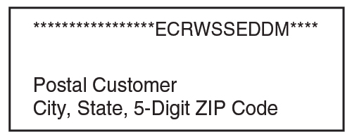
Citywide Cleanup Day
GRAND JUNCTION MAY 2020 NEWSLETTER
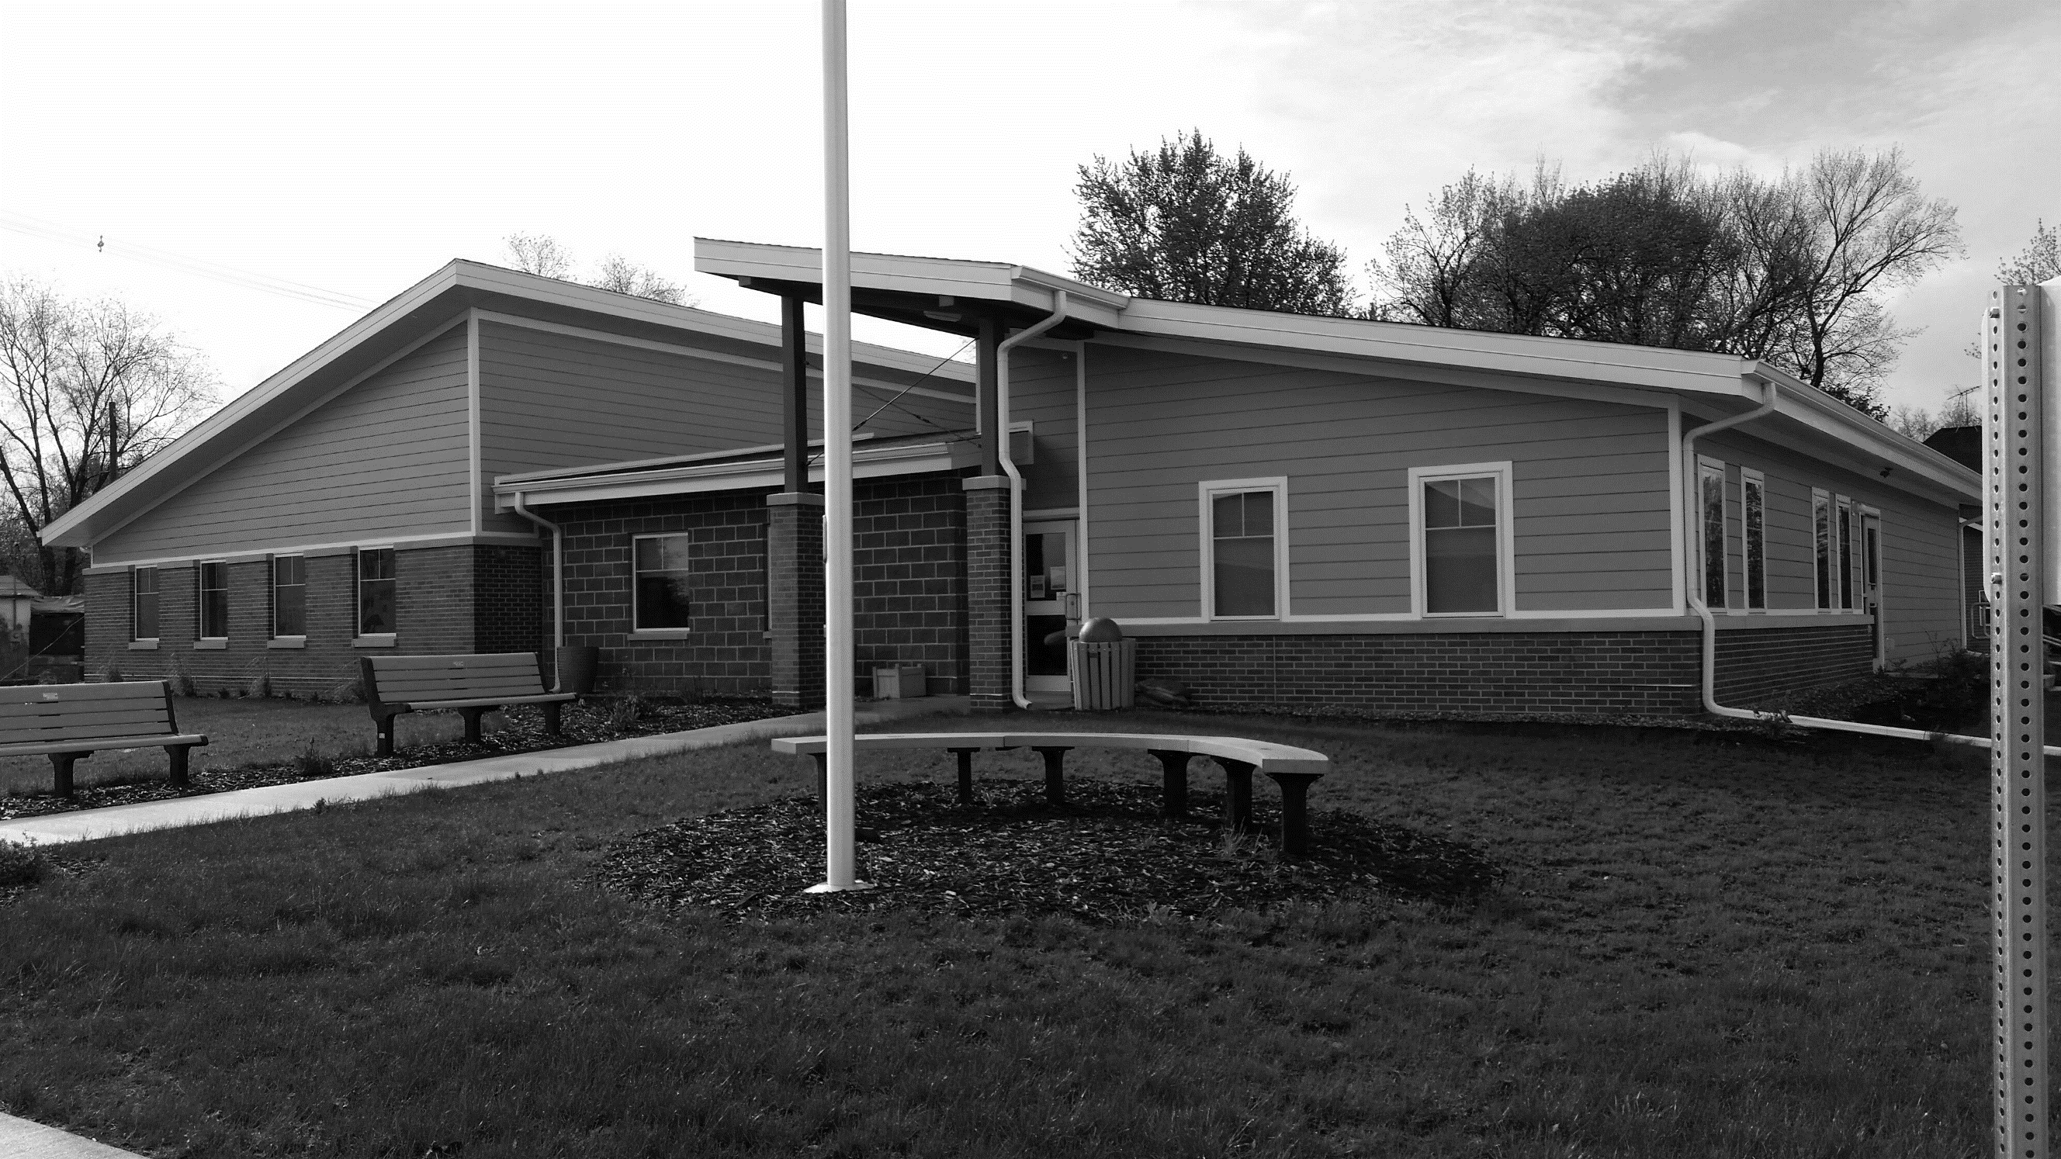
Changed to June 27
Due to the ongoing coronavirus situation, the GJ City Council voted to change the date of Citywide Cleanup Day to June 27.
Cleanup will begin at 7 a.m. If we can do curbside pickup, have the items you want picked up at the curb by 7 a.m. on June 27. Do not put any items out before Friday, June 26.
Call City Hall or the Light Plant on Friday, June 26 if you need help getting a large item – such as a freezer – out of your house.
No regular garbage will be picked up. You can get rid of items such as computers, TVs, furniture, appliances, humidifiers, and air conditioners.
Yard waste should be separated from other items.
We need your help! To volunteer, meet on 13th Street between Main and Railroad on the north side of the tracks. Bring gloves and a mask (if needed) and wear shoes.

The Ladies Club will provide sandwiches and chips along with brownies, cinnamon rolls, and squares. Drinks also will be provided.
REMEMBER: NO garbage, NO tires, NO batteries, NO paint, NO slate siding or shingles, NO oil or gas items, NO LP tanks, NO barrels.
School Summer Lunch Program Starts June 8
Contact City Hall at 515-738-2585 or grandjct@iowatelecom.net.
Office hours are Monday ─ Friday, 9 am to noon or by appointment
www.grandjunctioniowa.org
The Greene County Schools’ current Grab-and-Go lunch program will move to the Summer Lunch Program on June 8. May 28 is the last day that meals will be served under the current meal structure.
The school aims to run the summer lunch program like it has in the past with the Grand Junction Community Center as a serving site. Kids will be required to pick up meals in person.
The school will follow social distancing requirements and limit the number of people at any one time. If it is unable to immediately begin that service model, it will begin with a sack lunch service delivery model.
Remember to Do the 5:
1 HANDS: Wash them often
2 ELBOW: Cough into it
3 FACE: Don’t touch it
4 FEET: Keep at least 6 feet apart
5 FEEL sick? Stay home!

Primary Election Absentee Ballots Available
The Iowa Primary Election is set for Tuesday, June 2, and the Iowa Secretary of State is encouraging residents to vote absentee at home to stay safe, practice social distancing, and help slow the spread of COVID-19.
Absentee Ballot Request Forms were mailed to all registered voters in Iowa. If you want to receive a ballot by mail, you must fill out the Absentee Ballot Request and return it to the Greene County Auditor by Friday, May 22, at 5 p.m.
To vote in the Iowa Primary, you must be a registered member of either the Democratic or Republican party. If you are registered as “No Party” you must update your voter registration by checking one of the party boxes in the Primary Election Only portion of the form.
For more information, go to voterready.iowa.gov or call the Greene County Auditor at 515-386-5680.
New Finance Officer Hired
The City Council has hired Angie Jones as its new part-time Finance Officer effective April 14. Angie is a Licensed Insurance Agent for Heritage Insurance in Jefferson and is a firefighter and EMT with Grand Junction Fire and Rescue. Angie replaces Melody Larsen, who worked for the city for two years before taking another position out of town.
Swimming Pool Torpedoed By Toy, Repairs Needed
Although per Iowa coronavirus guidelines swimming pools are not yet allowed to be open, the Grand Junction pool must first undergo repair anyway due to damage done to pipes over the winter from a stuck toy.
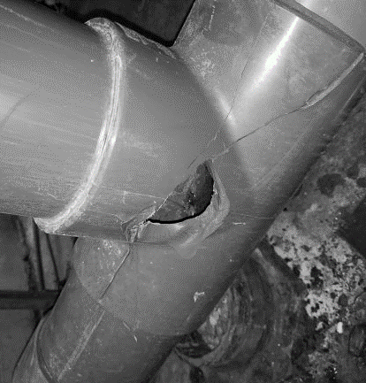
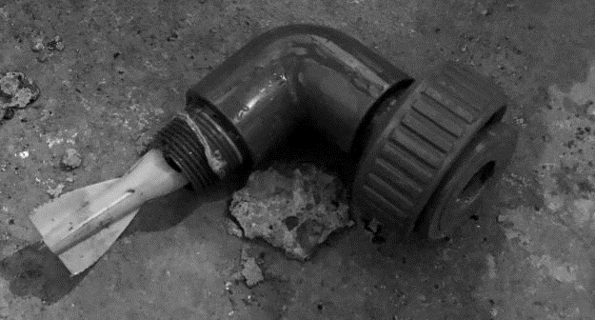
The cost of repairing the piping has been estimated around $2,000. The Parks & Rec Committee plans to get bids on repairing the damage in order that the city may be able to open the pool when the state does allow pools to reopen for the summer.
Council Okays Road Repairs
At its May meeting, the City Council voted to contract with Sta-bilt Construction to repair 20 blocks of city streets, focusing on areas of 10th, 11th, 12th, 15th, and 19th not included last year. The council aims to establish an ongoing rotation of street repair to better maintain all city streets.
Get Dog Tags, ATV Permits
Grand Junction’s Code of Ordinances requires dogs to be licensed and the State of Iowa requires ATVs to have permits. Dog tags are $5 and permits for ATVs and golf carts are $15 again this year. Don’t forget to register your dogs and ATVs in City Hall.

