The Circuit Writer
Volume 39 Issue 9

As we began our mission and vision process last fall, I asked folks at an administrative council meeting to anonymously complete cards with their dreams for Monterey UMC. The only requirement for this task was that it begin with IMAGINE. The statements below reflect our responses.

Imagine:
- Children laughing
- Smiling, joy
- A place where people encounter Christ in such a way that they live their discipleship
- MUMC is the “happening” place
- Worship is full on Sunday morning with laughter and praise
- Multigenerational educational opportunities.
We have had a good year! Our sanctuary is full with children laughing, smiling and singing! We have had spiritual growth in such a way that the face of our congregation has changed and is changing. We are taking the church into Monterey, serving in the community in such a way that people witness our faith! The pews are fuller every Sunday with joy and praise. And we have weekday opportunities involving everything from music to service to learning! Thank you for a wonderful year.

May we continue living our faith! May you see the face of Christ in every person you meet, and may you be Christ for every person you meet!

I will never stop giving thanks for you, remembering you in my prayers.

Denna

Monthly & Weekly Church Scheduling
Sunday School & Worship 9:45am & 11:00am
Youth Group Sundays 5:30pm – 7:00 pm
Monterey Hilltop Chorale Mondays at 6:00pm
Civitan Club 3rd Tuesday of each month at 6:00pm
Choir Rehearsal Wednesdays at 6:30pm
Cottage Ministry Friday & Saturday, 9am – Noon
Garden Club 2nd Tuesday of each month at 10:30am

September Worship Leaders
Liturgist Al Bevan
Ushers Linda Jensen & Janet Erskine
Acolytes Children of the Church

A Record of our faithfulness August 2018

AUGUST FINANCIAL RESULTS (Operating Funds)
07/01/18 BEGINNING BALANCE $15,294.47
TITHES AND OFFERINGS $13,970.76
OPERATING EXPENSES ($12,925.02 )
07/31/18 ENDING BALANCE $16,340.21

Upcoming Meetings & Events

**Volunteer now for Red Bird Mission Trip**

Applications are on the back table. Applications are due by September 16th.

Youth Ministry: Are you available to help with the youth? We want you! Contact Pastor Denna for more information.

Backpack Ministry: As you are shopping, can you purchase granola bars for the backpack ministry? Leave in the narthex for Judy Webster to pick-up.

Burks Elementary Team: Monterey UMC is an adopter of Burks Elementary. Would you like to be a reading partner? Stay tuned for ways to volunteer and help the students succeed.

Celebrating the Harvest: Our 5th Sunday luncheon will be held on Sunday, September 30th.

The Cottage

Sales have picked up in August! We had 45 people just this weekend and 4 of those were new! Thanks so much for the donations. People have remarked about how nice the items were that we have for sale. We gave 4 families food, 2 of which were new. God is so good and big thanks to all his helpers!!

Several of our regular ladies have asked for assistance getting to and from doctors, so I will be assisting those. Please let me know if you would like to be on the list to help transport. It would be greatly appreciated. It’s all about connections!

Thanks to all our helpers.
Blessings, Deborah

THE GARDEN CLUB

The Garden Club gave 5 scholarships to Monterey High School seniors a few months ago. Amazing young people! There was one your woman I could not get out of my mind and heart. I listened to her story and read her essay and sat in awe of her plans for her future. She is at the University of TN and plans to become an attorney, one who will return to this area and practice with people who cannot afford representation, those who fall through the cracks because the cannot fight or go through hard times on their own. This is a person journey for her, she has lived this scenario herself. She is just extraordinary!! I am hoping that we can adopt her with our support. Send care packages, gas cards, cookies or just a card of encouragement!! If we could commit to once a month, one contact by signing up just once, none of us will find this a burden. Remember the times when we so loved having a kind word! Can we do this ? We sure can!!

Monterey’s SEPTEMBER Birthdays

6 Deborah Wolfe
9 Sandy Hart
17 Harold Broughton
18 Holsten Hayes
19 Peggy Speck
20 Douglas Biggs
20 Chuck Talbot
25 Charles “Pokey” Looper
28 Dorothy Burns

MONTEREY’S SEPTEMBER ANNIVERSARIES

17 John & Karen Logsdon

MUMC Wednesdays - starting August 22nd

4:30pm Dinner

5:00pm Early Childhood Music Ministry - FREE music classes for children and a guardian.

5:00pm Book Study for adults

The Joy Stealers - Deborah Wolfe will lead this study about overcoming obstacles to hope and happiness and how to handle worry, negativity, hurt and guilt that rob us of happiness.

An Arrow Pointing to Heaven - Bob Cournoyer will lead a 10-week study of the life and music of Rich Mullins, the forerunner of Contemporary Christian Music. This study will challenge the sensibilities of what it means to follow Jesus in today's world, and build upon his legacy of joy, compassion, brokenness, unblinking honesty, and the wonder of an Awesome God. Coming soon

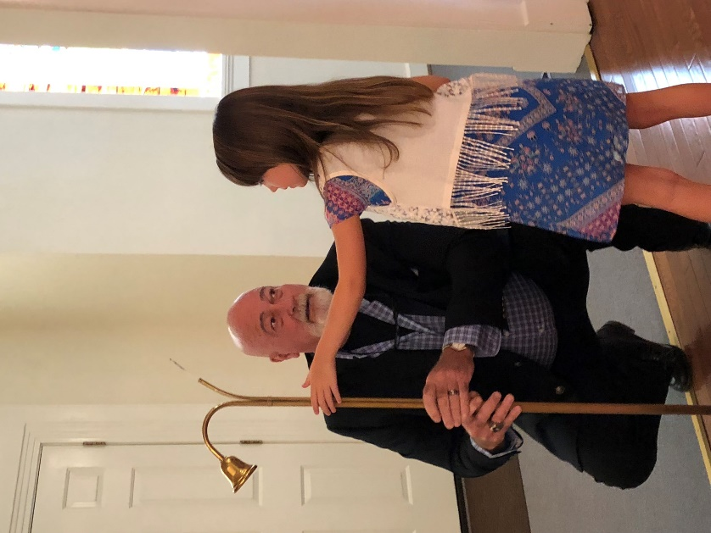
Ken Hall receiving Acolyte training!!

Dear Friends,

Now that things have settled into somewhat of a routine, I wanted to express my sincere appreciation for all the prayers, visits, phone calls, cards, text messages and Facebook posts, following my “Grand Opening” at Saint Thomas Hospital. It was certainly an unexpected journey. What was not unexpected, was the outpouring of love and concern from all of you because of the enduring love of Christ that so permeates your hearts. Please know that all the sentiments expressed reminded me that God is always with us and of the blessings that come from the host of believers.

Sending my sincere thanks and love in Christ,
Ron, Vikki and family

30
Monterey United Methodist Church
September 2018
Trust in the Lord with all your heart, and do not rely on your own insight. In all your ways acknowledge him,
and he will make straight your paths. Proverbs 3:5-6
Sun | Mon | Tue | Wed | Thu | Fri | Sat
 |  |  |  |  |  | 1
 |  |  |  |  |  | 9:00a Cottage Ministry
2 | 3 | 4 | 5 | 6 | 7 | 8
9:45a Sunday School  11:00a Worship Service  5:30p Youth Group | 6:00p Monterey Hilltop Chorale |  | 4:30p Dinner  5:00p Music for Children  5:00[ Study for adults  6:00p Choir Practice | 5:00 Trustee Meeting | 9:00a Cottage Ministry | 9:00a Cottage Ministry
9 | 10 | 11 | 12 | 13 | 14 | 15
99:45a Sunday School  11:00a Worship Service  5:30p Youth Group | 6:00p Monterey Hilltop Chorale | 10:30 Garden Club  6:00 Administrative Council Meeting | 4:30p Dinner  5:00p Music for Children  5:00[ Study for adults  6:00p Choir Practice | Monterey High Football Team Meal | 9:00a Cottage Ministry | 9:00a Cottage Ministry
16 | 17 | 18 | 19 | 20 | 21 | 22
9:45a Sunday School  11:00a Worship Service  5:30p Youth Group  Applications due for “Red Bird Mission Trip” | 6:00p Monterey Hilltop Chorale | 6:00 Civitan Club | 4:30p Dinner  5:00p Music for Children  5:00[ Study for adults  6:00p Choir Practice |  | 9:00a Cottage Ministry | 9:00a Cottage Ministry
23/30 | 24 | 25 | 26 | 27 | 28 | 29
9:45a Sunday School  11:00a Worship Service  5:30p Youth Group  9:45a Sunday School  11:00a Worship Service  5:30p Youth Group  6:00 Jim Brady Trio | 6:00p Monterey Hilltop Chorale |  | 4:30p Dinner  5:00p Music for Children  5:00[ Study for adults  6:00p Choir Practice | 5:00 Finance Committee Meeting | 9:00a Cottage Ministry | 9:00a Cottage Ministry

