Excel Chapter 3
  - Data Visualization and Images
Name: _______________________________________________________
Class: _______________________________________________________
Date: _______________________________________________________
- Changing the style does not change the layout (the position of the elements on the chart area).
  - True
  - False
- Number formatting options for an axis include Currency, Date, and Percentage.
  - True
  - False
- When you move a chart to a new sheet, you cannot change the sheet name.
  - True
  - False
- The Chart Filters feature allows you to remove values from your chart, and then later you can choose to display all the data again.
  - True
  - False
- Only pictures that are saved on your computer can be added to an Excel worksheet.
  - True
  - False
- After a conditional formatting rule is created, if the data changes, the formatting will be automatically updated to reflect the new data.
  - True
  - False
- What chart type is useful for showing trends in data over time, such as days, months, or years?
  - Pie
  - Bar
  - Column
  - Line

- What range of data would you select to create a pie chart of Product 1 sales for January to March?
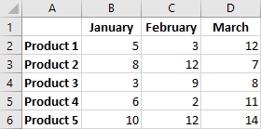
  - A1:B6
  - A1:D2
  - A2:D2
  - A1:D6
- Which of the following is NOT one of the chart elements?
  - The chart title
  - The legend
  - The horizontal axis
  - The pivot area
- The selection of data shown in the image below could produce which of the following charts?
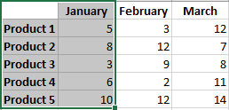
  - 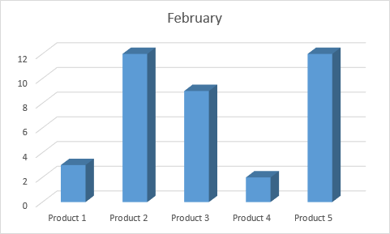
  - 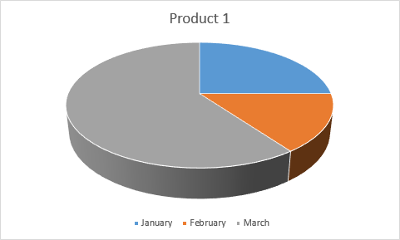
  - 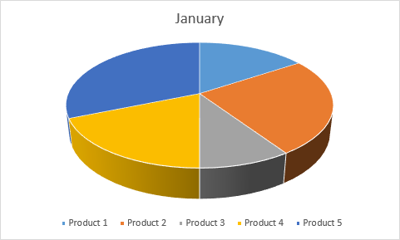
  - 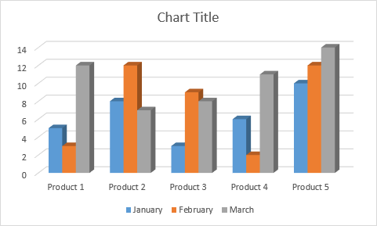
- After moving a chart to a chart sheet, which of the following is true?
  - You can continue to edit all of the elements using chart tools.
  - You can no longer make any changes to the chart.
  - You can’t move the chart again.
  - You can move but not edit the chart.

- Which feature could have been used to modify the first chart to look like the second?
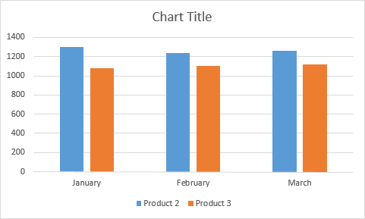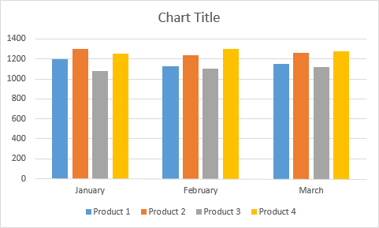
  - Change Chart Type
  - Select Data
  - Chart Filters
  - Either Select Data or Chart Filters
- After inserting a picture or shape on a worksheet, which aspects of the image’s appearance can you edit?
  - Its size and style
  - Its size and color
  - Its style and color
  - Its size, style, and color
- Which Conditional formatting rule would change the first group of data to look like the second?
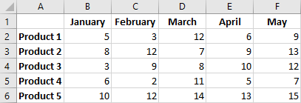
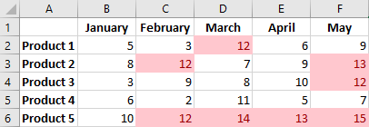
  - Greater than 10
  - Top 5
  - Greater than 5
  - Greater than 10 or Top 5

