

[This Photo](http://www.scuolasettanni.gov.it/) by Unknown Author is licensed under [CC BY-SA-NC](https://creativecommons.org/licenses/by-nc-sa/3.0/)

**The Circuit Writer**

Volume 39 Issue 12

What a wonderful church family! If I had any more fun at our Christmas Open House, I think it would have been the end of me! I laughed so much that my cheeks were sore by the end of the evening. A beautiful part of a faith family is sharing these times together. I am eternally grateful for you and your witness to the world.

I am excited to see new faces in our congregation each week. Please continue to reach out during this holiday season, inviting friends and neighbors into this experience of Christ that is transforming our hearts and all of Monterey!

Check these dates on your calendar and bring a friend:

Advent Services – Every Sunday in December

Art in Advent begins – Dec. 2

Christmas Chorale Concert – Monday, Dec. 10th

@ 6 pm

Choir’s Music Program - Sunday, Dec. 16th

Ugly Christmas Sweater Day – Sunday, Dec 16th

Worship Service at Standing Stone – Sunday,

Dec 23rd @ 2 pm

Christmas Eve Candlelight Service – Monday,

Dec. 24th @ 5 pm

Merry Christmas friends!

Denna

**Monthly & Weekly Church Scheduling**

Sunday School & Worship 9:45am & 11:00am

Youth Group Sundays 5:30pm – 7:00 pm

Monterey Hilltop Chorale Mondays at 6:00pm

Civitan Club 3rd Tuesday of each month at 6:00pm

Choir Rehearsal Wednesdays at 6:00pm

Cottage Ministry Friday & Saturday, 9am – Noon

Garden Club 2nd Tuesday of each month at 10:30am

**December Worship Leaders**

Liturgist Micah Groover

Ushers John & Marion Barwick

Acolytes Children of the Church

**A Record of our faithfulness November 2018**

***NOVEMBER FINANCIAL RESULTS (Operating Funds)***

10/01/18       BEGINNING BALANCE        $10,695.84

                     TITHES AND OFFERINGS   $10,781.25

                     OPERATING EXPENSES     ($14,660.74)

10/31/18       ENDING BALANCE               $6,816.35

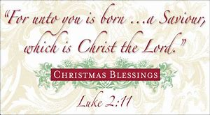

**Upcoming Meetings & Events**

**Are you willing to help prepare youth suppers for approximately 10 youth? December 16th**

**Beersheba Springs Christmas Program – Thursday, Dec. 6th 10 a.m. to 2 p.m.**

**Group Membership Sunday – December 9th**

**Christmas Chorale Concert – Monday, December 10th at 6pm**

**Ugly Christmas Sweater Day – Sunday, December 16th**

**Worship Service @ Standing Stone – Sunday, December 23rd @ 2 pm**

**Christmas Eve Candlelight Service – Monday, December 24th @ 5 pm**

**Youth Ministry:**  Are you available to help with the youth? We want you!  Contact Pastor Denna for more information.

**Backpack Ministry**:  As you are shopping, can you purchase granola bars for the backpack ministry?  Leave in the narthex for Judy Webster to pick-up.

**Burks Elementary Team**:  Monterey UMC is an adopter of Burks Elementary. Would you like to be a reading partner? Stay tuned for ways to volunteer and help the students succeed.

**Don’t forget our Art in Worship for Advent starts December 2nd and continues through Advent. This is something you definitely do not want to miss.**

**MONTEREY’S December BIRTHDAYS**

**3rd - Ron Sontag**

**6th - Annie Looper**

**12th – Judy Powell**

**12th – Alfeda Ford**

**13th – Joyce Steinmetz**

**13th – Meretha Durham**

**15th – Kathy Denton**

**19th – Richard Jackson**

**20th – Patricia Hudgens**

**23rd – Sandi Vanacore**

**29th – Ed Bruce**

**MONTEREY’S december ANNIVERSARIES**

1st – John & Marion Barwick

21st – Richard & Linda Jensen

29th – Ed & Judith Bruce

**MUMC Wednesdays**

**5:00pm Early Childhood Music Ministry -** FREE music classes for children and a guardian.

**The Cottage**

The Cottage saw about 335 this quarter, with about a dozen family’s meals and many smaller amounts of food given. We are still assisting Marcy with additional food as well. Donations have been wonderful and we are well stocked for Christmas shopping. We have an angel that supplies us with wonderful jewelry, faithful servants who help keep the food pantry full, and the best volunteers!. We have dozens and dozens of gifts for the Burke`s first graders to shop too. About 3 weeks ago we hit a new all-time in one day, with over 40 visitors in one day! God is Good all the Time!  Deborah

**Fun Filled Days with Our Teens**

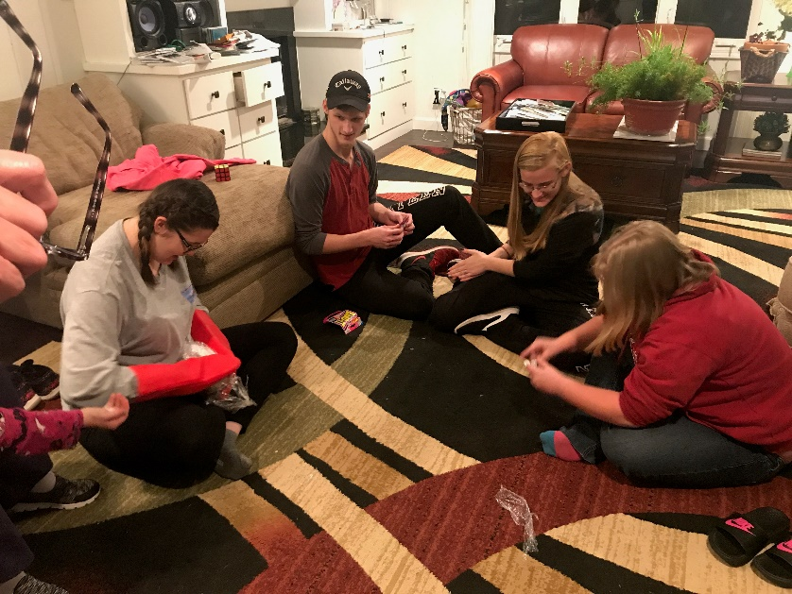

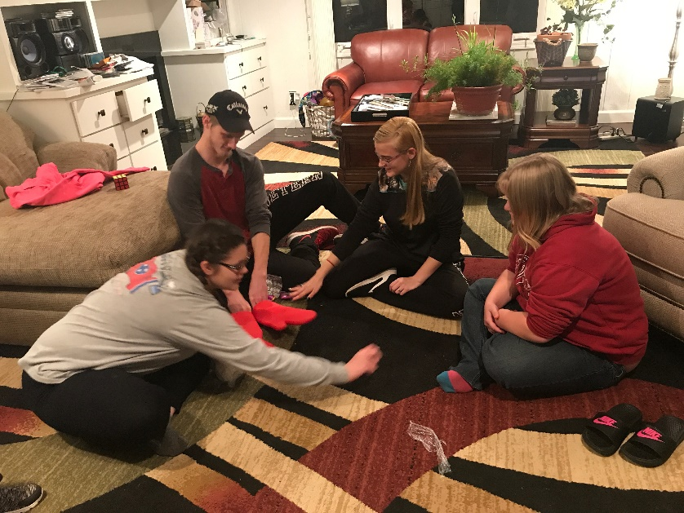



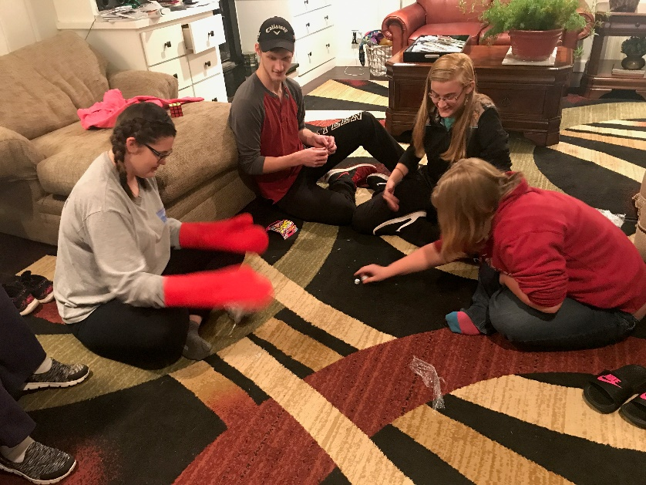

**Not Only Christmas Day**

Lord, this is my [prayer](https://www.thoughtco.com/basics-to-prayer-701334)  
Not only on Christmas Day  
But until I see you face to face  
May I live my life this way:

Just like the baby Jesus  
I ever hope to be,  
Resting in your loving arms  
Trusting in your [sovereignty](https://www.thoughtco.com/what-is-gods-sovereignty-700697).

And like the growing Christ child  
In wisdom daily learning,  
May I ever seek to know you  
With my mind and spirit yearning.

Like [the Son](https://www.thoughtco.com/origin-of-the-son-of-god-700710) so faithful  
Let me follow in your light,  
Meek and bold, humble and strong  
Not afraid to face the night.

Nor cowardly to suffer  
And stand for truth alone,  
Knowing that [your kingdom](https://www.thoughtco.com/what-is-the-kingdom-of-god-701988)  
Awaits my going home.

Not afraid to sacrifice  
Though great may be the cost,  
Mindful how you rescued me  
From broken-hearted loss.

Like my risen Savior  
The babe, the child, the Son,  
May my life forever speak  
Of who you are and all you've done.

So while this world rejoices  
And celebrates [your birth](https://www.thoughtco.com/the-christmas-story-of-the-birth-of-jesus-700208),  
I treasure you, the greatest gift  
Unequaled in your worth.

I long to hear the same words  
That welcomed home your Son,  
"Come, good and faithful servant,"  
Your Master says, "Well done."

And may heaven welcome others  
Who will join with me in praise  
Because I lived for [Jesus Christ](https://www.thoughtco.com/profile-of-jesus-christ-701089)  
Not only Christmas Day

-- [Mary Fairchild](https://www.thoughtco.com/mary-fairchild-699909)

**We will be having a Greeter, Usher and Liturgist training on Sunday, January 13th after worship. Lunch will be provided. Please contact the church office if you are interested in attending.**

**Don’t forget to check your mailboxes at the church for the Christmas cards that are already arriving. New mailboxes have been added for all the new members. If I have forgotten anyone please call or come by the church office and let me know.**

Church Members enjoying a wonderful day of fellowship at Beersheba Springs.

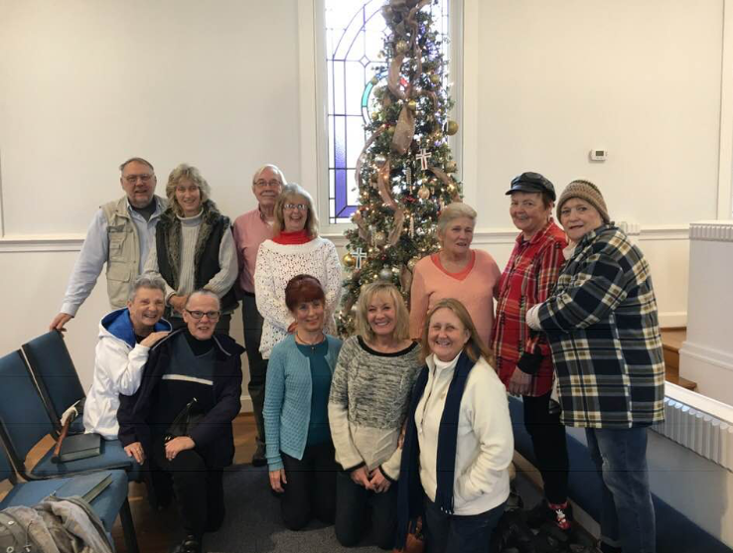

**Open House at the Parsonage**

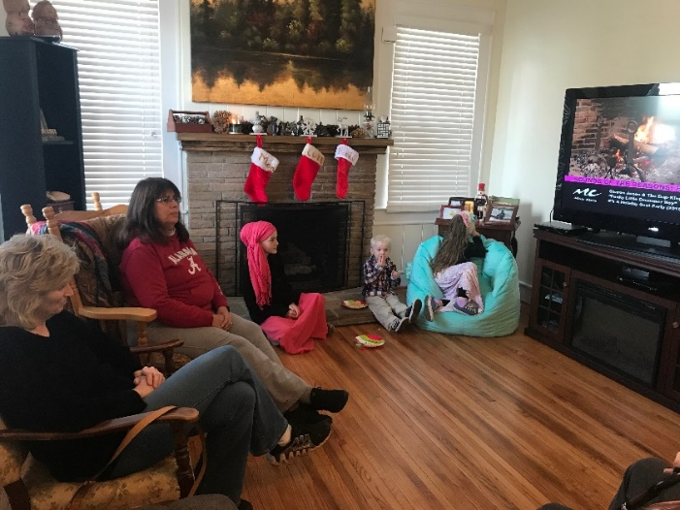

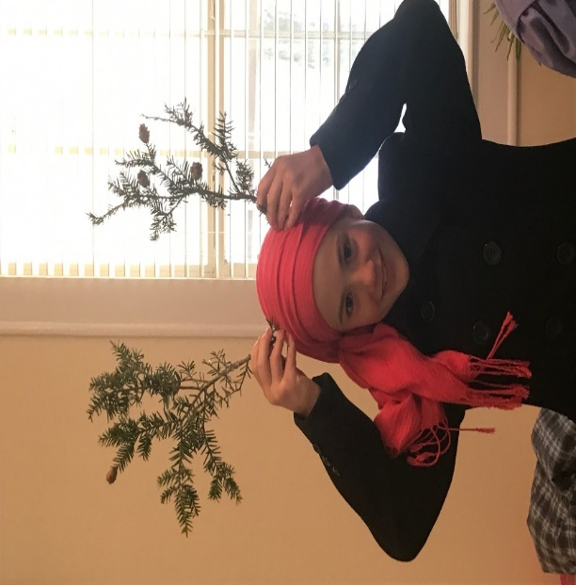

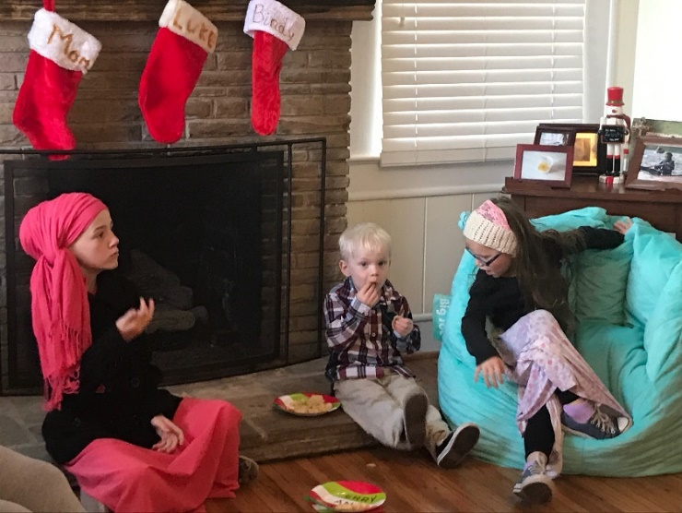

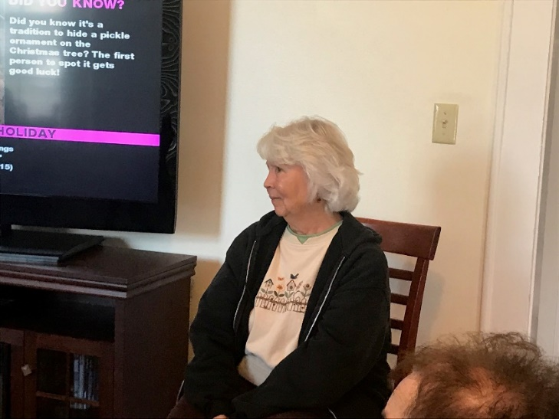



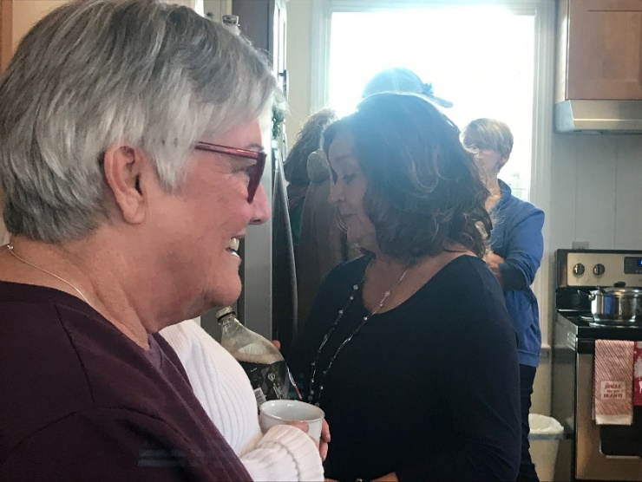



**Monterey Christmas Parade**

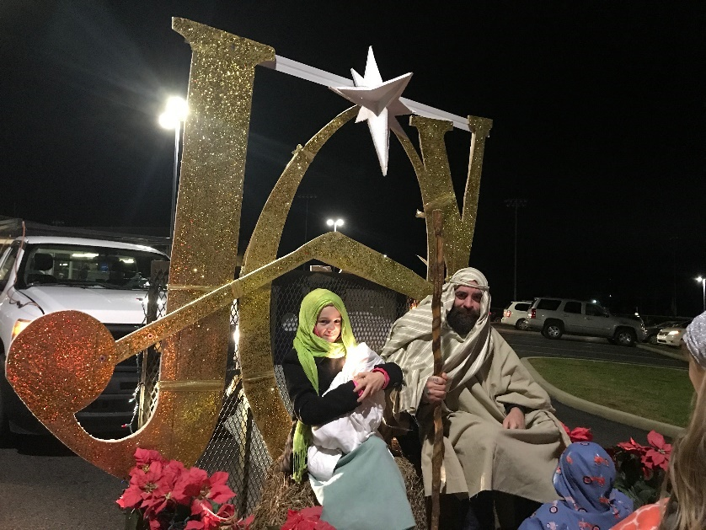



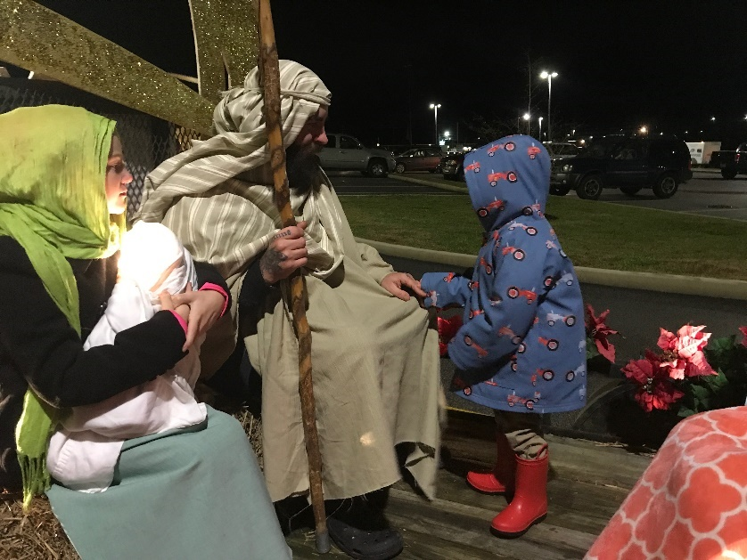

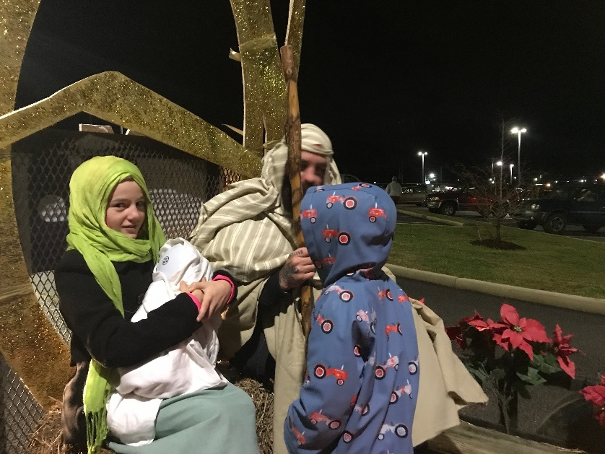

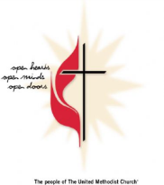

**M**onterey **U**nited **M**ethodist **C**hurch

**December 2018**

*For a child has been born to us, a son given to us; authority rests upon his shoulders; and he is named*

*Wonderful Counselor, Mighty God, Everlasting Father, Prince of Peace.*

Isaiah 9:6 *NRSV*

|  |  |  |  |  |  |  |
| --- | --- | --- | --- | --- | --- | --- |
| Sun | Mon | Tue | Wed | Thu | Fri | Sat |
|  |  |  |  |  |  | 1 |
|  |  |  |  |  |  | 9:00a Cottage Ministry  Poinsettia Orders Due Today |
| 2 | 3 | 4 | 5 | 6 | 7 | 8 |
| **First Sunday of Advent/Communion**    9:45a Sunday School  11:00a Worship Service  5:30p Youth Group | 6:00p Monterey Hilltop Chorale |  | 5:00 pm Music for Children  6:30p Choir Practice | Beersheba Springs Christmas Program 10 am to 2 pm | 9:00a Cottage Ministry | 9:00a Cottage Ministry |
| 9 | 10 | 11 | 12 | 13 | 14 | 15 |
| **2nd Sunday of Advent**  Group Membership  9:45a Sunday School  11:00a Worship Service  5:30p Youth Group | **6:00p Christmas Chorale Concert** | 10:30a Monterey Garden Club  6:00 pm Administrative Council | 5:00 pm Music for Children  6:30p Choir Practice |  | 9:00a Cottage Ministry | 9:00a Cottage Ministry |
| 16 | 17 | 18 | 19 | 20 | 21 | 22 |
| **3rd Sunday of Advent**  Christmas Musical  Ugly Christmas Sweater  9:45a Sunday School  11:00a Worship Service  5:30p Youth Group | 6:00p Monterey Hilltop Chorale | 6:00p Civitan Club | 5:00 pm Music for Children  6:30p Choir Practice |  | 9:00a Cottage Ministry | 9:00a-Cottage Ministry |
| 23 | 24 | 25 | 26 | 27 | 29 | 30 |
| **4th Sunday of Advent**  9:45a Sunday School 31  11:00a Worship Service  5:30p Youth Group  2 pm Standing Stone Worship | 6:00p Monterey Hilltop Chorale  ***5 pm – Christmas Eve Candle light Service*** | **CHRISTMAS** | 5:00 pm Music for Children  6:00 pm Choir Practice |  | 9:00a Cottage Ministry |  |