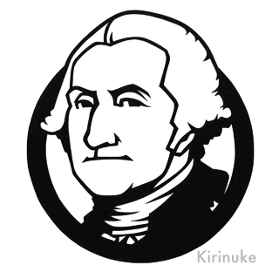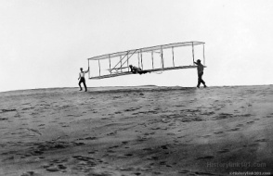**The City of Williamson**

***P.O. Box 9***

*Williamson, Georgia 30292*

**Steve Fry, Mayor Bunny Scoggins, City Council Post 3**

**Stephen Levin, City Council Post 1 Carol Berry, City Council Post 4**

**Melissa Kelsey, City Council Post 2 Brenda Bennett, City Council Post 5**

**Annotated AGENDA**

**REGULAR MONTHLY MEETING**

**6 December 2018 7:00 PM**

1. **C:\Program Files (x86)\Microsoft Office\MEDIA\CAGCAT10\j0183290.wmfCALL TO ORDER, INVOCATION, PLEDGE, WELCOME……….**Mayor Steve Fry: 7:25
2. **APPROVAL OF THE AGENDA** (O.C.G A. § 50-14-1 (e) (1)): CB Motion, MK Second and vote to Approve.
3. **APPROVAL OF THE MINUTES** (O.C.G.A. § 50-14-1(e) (2)):
4. Minutes from Regular Monthly Meeting held 8 November, 2018: BS motioned, MK second, vote to approve
5. **FINANCIAL REPORT:** Mayor presented financial reports. BS Motion, CB Second and vote to approve
6. **REPORTS FROM DEPARTMENTS, COMMITTEES AND BOARDS**
7. City Clerk Report: No report except GA Rural Water Financial Workshop helpful with utility billing.
8. Council Member Report: MK reported that Christmas parade cancelled, also discussed Christmas caroling and asking for canned food donations; CB reported not to forget about our employees and appreciating our employees and volunteers; BS reported that she has a complaint about the trash pickup at pavilion and other locations,
9. City Attorney Report: No report other than agenda.
10. Mayor’s Report
11. County Matters: See RLM’s written report; Motion, Second and vote to approve Joint Board of Elections and Registrations
12. Library Report: Karen gave report
13. **UNFINISHED BUSINESS**
    1. Helicopter Pavilion Rails Update: Mayor gave report. Still working on items.
    2. Progress on Installing Turnarounds in Subdivisions with Dead-End Streets: Mayor gave update
    3. Second Reading of Proposed Update to Municipal Code Title 8, Traffic Regulations, Chapter 8-3: Mayor presented updates: After discussion MK motioned, BS seconded, vote to approve
    4. Engineering Review for Upgrades to Water Lines and Additional Service: Mayor gave report about meeting with Scott Huckaby, Mark Whitley and Brad Vaughan and flow testing to analyze pressure in Ashley Glen; researching options upgrades ($300,000); there was further discussion regarding engineering needs and options; there is a $30,000 possible fix instead of $300,000
    5. Second Reading of Proposed Municipal Code Section 7-1-21, Business Hours: BS motioned, MK seconded and vote to approve
    6. There was a presentation of other modifications for Code, there was a motion, second and vote to approve 1st reading of revisions (fireworks, chapter 9 and violations).
14. **NEW BUSINESS**
    1. Christmas Caroling Event Details Update: Discussed above
    2. Discussion Concerning Enforcement of ROW Disturbance Ordinance and Bonding: Mayor made a presentation;
15. **EXECUTIVE SESSION:** O.C.G.A. § 50-14-3 to discuss personnel 8:52-9:09
16. **PUBLIC COMMENT:** There was discussion about the use of Howard Street by delivery trucks
17. There was a motion, second and vote to approve bonuses $500 to Karen, $400 to Christy, $300 to Julia, $100 to Scott Huckaby, $50 to Fred
18. Mayor Fry reported on clean up at Gladys Rowe’s home.
19. **ADJOURNMENT:** 9:12