Excel Chapter 2
  - Recording Student Grades
Name: _______________________________________________________
Class: _______________________________________________________
Date: _______________________________________________________
- To insert a new column between Last and Student ID#, you would select column B.
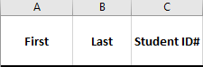
  - True
  - False
- If you hide rows 3:5 in your worksheet, row 4 will not print.
  - True
  - False
- To rename a worksheet, you can double-click the sheet tab and type the new name without pressing [Delete] or [Backspace].
  - True
  - False
- While multiple sheets are selected, you can modify all of the selected sheets by making changes to one of them.
  - True
  - False
- Functions can be entered only by typing them directly into a cell.
  - True
  - False
- Selecting a blank cell at the bottom of a column and clicking AutoSum will enter the SUM function, which will add all of the numbers in that column.
  - True
  - False

- The [F5] key can be used to edit a cell reference to be a relative reference, an absolute reference, or a mixed reference.
  - True
  - False
- When entering a formula, if you type the first few letters of a cell name, the AutoFill list will suggest the name for you.
  - True
  - False
- After sorting the Quiz 1 grades in column D from highest to lowest, what would be the correct order of the students?
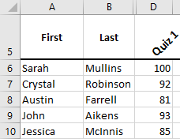
  - Sarah, Crystal, Austin, John, Jessica
  - Jessica, John, Sarah, Austin, Crystal
  - Sarah, John, Jessica, Austin, Crystal
  - Sarah, John, Crystal, Jessica, Austin
- What cell reference should you enter if you want to create a formula that refers to cell A3 on the Expenses worksheet?
  - Expenses!A3
  - Exp!A3
  - ExpensesA3
  - Expenses!A3!
- Which of the following images displays the correct sheet tabs after you have copied the Q1 Revenue sheet?
  - 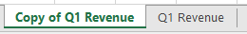

- What would be the result of the formula in cell A4 below?
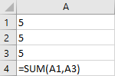
  - 5
  - 10
  - 15
  - 20
- Which formula will appear in cell E6 if the formula in cell E5 is copied to cell E6?
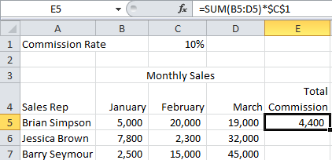
  - =SUM(B5:D5)*$C$1
  - =SUM(B5:D5)*C1
  - =SUM(B6:D6)*$C$1
  - =SUM(B6:D6)*$D$6

- Which of the following best describes what would occur in cell E5 if the rate in cell C1 were changed to 15%?
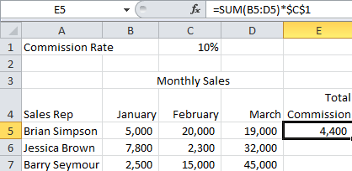
  - The rate in cell C1 cannot be changed because it is a percentage.
  - The formula result in cell E5 would remain the same because the formula uses an absolute cell reference to cell C1.
  - The formula in cell E5 would need to be reentered before the new commission percentage could be calculated.
  - The result would be updated to reflect the new commission percentage of 15%.
- After selecting a cell, the following methods can be used to create a name for the cell:
  - Type the name into the name box.
  - Choose the Use in Formula menu button from the Ribbon.
  - Right-click the cell and choose Name.
  - Type the name in the Formula Bar.

