Chapter 5
Banking Tasks
Name: ______________________________
Class: ______________________________
Date: ______________________________
- If you have previously used an account in QuickBooks but are no longer doing so, what should you do with it?
- Delete it.
- Void it.
- Make it inactive.
- Edit the name of it to an account you do use.
- Esmerelda is starting to use PayPal to pay vendors. What kind of account should she set it up as in QuickBooks?
- Credit card
- Bank
- Other Current Asset
- Expense
- Where do you pay a bill by credit card when the bill was not entered through the Enter Bills window?
- The Pay Bills window
- The Write Checks window
- The Enter Credit Card Charges window
- The Accounts Payable Register window
- Rossi received a non-sufficient funds notice from his bank for a check written by a customer who was invoiced. In which window does he record the “bounced” check?
- Create Invoices
- Write Checks
- Make Deposits
- Receive Payments

- Morgan entered a debit card transaction in the Enter Credit Card Charges window. How can she fix the error?
- Change the code on the credit card transaction to “DB.”
- Delete the credit card transaction and reenter it through the Write Checks window.
- Delete the credit card transaction and enter it into the Debit Card register.
- Convert the transaction in the Enter Credit Card Charges window.
- What is the value of the equity account(s) for Average Guy Designs?
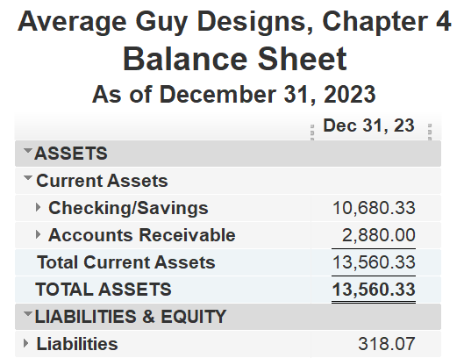
- $13,242.26
- $13,560.33
- $10,680.33
- $318.07
- Which button would you use to attach a file to a transaction?
- What displays when you double-click Design Income in the Chart of Accounts?
- Account Register
- Profit & Loss report
- QuickReport
- Sales reports

- Which “behind-the-scenes” images show what happens when you make a deposit into Checking?
- 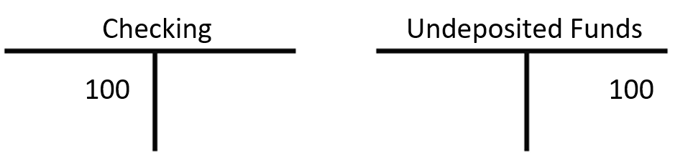
- 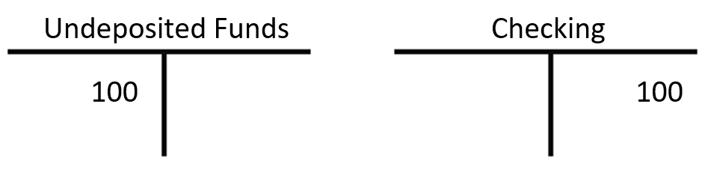
- 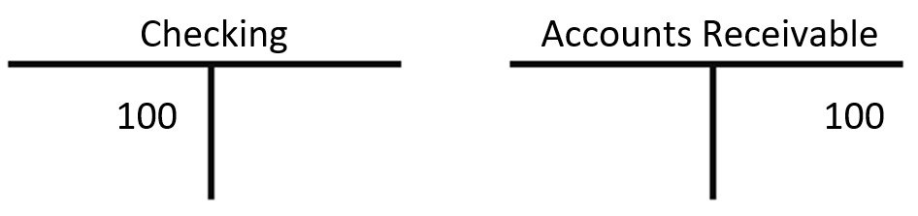

- Which account has its own register?
- Sales
- Rent Expense
- Retained Earnings
- Checking
- Elijah wants to make sure what he enters in QuickBooks matches what’s on his bank statement. He should perform a(n):
- bank match
- account match
- reconciliation
- discrepancy search
- In the Chart of Accounts, what are bank accounts listed as?
- Credits
- Debits
- Assets
- Liabilities
- Which statement about transferring funds between two asset accounts is true?
- You debit the account that is increasing and credit the account that is decreasing.
- You credit the account that is increasing and debit the account that is increasing.
- You credit both the account that is increasing and the account that is decreasing.
- You debit both the account that is increasing and the account that is decreasing.
- Rasha doesn’t like how her Chart of Accounts is sorted and that she must scroll up/down to find accounts. What can she do to make it easier to find the accounts she needs?
- She can use the Item List; accounts are much easier to find there.
- Nothing; she’ll just have to get used to it.
- She can press [Ctrl]+[s] to open the Search feature and type in her account name.
- She can click a column heading to sort that column.
- Which statement about making deposits is true?
- Funds received through sales are held in Savings, and you must move them to Checking.
- Funds received through sales are held in Undeposited Funds, and you must move them to your bank account.
- Funds received through sales are held in Accounts Payable, and you must move them to your bank account.
- Funds received through sales are held in Accounts Receivable, and you must move them to your bank account.

- A credit card is a liability, so its normal balance is a(n):
- sale
- debit
- payment
- credit
- Adam entered a utility bill via the Enter Bills window and paid it via the Write Checks window using a debit card. Later he noticed that the transaction expense shows as twice the amount he paid. Why?
- He used a debit card when he should have used a credit card.
- QuickBooks always shows double charges because of debits and credits.
- He used the Write Checks window instead of the Pay Bills window.
- He entered the bill twice.
- Which statement about deleted and voided transactions is true?
- Both are recorded and become part of the overall records.
- Both are removed from the overall records.
- Deleted transactions are removed; voided transactions are recorded and become part of the overall records.
- Voided transactions are removed; deleted transactions are recorded and become part of the overall records.

- Wasim is a meticulous recordkeeper and has been printing his QuickBooks reports every day, but he’s becoming concerned about the cost and overuse of paper. How else can Wasim keep a record of his QuickBooks reports?
- He can email the reports to himself as PDF or Word files.
- He can export the reports to Word.
- He can save the reports to his computer as PDF files.
- He can choose FileSave As from the menu bar.
- On the Balance Sheet Summary report you will see that:
- long-term and short-term assets are equal to long-term and short-term liabilities
- assets are equal to liabilities and equity combined
- credits and debits are equal
- bank accounts are equal to the equity accounts
- Lamar finds reconciling his bank statement with his QuickBooks file at the end of the month too time-consuming. Upon learning that his bank offers a bank feed with QuickBooks, Lamar signs up for the service. How will this change his monthly reconciliation?
- It won’t. Reconciliation will likely take just as long and be just as complicated.
- He will not have to do reconciliation at all anymore.
- Reconciliation will be quicker because most transactions will be matched already.
- The teller will do the reconciliation for him.
- Fajer is performing a reconciliation that shows a difference between her QuickBooks account and bank statement. What is the first thing she should do to try to resolve it?
- Look for a transaction in the same amount as the difference and ensure whether it should be cleared.
- Determine whether there is a bank error.
- Cancel the reconciliation and start over or change the difference to a previously cleared amount.
- Run a Reconciliation Discrepancy report.
- Ming just received funds from multiple customers that she doesn’t want to track individually via PayPal. Where should she record this in QuickBooks?
- Make Deposits window
- Write Checks window
- Customer Receipts window
- PayPal Income window

- Match each report to the question it answers.
REPORTS |  | QUESTIONS ANSWERED
- Register QuickReport  - Reconciliation Summary  - Company Snapshot  - Balance Sheet | _____  _____  _____  _____ | - What changes in transactions may affect my next reconciliation?  - What checks haven’t cleared the bank as of the last statement?
- Reconciliation Discrepancy | _____ | - Which report shows all asset, liability, and equity accounts?  - Where can I get a quick view of my
company’s bottom line?
- What are all the transactions in my
 |  | Checking account involving a specific payee?

- Match each description to its term.
DESCRIPTIONS |  | TERMS
- Funds taken directly from the Checking account | _____ | - Reconciliation reports  - Credit card reconciliation
- After this, write a check or enter a bill for the payment | _____ | - Company Snapshot  - Debit card purchase
- Shows transactions that have and haven’t yet cleared the bank | _____ | - Balance Sheet
- Shows all asset, liability, and equity accounts | _____
- Quick view of a company’s bottom line | _____

