United States of America timeline
A chronology of key events:
1565 - First permanent European settlement in North America - St Augustine, present-day Florida - founded by the Spanish. North America is already inhabited by several distinct groups of people, who go into decline following the arrival of settlers.
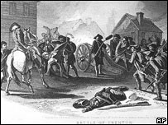
Revolution: The Continental Army fought against British rule
BBC History: Was the American Revolution inevitable?
BBC History: Rebels and Redcoats
1607 - Jamestown, Virginia, founded by English settlers, who begin growing tobacco.
1620 - Plymouth Colony, near Cape Cod, is founded by the Pilgrim Fathers, whose example is followed by other English Puritans in New England.
17th-18th centuries - Hundreds of thousands of Africans brought over and sold into slavery to work on cotton and tobacco plantations.
1763 - Britain gains control of territory up to the Mississippi river following victory over France in Seven Years' War.
War of Independence
1774 - Colonists form First Continental Congress as Britain closes down Boston harbour and deploys troops in Massachusetts.
1775 - American Revolution: George Washington leads colonist Continental Army to fight against British rule.
1776 4 July - Thomas Jefferson's American Declaration of Independence endorsed by Congress; colonies declare independence.
1781 - Rebel states form loose confederation, codified in Articles of Confederation, after defeating the British at the Battle of Yorktown.
ABRAHAM LINCOLN
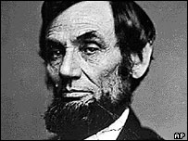
16th president preserved Union, emancipated slaves
Born in Kentucky, 1809
Known as 'Honest Abe' and the 'Great Emancipator'
His Gettysburg Address honoured the Union dead, set out the principles they died for
Assassinated in 1865
2002: Words of Lincoln console nation
1783 - Britain accepts loss of colonies by virtue of Treaty of Paris.
1787 - Founding Fathers draw up new constitution for United States of America. Constitution comes into effect in 1788.
1789 - George Washington elected first president of USA.
1791 - Bill of Rights guarantees individual freedom.
1803 - France sells Louisiana territories to USA.
1808 - Atlantic slave trade abolished.
1812-15 - War of 1812 between the US and Britain, partly over the effects of British restrictions on US trade during the Napoleonic Wars.
19th century - Residual resistance by indigenous people crushed as immigration from Europe assumes mass proportions, with settlers moving westwards and claiming "manifest destiny" to control North America; number of states in the union rises from 17 to 45.
1846-48 - US acquires vast tracts of Mexican territory in wake of Mexican War including California and New Mexico.
Civil War
1854 - Opponents of slavery, or abolitionists, set up Republican Party.
1860 - Republican candidate Abraham Lincoln elected president.
1860-61 - Eleven pro-slavery southern states secede from Union and form Confederate States of America under leadership of Jefferson Davis, triggering civil war with abolitionist northern states.
1863 - Lincoln issues Emancipation Proclamation, declaring slaves in Confederate states to be free.
1865 - Confederates defeated; slavery abolished under Thirteenth Amendment. Lincoln is assassinated.
1876 - Sioux Indians defeat US troops at Little Big Horn.
1890 - US troops defeat Sioux Indians at Wounded Knee.
1898 - US gains Puerto Rico, Guam, the Philippines and Cuba following the Spanish-American war. US annexes Hawaii.
World War I and the Great Depression
1917-18 - US intervenes in World War I, rejects membership of League of Nations.
FRANKLIN D ROOSEVELT
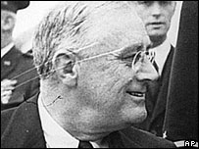
FDR led the US through the Great Depression and World War II
BBC History: Franklin Delano Roosevelt
1939: FDR proclaims US neutrality
1920 - Women given the right to vote under the Nineteenth Amendment.
1920 - Sale and manufacture of alcoholic liquors outlawed. The Prohibition era sees a mushrooming of illegal drinking joints, home-produced alcohol and gangsterism.
1924 - Congress gives indigenous people right to citizenship.
1929-33 - 13 million people become unemployed after the Wall Street stock market crash of 1929 triggers what becomes known as the Great Depression. President Herbert Hoover rejects direct federal relief.
1933 - President Franklin D Roosevelt launches "New Deal" recovery programme which includes major public works. Sale of alcohol resumes.
World War II and the Cold War
1941 - Japanese warplanes attack US fleet at Pearl Harbour in Hawaii; US declares war on Japan; Germany declares war on US, which thereafter intervenes on a massive scale in World War II, eventually helping to defeat Germany.
1945 - US drops two atomic bombs on Hiroshima and Nagasaki. Japan surrenders.
1947 - US enunciates policy of aid for nations it deems threatened by communism in what became known as the Truman Doctrine. Cold War with Soviet Union begins.
1948 - America's programme to revive ailing post-war European economies - the Marshall Plan - comes into force. Some $13bn is disbursed over four years and the plan is regarded as a success.
1950-54 - Senator Joseph McCarthy carries out a crusade against alleged communists in government and public life; the campaign and its methods become known as McCarthyism. In 1954 McCarthy is formally censured by the Senate.
1950-53 - US forces play leading role against North Korean and Chinese troops in Korean War.
Desegregation and the Vietnam war
1954 - Racial segregation in schools becomes unconstitutional; start of campaign of civil disobedience to secure civil rights for Americans of African descent.
JOHN F KENNEDY
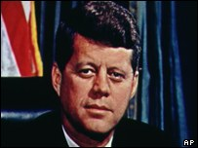
Killed by an assassin's bullet in Dallas, 1963
BBC History: John F Kennedy
BBC History: Listen to some of JFK's key speeches
On This Day 1963: Kennedy shot dead
2003: What made the Kennedys tick?
1960 - Democratic Party candidate John F Kennedy elected president, narrowly defeating his rival Richard Nixon.
1961 - Bay of Pigs invasion: an unsuccessful attempt to invade Cuba by Cuban exiles, organised and financed by Washington.
1962 - US compels Soviet Union to withdraw nuclear weapons from Cuba in what has become known as the Cuban missile crisis.
1963 - President John F Kennedy assassinated; Lyndon Johnson becomes president.
1964 - US steps up its military intervention in Vietnam. Civil Rights Act signed into law; it aims to halt discrimination on grounds of race, colour, religion, nationality.
1968 - Black civil rights leader Martin Luther King assassinated.
1969 - Republican Party candidate Richard Nixon elected president amid growing public opposition to Vietnam war. US military presence in Vietnam exceeds 500,000 personnel.
US astronaut Neil Armstrong becomes the first person to walk on the Moon.
MARTIN LUTHER KING JR
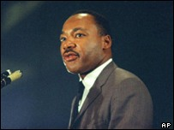
Civil rights leader was renowned for his stirring oratory
Special feature: Marching for Freedom 1963
BBC History: Martin Luther King Jr
On This Day 1968: Martin Luther King shot dead
1972 - Nixon re-elected and makes historic visit to China.
1973 - Vietnam ceasefire agreement signed. The campaign had claimed some 58,000 American lives.
1974 - In a TV address, Nixon announces his resignation in the wake of the Watergate scandal, over a 1972 break-in at the Democratic Party headquarters. Gerald Ford is sworn-in as his successor.
1976 - Democratic Party candidate Jimmy Carter elected president.
1979 - US embassy in Tehran, Iran, seized by radical students. The 444-day hostage crisis - including a failed rescue attempt in 1980 - impacts on Carter's popularity and dominates the 1980 presidential election campaign.
Global assertiveness
1980 November - Republican Party's Ronald Reagan elected president. Reagan goes on to adopt a tough anti-communist foreign policy and tax-cutting policies which lead to a large federal budget deficit.
1981 January - Iran frees the 52 US embassy hostages, on the same day as President Reagan's inauguration.
RONALD REAGAN
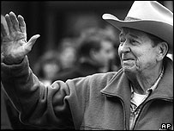
Former president, said to have restored US self-confidence
On This Day 1980: Reagan beats Carter in landslide
Ronald Reagan: A life in pictures
2004: How will history remember Reagan?
1983 - US invades Caribbean nation of Grenada, partly prompted by its concerns over the island's ties with Cuba.
1984 - Ronald Reagan re-elected president, beating Democratic Party candidate Walter Mondale.
1986 January - Space shuttle Challenger explodes shortly after take off from Cape Canaveral. All seven crew members are killed. Manned space flights are suspended until September 1988.
1986 - US warplanes bomb Libyan cities. "Irangate" scandal uncovered, revealing that proceeds from secret US arms sales to Iran were used illegally to fund Contra rebels in Nicaragua.
1988 - Reagan's vice-president, George Bush, elected president.
1989 - US troops invade Panama, oust its government and arrest its leader, one-time Central Intelligence Agency informant General Manuel Noriega, on drug-trafficking charges.
1991 - US forces play dominant role in war against Iraq, which was triggered by Iraq's invasion of Kuwait and ended with the expulsion of Iraqi troops from that country.
The Clinton years
1992 - Democratic Party candidate Bill Clinton elected president.
1992 - Congress passes North American Free Trade Agreement, or Nafta, intended to create free-trade bloc among US, Canada and Mexico.
THE US IN SPACE
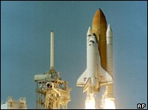
Shuttle programme goes on despite losses of two craft
Timeline: Space flight
In Depth: 2003 Shuttle disaster
In Depth: Space Shuttle - Return to flight
2004: President Bush unveils space plans
1995 - Oklahoma bomb kills more than 160 people in worst ever incident of its kind in US.
1996 - Clinton re-elected, beating Republican rival Bob Dole.
1998 - Scandal over Clinton's purported sexual impropriety with White House worker Monica Lewinsky dominates domestic political agenda and leads to impeachment proceedings in Congress.
1999 March-June - US plays leading role in Nato bombardment of Yugoslavia in response to Serb violence against ethnic Albanians in the province of Kosovo.
Democrats lose
2000 November - Republican Party's George W Bush wins presidency.
BILL CLINTON
Former Democrat president shows off his musical talent
In Depth: The Clinton years
2004: 'My Life' retains Clinton's flaws
January 2001: Bill Clinton's farewell
2001 July - US tests its controversial missile defence shield, or "Son of Star Wars".
11 September attacks
2001 11 September - Co-ordinated suicide attacks on various high-profile targets, prompting the US to embark on a ''war on terror'' which includes the invasion of Afghanistan and Iraq.
2001 October - US leads massive campaign of air strikes against Afghanistan and helps opposition forces defeat the Taleban regime and find Saudi-born dissident Osama Bin Laden, who is suspected of masterminding the 11 September attacks.
2001 October - USA Patriot Act approved by the Senate, giving the government greater powers to detain suspected terrorists, eavesdrop on communications and counter money-laundering. In November, President Bush signs a directive to try suspected terrorists in military tribunals rather than the courts.
2001 December - Energy giant Enron declared bankrupt after massive false-accounting comes to light.
2002 January - State of the Union address: President George W Bush includes Iraq, Iran and North Korea in what he describes as an "axis of evil".
UNDER ATTACK
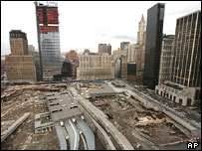
Ground Zero: Hijacked planes struck the World Trade Center towers
In Depth: America's day of terror
2002 State of the Union address: "Axis of evil"
2002 June/July - Telecoms giant WorldCom's multi-billion dollar accounting fraud is revealed, eclipsing the Enron scandal to become the biggest business failure in US history.
2002 November - President Bush signs into law a bill creating a Department of Homeland Security, the biggest reorganisation of federal government in more than 50 years. The large and powerful department is tasked with protecting the US against terrorist attacks.
2003 February - Space shuttle Columbia's 28th mission ends in tragedy when the craft breaks-up while re-entering the atmosphere. The seven astronauts on board are killed.
Iraq war
2003 March - Missile attacks on Baghdad mark the start of a US-led campaign to topple the Iraqi leader Saddam Hussein. US forces advance into central Baghdad in early April.
IRAQ WAR
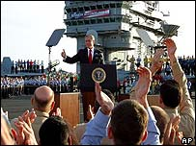
2003: President George W Bush on the USS Abraham Lincoln
Bush: "We have seen the turning of the tide"
In Depth: The struggle for Iraq
2003 1 May - Speaking on the deck of the aircraft carrier Abraham Lincoln, President Bush declares that the main part of the war in Iraq is over.
2004 May - Furore over pictures showing the abuse of Iraqi prisoners in US custody.
2004 July - Senate report says US and allies went to war in Iraq on "flawed" information. Independent report into 11 September 2001 attacks highlights deep institutional failings in intelligence services and government.
Bush second term
2004 2 November - Presidential elections: George W Bush wins a second term.
2005 August - Hundreds of people are killed when Hurricane Katrina, the most destructive storm to hit the US in decades, sweeps through gulf coast states. Much of the city of New Orleans is submerged by flood waters.
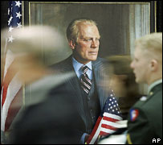
Gerald Ford: 38th president was given a state funeral in 2007
Obituary: Gerald Ford
Gerald Ford: Life in pictures
2006 March - Congress renews the USA Patriot Act, a centrepiece of the government's fight against terrorism, after months of debate about its impact on civil liberties. The government agrees to some curbs on information gathering.
2006 April-May - Millions of immigrants and their supporters take to the streets to protest against plans to criminalise illegal immigrants.
2006 May - The only man to be charged over the September 11 attacks, self-confessed al-Qaeda conspirator Zacarias Moussaoui, is sentenced to life in jail.
2006 November - Democratic Party wins control of the Senate and House of Representatives in mid-term elections. Defence Secretary Donald Rumsfeld steps down.
2007 January - President Bush announces a new Iraq strategy; thousands more US troops will be dispatched to shore up security in Baghdad.
CREDIT CRUNCH
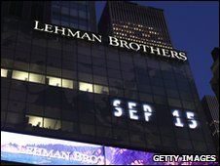
The 2008-9 financial crisis sent shockwaves throughout the world
Inside the collapse of Lehman Brothers
Lehman collapse
2008 September - Turmoil in the US and international financial markets as major Wall Street investment bank Lehman Brothers collapses and other big US financial players face growing troubles as a result of the "credit crunch". With hundreds of billions of dollars wiped out in bad loans and a prolonged property slump, the US faces its worst financial crisis since the Great Depression.
Obama elected
2008 November - Democratic Senator Barack Obama becomes the first black president of the United States.
THE GEORGE W BUSH YEARS
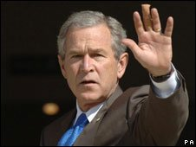
Wave of support after 9/11 yielded to derision at home and abroad
How does the Bush presidency rate?
Rise and fall of Bush's popularity
2009 January - First "Tea Party" rally held in protest at Obama administration's plans to bail out banks and introduce healthcare reform. The populist and libertarian movement acts as focus for conservative opposition to the president's reform plans.
2010 March - Democrats in Congress succeed in passing a bill on health care reform, despite strong Republican opposition, procedural setbacks and public scepticism.
US and Russia announce agreement on a new nuclear arms reduction treaty to replace the 1991 Strategic Arms Reduction Treaty. The pact was to be signed on 8 April.
President Obama unveils a new defence policy significantly curtailing the circumstances in which the US would use nuclear weapons.
2010 May-June - Deepwater Horizon oil rig disaster in the Gulf of Mexico causes the United States' biggest oil spill to date.
OPPOSITION TO OBAMA
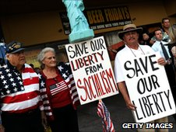
Tea Party agenda provides rallying point for disgruntled conservatives
What is the Tea Party?
Storm in a Tea Party cup?
2010 November - Republicans make sweeping gains in mid-term elections, regaining control of House of Representatives.
2011 May - US forces kill Al-Qaeda leader Osama Bin Laden in an operation in the Pakistani city of Abbottabad.
2011 July - The final Space Shuttle mission is completed with the landing of Atlantis on 21 July, bringing about the end of the 30-year programme.
2011 September - Anti-capitalist protesters take to the streets of major cities, marching under the slogan "Occupy Wall Street", against "corporate greed" and increasing government debt. The protests inspire marches in other cities worldwide.
2012 January - President Obama unveils a revised defence strategy involving budget cuts, but insists US will maintain its military superiority.

