SPORTS & ORTHOPEDIC SPECIALISTS  PAYMENT AND BILLING INFORMATION FORM FOR CASH PAYMENT PATIENTS | 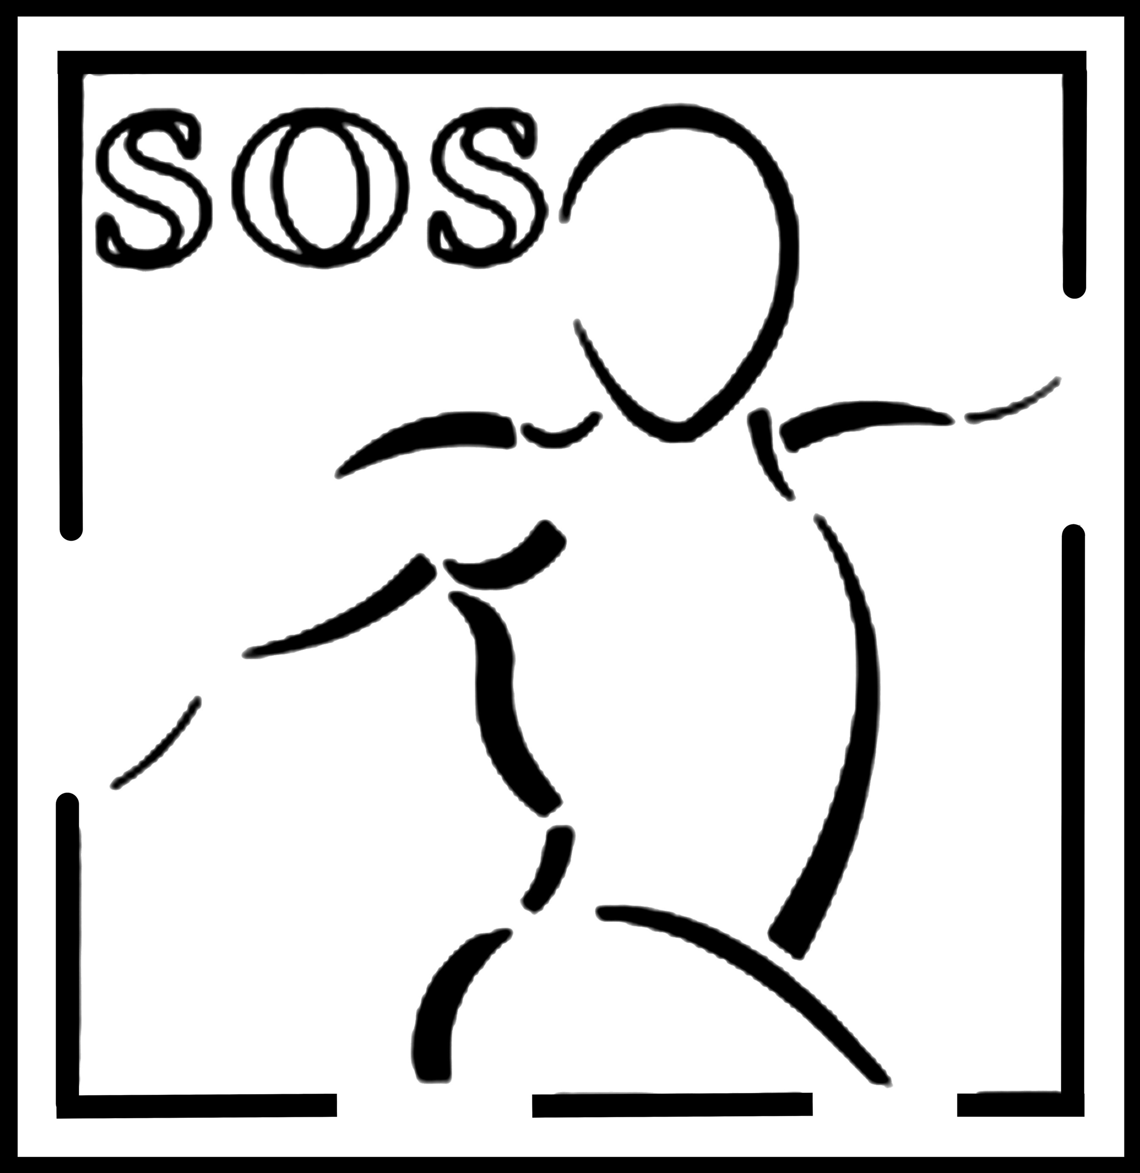
PATIENT NAME:

CASH PAYMENT RTAES ARE AS FOLLOWS

PATIENT EVALUATION
60 Minutes: $160
30 Minutes: $120

FOLOW UP VISITS
30 Minutes: $80
45 Minutes: $120
60 Minutes: $160

PAYMENT IS DUE AT THE TIME OF THE VISIT

Our Cash Payment charges are not associated with medical billing (CPT) codes.

- Our Cash Payment charges are a discounted rate that we offer based partially on reduced paperwork and billing expenses and partially as a patient courtesy.
- They are not associated with a medical billing (CPT) code.
- Medical codes are required for billing to insurance companies and to most Health Saving Accounts (HSA). They are also necessary for establishing patient medical
- costs for any legal proceedings.
- You are therefore not eligible to use our discounted cash payment rates if you will be needing medical billing (CPT) codes.
- You may request that we change your Cash Payment codes to CPT codes.
Before we can change the codes you will need to switch from a Cash Payment patient to a Private Insurance patient and fill in the appropriate paperwork.
There is a higher cost associated with the CPT codes than with the Cash Payment codes. You will be responsible for the higher CPT code charges if you opt to change
to insurance rates. Please inquire about these rate differences if you choose to change codes.

I understand the policies associated with the Cash Payment rate as outlined above.

___________________________________________________________ _____________________
Patient Signature (Parent or Guardian if Minor) Date

