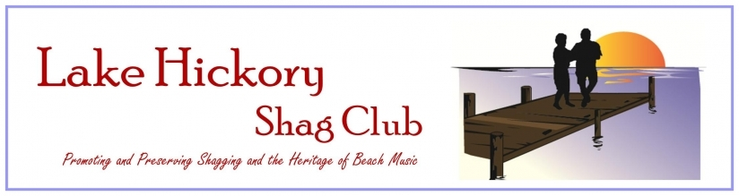
LHSC
MERCHANDISE

Short sleeve T-shirts – imprinted front only - $15.00
Short Sleeve T-Shirts – imprinted front & back - $20.00
Long Sleeve imprinted front & back – $25.00
Variety of colors
Front Back
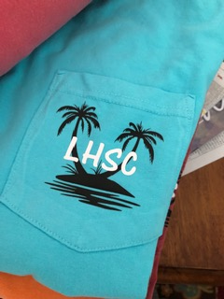

MERCHANDISE WITH LOGO LHSC ONLY IF AVAILABLE
Mug__________________ Item________________
**Make Check payable to Lake Hickory Shag Club**
Name:__________________________Amount $________
Phone # ____________Email________________________
Shirt Size: ___________
_______________________________________________________________________________

You may bring your own shirt to have imprinted:
Cost: Front only -$7.00
Front & Back - $15.00
Name_______________Email __________________________

Front $_______ Front & Back $_______ Amount $ ________

