Chapter 4
Working with Vendors
Name: ______________________________
Class: ______________________________
Date: ______________________________
- What tab do you select to enter the default expense accounts for a vendor?
- Payment Settings
- Tax Settings
- Accounting Settings
- Additional Info
- What must your mouse pointer look like in order to allow you to QuickZoom on a report?
- What’s another name for the profit & loss report?
- Balance sheet
- Expense statement
- Income statement
- Net Profit report
- Hakim wants to see all vendor transactions that affect Accounts Payable. What report does he run?
- Profit & Loss report
- Vendor Balance Detail report
- Expense by Vendor report
- Vendor Balance Summary report

- Samantha wants to pay a bill she entered into Accounts Payable with a credit card. What does she do?
- She enters the payment in the Enter Credit Card Charges window.
- She enters the payment in the Write Checks window and enters CC as the check number.
- She checks the credit card option in the Enter Bills window.
- She sets credit card as the Payment Method in the Pay Bills window.
- Which “behind-the-scenes” images show what happens when you pay a bill?
- 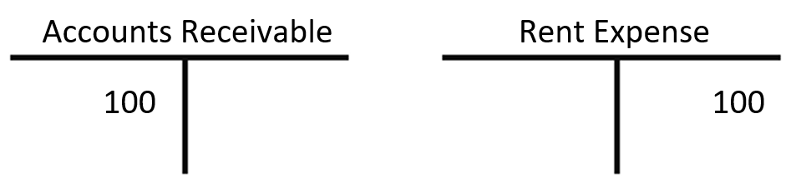
- 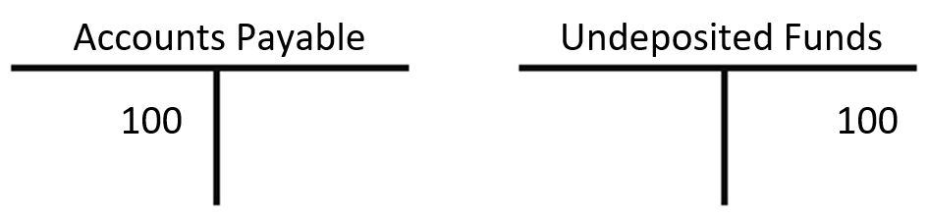
- What does this checkbox mean when displayed in the Enter Bills window?
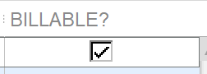
- You have just entered a bill into Accounts Receivable.
- The expense is to be passed on to a customer.
- The bill is marked to bypass Accounts Payable.
- The expense is to be held until a bill arrives.
- Kwang just wrote a check for a bill that was entered in the Enter Bills window. What should he do to correct his mistake?
- Delete the bill entered through the Enter Bills window.
- Enter the payment through the Pay Bills window.
- Void the check and enter the payment through the Pay Bills window.
- Delete the check and record the payment using a journal entry.

- What is the net income for Average Guy Designs in December 2023?
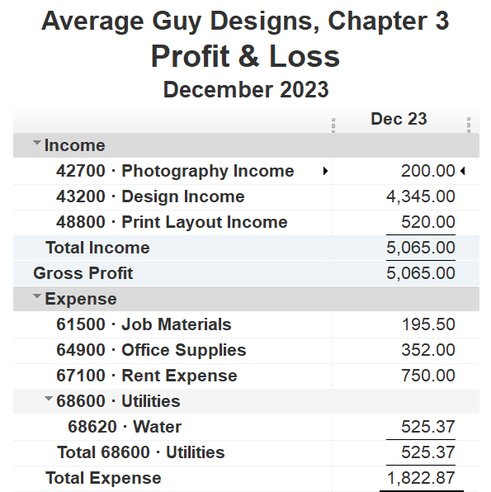
- $6,887.87
- $5,065.00
- $4,539.63
- $3,242.13
- What must you specify when entering a bill?
- Vendor
- Transaction
- Customer
- Income account
- What would prevent you from deleting a vendor from the Vendor List?
- You have entered an account number for the vendor.
- The vendor is a subcontractor.
- The vendor is also a customer.
- The vendor has been used in a transaction.
- What happens if you enter a bill through the Enter Bills window but pay it through the Write Checks window?
- You will expense the purchase properly.
- You will understate your expenses.
- You will “clear out” the bill in Accounts Payable but not enter the expense.
- You will expense the purchase twice AND not “clear out” the entry in Accounts Payable.

- You use the Pay Bills window to debit the _____ account.
- Accounts Receivable
- Accounts Payable
- Short Term Liability
- Checking
- Which statement about merging vendors is correct?
- You can merge up to seven vendors at a time.
- You can merge vendors with online transactions and direct deposits.
- You can unmerge vendors if you merge them by mistake.
- You must be logged in as an Admin user to merge vendors.
- Which statement about setting up subcontractors is true?
- They should be set up as vendors, not employees.
- They should be set up as both vendors and employees.
- They should be set up as employees.
- They should be set up as customers, not vendors.
- Up to how many default expense accounts can you have with each vendor?
- 2
- 3
- 4
- There is no limit.
- Akim is entering a bill from a vendor. When he selects the vendor, the default expense account for that vendor fills in, but, for this transaction only, he wants to use a different account. What should he do?
- Close the Enter Bills window, change the default expense account for the vendor, and reopen the vendor in the Enter Bills window.
- Remove the default expense account, finish the transaction, and create a duplicate transaction with the new expense account.
- Override the default expense account by changing it for this individual transaction.
- Leave the default expense account and add the other expense account in the next field.
- Which of these can you NOT edit after creating a new vendor?
- Tax ID
- Vendor name
- Opening balance
- Mailing address

- When bills are entered, which account is credited?
- Checking
- Undeposited Funds
- Accounts Receivable
- Accounts Payable
- Weyland’s customer will pay for the supplies needed for a new job. Using the Enter Bills window, how can Weyland pass the supplies cost on to the customer?
- He should check the “Billable?” box for the supplies in the Enter Bills window.
- He should create a separate bill for each supply and then convert those bills into invoices.
- He should make a note of the expense and then take care of the transaction outside of QuickBooks.
- He should create a bill estimate for the customer and enter the expense on it.
- Hayden recently set up her company file and is now entering her first few transactions. As she works in the Pay Bills window, she sees that Check is the only available payment method. Why isn’t Credit Card an option?
- She must select Credit Card as the default payment method for the vendor.
- She must have the vendor information set up first.
- She’s in the wrong window for paying bills.
- She must have a credit card account set up first.
- The Profit & Loss report reflects all transactions that have affected:
- bank and loan accounts
- income and expense accounts
- accounts receivable and accounts payable accounts
- credit card and liability accounts
- Nolan entered a bill but DIDN’T use the Pay Bills window. Which statement describes the behind-the-scenes effect of this?
- Income is double-stated, and Accounts Payable for the vendor is not cleared out.
- Income is double-stated, and Accounts Payable for the vendor is cleared out.
- Expenses are double-stated, and Accounts Payable for the vendor is not cleared out.
- Expenses are double-stated, and Accounts Payable for the vendor is cleared out.
- Ursula uses the cash basis of accounting and has a bill she needs to pay right away. What window should she use to record the transaction?
- Pay Bills
- Write Checks
- Enter Bills
- Create Statements
- Ahmed realizes that a customer with jobs is listed three times on the Customers & Jobs List. What should he do to have the customer listed only once?
- Move the jobs under one of the entries and then merge all three customer listings at once.
- Move the jobs under one of the entries, merge two of the entries, and then merge the resulting entry with the third one.
- Merge the jobs and then merge the three customers.
- Merge two entries first and then merge the resulting entry with the third one. Finally, move the jobs under the new entry.
- Bill’s employees and contractors earn commission for each customer they bring in, so he keeps careful track of this. What should he do in QuickBooks so he can create reports that display the information?
- Populate the Customer Type List and choose the correct entry on sales forms.
- Create a payment method that will track the individual responsible for the sale.
- Create a new entry in the Terms List that can be used to track those responsible for sales.
- Populate the Sales Rep List and choose the correct entry on sales forms.
- Jessica wants to find a report that she previously modified and saved. Which tab in the Report Center should she choose?
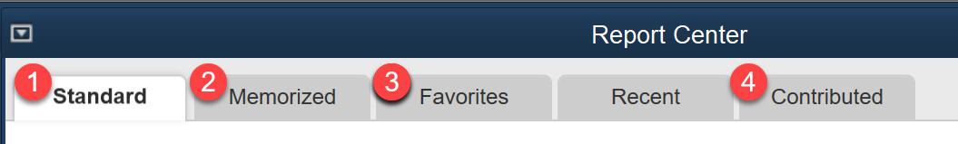
- 1
- 2
- 3
- 4

- Where do you click to edit the active vendor?
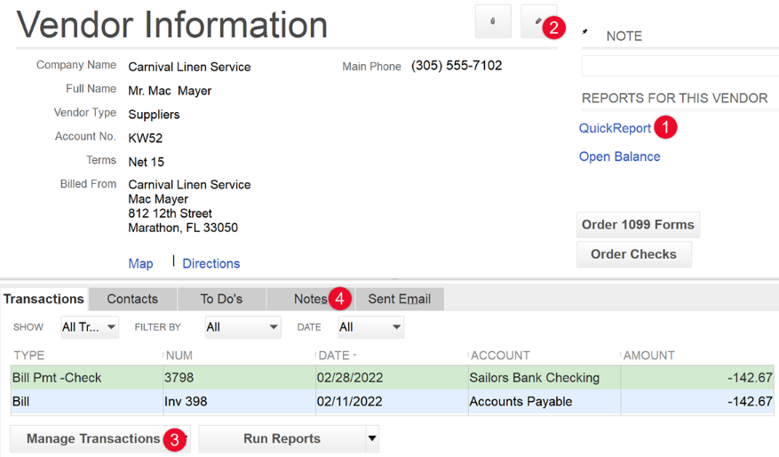
  - 1
  - 2
  - 3
  - 4
- Match the phrases to complete accurate statements.
- When entering bills…  - When paying bills… | _____  _____ | - …you can just write checks to pay bills
- With cash-basis accounting… | _____ | - …you debit Accounts Payable
 |  | - …you must specify the vendor
- Match each action involved with managing a Vendor List to its description.
ACTIONS |  | DESCRIPTIONS
- Create a subcontractor  - Edit a vendor | _____  _____ | - Do this for vendors not currently being used.
- Delete a vendor | _____ | - Do this on the fly in the Enter Bills window.
- Make a vendor inactive | _____ | - This cannot be undone.
- Merge list entries | _____ | - This action affects past and future transactions.
 |  | - This is allowed if you haven’t used the vendor in a transaction.

