A few reminders

IMPORTANT

As the weather is now changing dramatically can you please ensure that your child has a suitable outdoor clothing with them. A suitable coat, hat, scarf and gloves. All children must have suitable indoor footwear. Wellingtons can not be worn in the nursery and must be changed before bringing your child in the setting. Thank you.

Can all parents please help us by each month adding if possible 2 family observations onto tapestry. If you need any assistance please speak to a member of staff. Observations out of the setting give practitioners the opportunity to see new evidence of achievements and learning.

When coming to nursery if you have children with you we would be grateful if you could not let them play on our equipment. Therefore we ask you not to stand on the main hall with your child before each session. This area is quiet small so please do not your child run around. Thank you

Parents please do not let people you do not know into the nursery due to safeguarding reasons. Please shut the door if you do not know the person behind you.

Parents have you liked our Facebook page? “St Mary’s day nursery” Please do!

We put information on daily and reminders for organised events, such as photo day or parents evenings. We had parents evening Monday 29th October and were aware some parents didn’t make appointments! Please check Facebook and lookout in the setting for notices on doors or on the whiteboard. If you did miss the last parents evening and wish to speak to your child’s key person our next drop in is 27th November.

Our area of discussion is Making friends and Managing our feelings. We will be talking about getting to know one another and sharing/kindness when playing together. We will also be discussing how to follow instructions and the boundaries within the setting.

EYFS: These statements are taken from the EYFS. Making Relationships: May form a special friendship with another child.

Managing feelings and Behaviour: Aware of the boundaries set and behavioural expectations in the setting.

**Interest Table**

The Butterfly Room has a new area of Interest table which will be ‘Winter and the Festive Season’. If you have any books we can read on winter, objects or drawings relating to this interest or anything they would like to bring in to share with their friends then please hand to a member of staff. They then will receive certificates for joining in.

The children are really enjoying our new mud kitchen, experimenting and making mud pies.

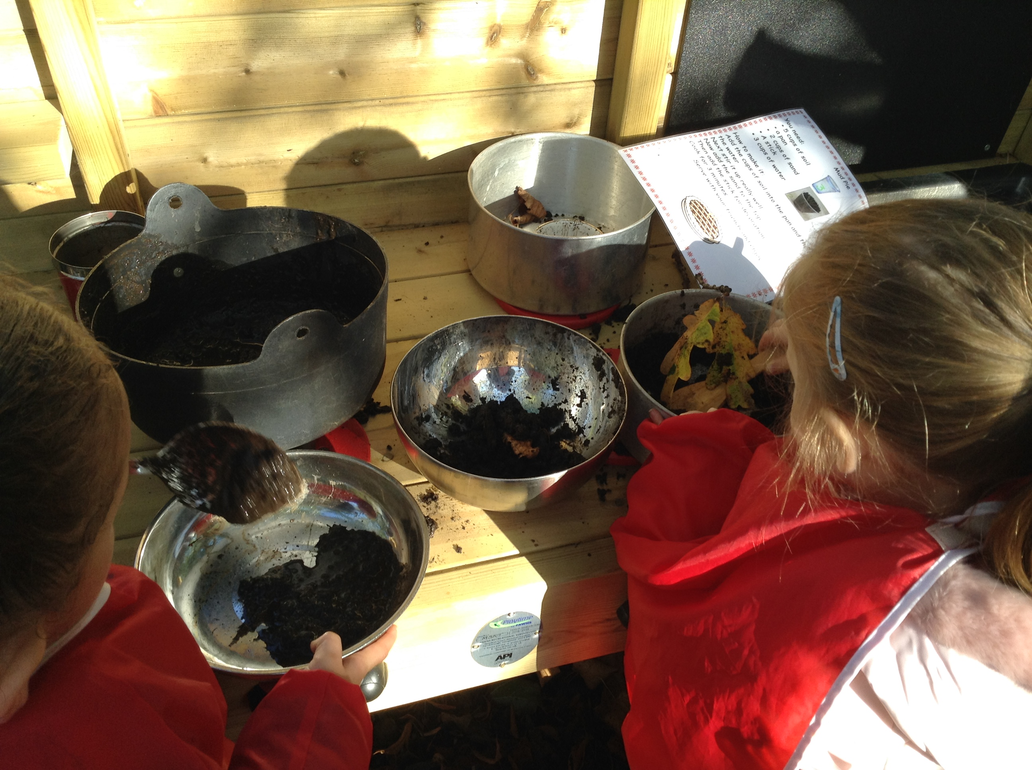

**November/December dates to remember.**

**Nov 5th – Guy Fawkes Day**

**Nov 7th – Diwali**

**Nov 11th – Remembrance Day**

**Nov 13th – Kindness Day**

**Nov 16th – Children in Need**

**Nov 22nd – Thanksgiving**

**Nov 27th – Drop in**

**Nov 30th – St Andrews Day**

**Dec 14th – Christmas Party/Jumper Day**

**Dec 21st – Christmas Nativity 10:00**

**We will close approx. 11:00am after the nativity on the 21st December and re-open 2nd January at 8:00am**

**Please see our notice boards for more information and details for our upcoming events nearer the time.**

**Butterfly Newsletter**

**November/December 2018**

[www.nspcc.org.uk/preventing-abuse/keeping-children-safe/online-safety](http://www.nspcc.org.uk/preventing-abuse/keeping-children-safe/online-safety)

This site above gives advice on setting parental controls, advice and how to talk to your child about keeping safe on the internet and much more!

General leaflets are now available in the entrance hall. There is also a CD copy of our nursery policies as well as safeguarding leaflets and the SNIX newsletter. Please help yourself to these!

**Tapestry**

Should you need any help with tapestry, please feel free to come and talk to a member of staff who will be happy to support you!

Safeguarding

Parents, we have a new safeguarding policy. Please see a member of staff for more details if you wish to look at the changes. We also have the contact details for the NSCB (local safeguarding board) should you ever need to contact them.

NSPCC Whistleblowing advice line:

0800 028 0285

Let’s Talk pants and the underwear Rule with the help of friendly dinosaur pantosaurus, talking pants is a simple way to teach a child how to stay safe. See link below for further info.

https://www.nspcc.org.uk/preventing-abuse/keeping-children-safe/underwear-rule/

Early Years Foundation Stage

Parents, as some of you may be aware we use the Early Foundation Stage framework when planning activities and experiences for your child. For more information on the EYFS please visit the following link:

<http://www.foundationyears.org.uk/eyfs-statutory-framework/>

<http://.foundationyears.org.uk/2015/03/what-to-expect-when-a-parentsguide/> is also available for all parents and carer’s to gain stronger insight into your child’s learning and development. A copy is also available to borrow in the nursery lending library situated in the cloakroom.

**Wow Board**

This has now been moved onto the big notice board for you to add to for any achievements that your child has done at home. We talk about this at group time and it gives the children the opportunity to share this with their friends also.

**Local Offer**

The local offer newsletter is available in our lending library should you wish to access it, this has lots of information for parents whose children has a special educational need or disability.

‘**What’s on”**

Parents our local Far Cotton rec centre has lots of varied events that you and your child can participate in. Please have a look at the latest dates on our whiteboard! Or follow this link for more information: https://tockify.com/nccevents/agenda?tags=Far-Cotton-Library

**Parent Information**