“Dispensationalism, a recent system of theology which has been popular for the last century or so, has taught the Scripture as if God has different plans and different futures for the peoples in the various eras of history. But this is clearly not the case. God has one covenant of grace, which was promised right after the fall in Genesis 3:15 proclaiming that the seed of the woman would crush the seed of the serpent. To conclude, Old Testament saints were clearly saved the same way the New Testament saints were, by grace alone, through faith alone, in the person and work of Christ alone, as revealed in the Scriptures alone, to the glory of God alone.” John Hendryx, Reformed Theologian

INTRODUCTION. (Ephesians 3:1-7) The Dispensation of Grace (or the Ecclesiastical Dispensation) extends from the cross of Jesus Christ to the translation of the church. It is also commonly referred to as the Church Age, and it is an indefinite period of time. Therefore, it is the parenthetical dispensation. During this time individual salvation is complete, mysteries are revealed, the church is established (Matthew 16:18) and the Holy Spirit descends. The purpose of God for this time was not generally revealed in the Old Testament, and it was generally unknown to the Patriarchs and Prophets.

- THE REASON FOR THE CHURCH AGE.
- Israel rejected the Lord Jesus Christ. (John 19:15)
- Israel failed to reach the Gentiles. (Isaiah 49:6)
- As a result, the Church was established and Israel was set aside temporarily. (Romans 11:25)
- See Matthew 11:7-15, 17:10-13, and Romans 10:19-11:29.

Matthew 3:1 In those days came John the Baptist, preaching in the wilderness of Judaea,
2 And saying, Repent ye: for the kingdom of heaven is at hand.
Matthew 4:17 From that time Jesus began to preach, and to say, Repent: for the kingdom of heaven is at hand.
Isaiah 49:6 And he said, It is a light thing that thou shouldest be my servant to raise up the tribes of Jacob, and to restore the preserved of Israel: I will also give thee for a light to the Gentiles, that thou mayest be my salvation unto the end of the earth.

- THE REVELATION OF THE CHURCH AGE.
- The substitutionary atonement of our Lord Jesus is complete. (Hebrews 12:2)
- Salvation is by grace through faith. (Ephesians 2:8-9)
- The appeal is to the individual. (Revelation 22:17)
- Believers are spiritually regenerated. (John 3:7)
- Believers are indwelt by and sealed to the Holy Spirit. (Ephesians 1:13, 4:30)
- The church is separate from Israel but consists of Jews and Gentiles. (Ephesians 2:14-15)
- The church is commissioned to preach the gospel to the world. (Matthew 28:19-20)

1 Peter 1:9 Receiving the end of your faith, even the salvation of your souls. 10 Of which salvation the prophets have inquired and searched diligently, who prophesied of the grace that should come unto you: 11 Searching what, or what manner of time the Spirit of Christ which was in them did signify, when it testified beforehand the sufferings of Christ, and the glory that should follow.

1 Corinthians 10:32 Give none offence, neither to the Jews, nor to the Gentiles, nor to the church of God:

- THE (FINAL) RESULT OF THE CHURCH AGE.
Luke 18:8 …Nevertheless when the Son of man cometh, shall he find faith on the earth?
Luke 17:26 And as it was in the days of Noe, so shall it be also in the days of the Son of man.
2 Thessalonians 2:1 Now we beseech you, brethren, by the coming of our Lord Jesus Christ, and by our gathering together unto him, 2 That ye be not soon shaken in mind, or be troubled, neither by spirit, nor by word, nor by letter as from us, as that the day of Christ is at hand. 3 Let no man deceive you by any means: for that day shall not come, except there come a falling away first, and that man of sin be revealed, the son of perdition;
4 Who opposeth and exalteth himself above all that is called God, or that is worshipped; so that he as God sitteth in the temple of God, shewing himself that he is God.

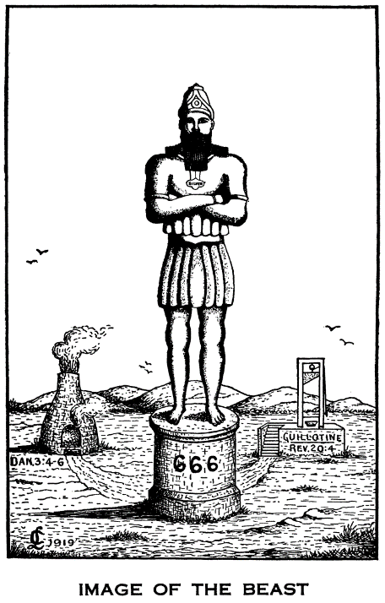
Daniel 2:36 This is the dream; and we will tell the interpretation thereof before the king.
37 Thou, O king, art a king of kings: for the God of heaven hath given thee a kingdom, power, and strength, and glory.
38 And wheresoever the children of men dwell, the beasts of the field and the fowls of the heaven hath he given into thine hand, and hath made thee ruler over them all. Thou art this head of gold.
39 And after thee shall arise another kingdom inferior to thee, and another third kingdom of brass, which shall bear rule over all the earth.
40 And the fourth kingdom shall be strong as iron: forasmuch as iron breaketh in pieces and subdueth all things: and as iron that breaketh all these, shall it break in pieces and bruise.
41 And whereas thou sawest the feet and toes, part of potters' clay, and part of iron, the kingdom shall be divided; but there shall be in it of the strength of the iron, forasmuch as thou sawest the iron mixed with miry clay.
42 And as the toes of the feet were part of iron, and part of clay, so the kingdom shall be partly strong, and partly broken.
43 And whereas thou sawest iron mixed with miry clay, they shall mingle themselves with the seed of men: but they shall not cleave one to another, even as iron is not mixed with clay.
44 And in the days of these kings shall the God of heaven set up a kingdom, which shall never be destroyed: and the kingdom shall not be left to other people, but it shall break in pieces and consume all these kingdoms, and it shall stand for ever.
45 Forasmuch as thou sawest that the stone was cut out of the mountain without hands, and that it brake in pieces the iron, the brass, the clay, the silver, and the gold; the great God hath made known to the king what shall come to pass hereafter: and the dream is certain, and the interpretation thereof sure.
Clarence Larkin (1919)

Daniel 9:24 Seventy weeks are determined upon thy people and upon thy holy city, to finish the transgression, and to make an end of sins, and to make reconciliation for iniquity, and to bring in everlasting righteousness, and to seal up the vision and prophecy, and to anoint the most Holy.
25 Know therefore and understand, that from the going forth of the commandment to restore and to build Jerusalem unto the Messiah the Prince shall be seven weeks, and threescore and two weeks: the street shall be built again, and the wall, even in troublous times.
26 And after threescore and two weeks shall Messiah be cut off, but not for himself: and the people of the prince that shall come shall destroy the city and the sanctuary; and the end thereof shall be with a flood, and unto the end of the war desolations are determined.
27 And he shall confirm the covenant with many for one week: and in the midst of the week he shall cause the sacrifice and the oblation to cease, and for the overspreading of abominations he shall make it desolate, even until the consummation, and that determined shall be poured upon the desolate.

Deuteronomy 32:20 And he said, I will hide my face from them, I will see what their end shall be: for they are a very froward generation, children in whom is no faith.
21 They have moved me to jealousy with that which is not God; they have provoked me to anger with their vanities: and I will move them to jealousy with those which are not a people; I will provoke them to anger with a foolish nation.

1 Peter 2:10 Which in time past were not a people, but are now the people of God: which had not obtained mercy, but now have obtained mercy.

Isaiah 65:1 I am sought of them that asked not for me; I am found of them that sought me not: I said, Behold me, behold me, unto a nation that was not called by my name.

Matthew 8:11 And I say unto you, That many shall come from the east and west, and shall sit down with Abraham, and Isaac, and Jacob, in the kingdom of heaven. 12 But the children of the kingdom shall be cast out into outer darkness: there shall be weeping and gnashing of teeth.

