LK E Röttger 2018

Great Britain: A Short History of World Power
Between the 16th and the beginning of the 20th century the British Empire became the largest colonial empire that ever existed. Before its decline, due to the colonies’ achievements of autonomy in the 20th century, it comprised up to one fifth of the earth’s surface and about one quarter of the world‘s population.
Its development is divided into two separate empires, which had different colonial foci. The First British Empire mainly consisted of the thirteen colonies on the East Coast of the North American continent and therefore came to an end with the American Independence from British rule in 1783. The Second British Empire, which was also called the “Victorian Empire”, developed as a consequence of the loss of the American colonies and concentrated on land possessions in India and the Far East, as well as the authority over several sea routes.
In the beginning of the 16th century, England managed to outrun its rivals Spain, Portugal, Holland and France and became the biggest colonial power. With the help of its colonies, Britain acquired a nearly self-sufficient existence by receiving raw materials from its colonies throughout the world, while earning money by selling its products to the colonies. Consequently there was little dependency on other nations, which strengthened English economic power.
The extension of the empire usually took place at three stages. First, the land was discovered and explored, which then led to the establishment of trading posts. Emigration from England followed and settlements were built.
In the 19th century, the main motivation for colonization shifted from trade towards political influence. Possessing the authority over many territories meant military and strategic advantages. The imperialist approach however was much more rigid and was accompanied by a feeling of superiority of white people.
Towards the beginning of the 20th century, the British Empire began to decline. Many colonies started to demand autonomy from Britain because they had developed a strong feeling of nationality over the course of time. The transformation towards an independent country usually consisted of three stages as well.
As a Crown Colony, the people of itself were under the complete leadership of the mother country. But towards the end of the 19th century, many colonies established their own parliaments, which took over most responsibilities from the British government, except for defense and foreign affairs. By then these colonies had acquired the status of a self-governing colony.
The step towards the status of a Dominion separated the colony completely from political influence by the British and made it a free nation, which owed its loyalty to the Crown; although obligations did not exist anymore, the countries still represented British customs and values.
The term ”Dominion” would later be changed into “Commonwealth Nation” and the “British Empire” became “The British Commonwealth of Nations”. Today the Commonwealth is a voluntary association of 53 members including Australia, New Zealand, Canada and several countries in Africa or Asia. They benefit from several profitable ties, especially in commerce. The peaceful bond, which England managed to keep up with its former colonies, is regarded a major success in British diplomatic relations.

Colonies of The British Empire/Commonwealth of Nations

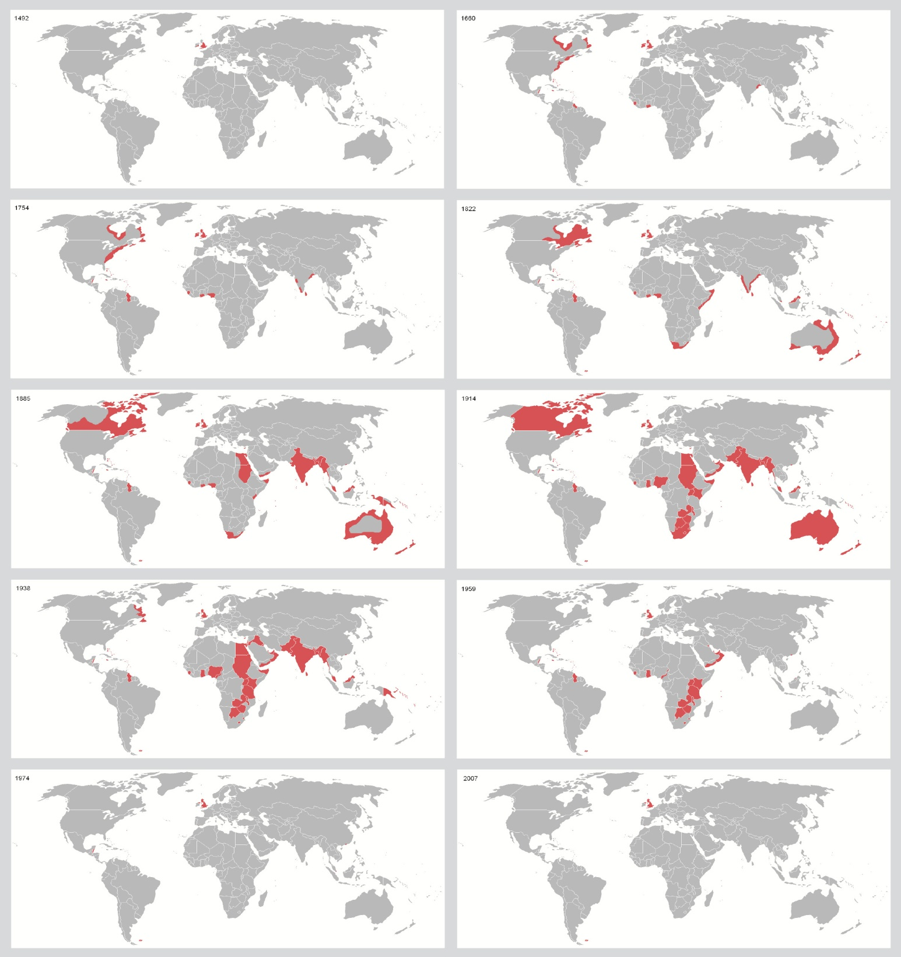
2007
1974
1959
1938
1914
1885
1822
1754
1650
1492

How The British Empire “lost” The American Colonies
The colonists resented those measures and reacted in increasing demonstrations of civil disobedience. For most of the 150 years, the settlers had been left to govern themselves. Therefore a strong tradition of self-government had been established. At the same time, British settlers believed that they were entitled to the full democratic rights of Englishmen. The Stamp Act of 1765, for example, imposed a tax on specially stamped paper, which had to be used for legal documents, magazines, playing cards, newspaper and all sorts of paper throughout the colonies. It was met with great resistance and was repealed in 1766. This episode was just the starting point of the growing resistance.
In 1781, Britain surrendered. The Treaty of Paris in 1783 acknowledged the existence of the United States of America and its separation from the British Empire. George Washington, a former commander, was elected to be the first President of the United States of America.
Out of twenty British colonies in North America, there were thirteen, which formed the original states of the United States of America. The American War of Independence stretched from 1775 until 1783 and ended in the separation of the British Empire. There were several causes for the outbreak of the war.
The destruction of a whole shipment of tea, which came to be known as “Boston Tea Party” defied a tax on tea and other goods. In 1775, the tensions deepened and war broke out. One year later, the Declaration of Independence was passed by thirteen American colonies. Spain, France and the Netherlands joined the war on the side of the Americans
It is important to say that there was not one event in particular that singularly led to the revolution. The impact of heavy taxation played a major part, as well as the underrepresentation of colonists in the British government. This can particularly be seen in the slogan “No taxation without representation”. The British government had implemented a serious of taxes to reduce debts.

Newspaper Excerpt
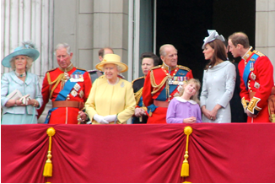
BBC News: Why does the UK love the Monarchy?
By Marc Easton, Home editor
Whatever republicans might wish, less than a fifth of the Queen's subjects in the UK say they want to get rid of the Royal Family - a proportion that has barely changed across decades.
According to polling data from Ipsos Mori, support for a republic was 18% in 1969, 18% in 1993, 19% in 2002 and 18% last year. Three-quarters of the population want Britain to remain a monarchy - a finding that has been described by pollsters as "probably the most stable trend we have ever measured".
Given the enormous social change there has been since the current Queen assumed the throne 60 years ago, it might seem surprising that a system of inherited privilege and power should have retained its popularity. In trying to explain the unlikely success of the monarchy, we shouldn't expect the answer to be based on reason.
It is not a pocket-book calculation of profit and loss - how much does the Queen cost compared to what she brings in for the tourist trade?
It is not a question of prevailing political attitudes - how can a liberal democracy justify power and privilege based on an accident of birth?
The British monarchy is valued because it is the British monarchy. We are an old and complicated society that yields deference to the theatrical show of society.

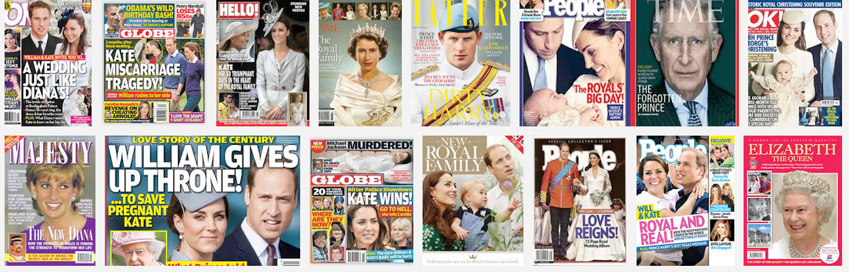
British Magazine Covers

- With reference to the text and the pictures above, try to explain why the concept of monarchy is still popular in the U.K.

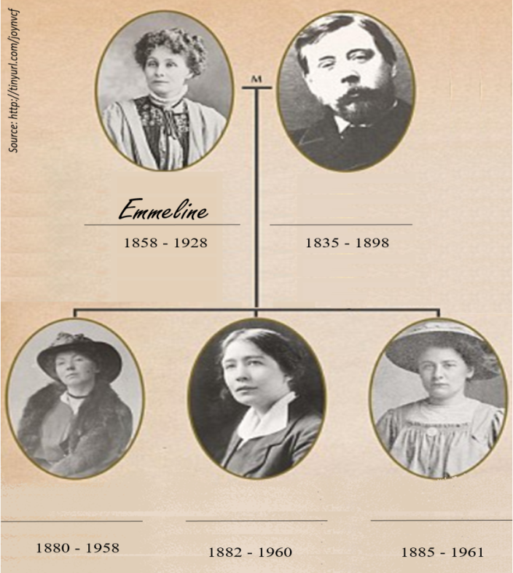
The Pankhurst Family: Democracy for Everyone
Richard Pankhurst (born in 1835) was an early supporter of the Women’s Rights movement. He married Emmeline Goulden and together, they founded the Women’s Franchise League and spoke out for women’s rights. They had three daughters: Christabel, Sylvia and Adela, whom they raised to believe in and fight for women’s rights as well. After Richard’s death, Emmeline and Christabel, the eldest daughter, founded the Women’s Social and Political Union (WSPU). This Union sometimes used violent methods to call attention to their main cause: women’s right to vote. Both Emmeline and Christabel were frequently arrested for their activities. Christabel agreed with her mother that using violent methods would help their cause. Sylvia and the youngest sister Adela, however, did not agree with their mother’s tactics and left the WPSU in protest.
Finally, in 1918, women were given the right to vote in Great Britain. However, this right was still restricted to women over the age of 30 and had several other restrictions. Ten years later, in 1928, shortly after the death of Emmeline, women were finally given the same voting rights as men.

Mahatma Gandhi created the ‘Quit India speech’ on August 8, 1942, on the eve of the ‘Quit India movement’
Key events:
1858
First Indian Revolution, called the Sepoy Mutiny fails which puts India under the direct rule of the British crown.
1885
The Indian National Congress is founded by a group of intellectuals, some of them British, as a forum for emerging nationalist feelings. This was the origin of the latter Congress Party.
1920-22
Peace activist Mahatma Gandhi launches an anti-British civil disobedience campaign.
1942-43
Congress launches the "Quit India" movement to force an orderly British withdrawal from India.
1947
British rule ends with the partition of the colony into mainly Hindu India and the Muslim-majority state of Pakistan.
“[…] Ours is not a drive for power, but purely a non-violent fight for India’s independence. In a violent struggle, a successful general has been often known to effect a military coup and to set up a dictatorship. But under the Congress scheme of things, essentially non-violent as it is, there can be no room for dictatorship. A non-violent soldier of freedom will covet nothing for himself, he fights only for the freedom of his country. The Congress is unconcerned as to who will rule, when freedom is attained. The power, when it comes, will belong to the people of India, and it will be for them to decide to whom it placed in the entrusted. […]
Then, there is the question of your attitude towards the British. I have noticed that there is hatred towards the British among the people. The people say they are disgusted with their behaviour. The people make no distinction between British imperialism and the British people. To them, the two are one. This hatred would even make them welcome the Japanese. It is most dangerous. It means that they will exchange one slavery for another. We must get rid of this feeling. Our quarrel is not with the British people, we fight their imperialism. […]
I know the British Government will not be able to withhold freedom from us, when we have made enough self-sacrifice. We must, therefore, purge ourselves of hatred. Speaking for myself, I can say that I have never felt any hatred. As a matter of fact, I feel myself to be a greater friend of the British now than ever before. One reason is that they are today in distress. My very friendship, therefore, demands that I should try to save them from their mistakes. As I view the situation, they are on the brink of an abyss. It, therefore, becomes my duty to warn them of their danger even though it may, for the time being, anger them to the point of cutting off the friendly hand that is stretched out to help them. People may laugh, nevertheless that is my claim. At a time when I may have to launch the biggest struggle of my life, I may not harbor hatred against anybody.”
Task
- Highlight the terms you don’t know and look them up in your dictionary.
- What is the excerpt of Gandhi’s speech about?
- Why do you think does Gandhi strongly support a non-violent approach in his resistance?

History of The Falkland Crisis

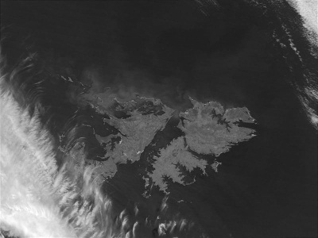
The Falklands from Outer Space
(commons.wikimedia.org)
The Falkland Islands are an archipelago, consisting of East Falkland and West Falkland (6760km² and 5280km²) and about 100 smaller islands. They are located in the South Atlantic Ocean, about 460 kilometres to the east of the closest mainland (South America). The islands have supposedly been discovered in 1592 by the English navigator John Davis. The French called the Islands „Les illes Malvines“, whereas the English name „Falkland islands“ derives from the British First Lord of the Admiralty, Viscount Lucius Cary Falkland.
East Falkland was settled by the French in 1764, while West Falkland was settled by the British one year later. The French sold their parts of the archipelago to Spain in 1770 and the British settlers left West Falkland four years later. In the framework of movements for independence from Spain, Buenos Aires declared its autonomy in 1810. As a result of the following wars between Spain and its colonies, Spanish settlers had to leave the Falkland Islands in 1811. The Islands remained unoccupied for a few years. In 1816, the United Provinces of the Rio de la Plata became independent from Spain. The young state Argentina, which developed over the following decades, claimed rights to the Falkland Islands, considering itself the legal successor of Spain. Nevertheless, the Islands were occupied by the British in 1833 who were unaware of Argentina’s claims. Argentina never withdrew its claim on the Islands.
Task
Why do Argentina and Great Britain claim rights to the Falkland Islands?
In the 1960’s, Argentina strengthened its position in the Falkland issue in order to reinforce the “decolonialisation of the world“. However, all 1.900 inhabitants – mostly of British ancestry – disapproved of being governed by Argentina. Negotiations between Great Britain and Argentina failed. Argentina claimed that Great Britain still acted like a colonial power and tried to reconquer its former colony. Great Britain referred to the UN principle of self-determination and insisted on the rights of the predominantly British Falklanders to belong to the country of their choice. Nevertheless, Great Britain was willing to find a compromise.
The British observer Lord Shackleton visited the Falkland Islands in 1976 and found evidence that, in contrast to his government’s expectations, the islands did offer an economic value. The surrounding sea area was rich in fish and oil, which could only be harvested if the Falkland Islands belonged to Great Britain. When a military junta took over the power in Argentina, Great Britain was given one more reason to hold on to its claim, since the British government was unwilling to hand the Falklander’s fate to a totalitarian regime. Thus, a situation was created in which both Argentina and Great Britain insisted on their territorial rights on the Falkland Islands. Internationally, the conflict created a dilemma for those countries which were allied with both Great Britain and Argentina. Ronald Reagan, at that time President of the United States, asked why there was such a passionate dispute over “that bunch of icy rocks“.

The Falklands War
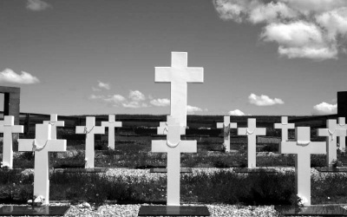
Argentine Graveyard from the Falklands War
(commons.wikimedia.org)
In 1982, the military junta in Argentina decided to stop negotiations with Great Britain and considered an imposition of a solution by forcing Britain. In February 1982, some Argentinean civilians were brought to Georgia, an island which belongs to the Falkland archipelago and was settled by very few people. The British government regarded this as an attempt of Argentina to enforce their presence on the islands. Therefore the British sent a warship to expulse all Argentineans. As a response, the military junta began to invade the islands in April and easily won control over the little British military base. About 10.000 Argentinean soldiers populated East and West Falkland very quickly. While allies of both countries called for a peaceful solution, the British Prime Minister Margaret Thatcher declared the Falkland Islands a war zone and sent a fleet with two air craft carriers and 28.000 soldiers. A British force reconquered South Georgia on April 25th.
Heavy Combat started at the beginning of May, when the British fleet arrived and a submarine scuttled the Argentine Navy light cruiser General Belgrano. The Argentine air force scuttled two destroyers (among them the HMS Sheffield) and two frigates, but it was unable to impede a landing of British troops on the north-west coast of East Falkland on May 21st. After its troops had been encircled on land and blockaded at sea, Argentina finally surrendered on June 21st.
- Fill in the gaps with the words listed below:
Thatcher / combat / Great Britain / conflict / oil drillings / military junta / British / Argentina / the Falkland Islands
Results
During the 72 days of , Argentina suffered from 700 casualties while ___________ lost 250 soldiers. The successful war gave the administration a political lift, whereas the in Argentina was brought down.
In April 1990, again declared part of its territory Tierra del Fuego. In 2010, Great Britain began in the ocean surrounding the islands and triggered new discussions. Therefore, the still remains unsolved. The Falklanders still consider themselves .

http://www.bbc.com/news/uk-18237280
The speech is taken from https://en.wikipedia.org/wiki/Quit_India_speech
http://en.wikipedia.org/wiki/Falkland_Islands
http://en.wikipedia.org/wiki/Falklands_War
http://tripideas.co.uk/posts/view/6694

