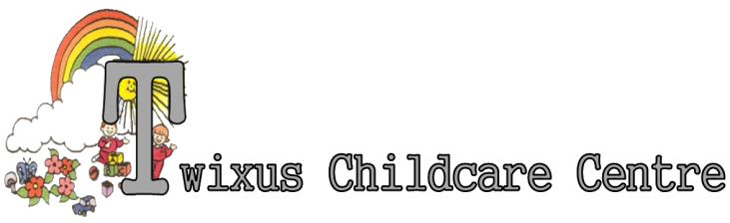
SOCIAL NETWORK POLICY

Twixus Child Care accepts that social networking is a part of society. However, Twixus feels that there is no place for social networking in relation to the setting.

This policy is part of the setting’s wider commitment to safeguarding the welfare of children within the setting. The safety of children at Twixus Child Care is paramount. Casual or inappropriate use of mobile phones by staff may pose a risk, if staff are distracted from caring for children.

State of social media

Social media, professional networking sites, rapid-fire communications, blog sites, and personal Web sites are all useful technologies and Twixus Child Care realises this fact. Every employee has an opportunity to express and communicate on-line in many ways, and Twixus Child Care does not wish to discourage an on-line presence. Above all else, everyone needs to use good judgement on what material makes its way on-line.

This policy will set forth guidelines that employees should follow for all on-line communications in reference to Twixus Child Care.

Relevant technologies
This policy includes (but is not limited to) the following specific technologies:
Personal blogs / Personal websites
Twitter
Facebook
Snapchat
Instagram
Tik Tok
Whats app

At no times should any posts be made in reference to Twixus, children, parents or other professionals that employees may come in to contact with through work. At no time must any photographs or materials be published that identify the setting, staff or children at the setting.
Any member of staff found to be posting remarks or comments that breach confidentiality or this policy and/or are deemed to be of a detrimental nature to the company or other employees or posting/publishing photographs of the setting, children or staff may face disciplinary action in line with the company disciplinary procedures.

Staff are not permitted to make reference to, breach confidentiality, imply, write detrimental information, threaten or imply threatening behaviour to anyone associated with Twixus Child Care or mention Twixus Child Care Centre in any way on any social networking site. Staff are not permitted to make reference to the work, what they do, what they have done, how they have done it or how it went at Twixus Child Care on any social networking site.

Further, if any employee becomes aware of social networking activity that would be deemed distasteful, detrimental in any way for the setting, threatening or fail the good judgement test, please contact any of the Office Team.

Company-sensitive matters

Any on-line communication regarding proprietary information such as redundancies, strategic decisions, staff meeting information or reduction of working hours is deemed inappropriate by the management for uncoordinated public exchange is forbidden

This policy reflects this Twixus Child Care’s commitment to safeguarding the welfare of the children in our care and as such any failure to comply with this policy may lead to disciplinary and dismissal proceedings against the individual.

This Policy has been written with reference to the following legislation and advice:
Early Years Foundation Stage
The Department for Education guidance on the use of mobile phones

Acceptance and Application of Terms: The Management and Staff at the Twixus Childcare Centre has agreed (by signature) to uphold the legislative terms and working practices of this policy. This policy will be reviewed annually and/or when legislative terms or practical application requires amendments.

