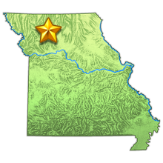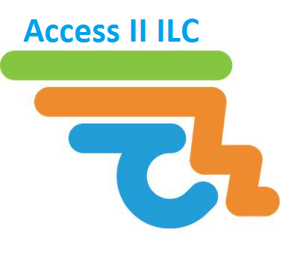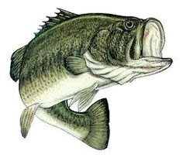

For complete contest rules/registration forms visit www.accessii.org

**For more information, call Access II I.L.C at 660-663-2423 ext. 231**

**Sunday, Sept. 8th Indian Creek Lake-Poosey Conservation**

Registration 6:30am

Fishing begins at 7:00am ends at 1:00pm

Weigh-ins to follow immediately

*Entry is* ***$60*** *per boat & includes Biggest Bass Competition Fee*

***1st place wins 50% of money raised!***

**Proceeds go toward benefiting people with disabilities in our community to live independent lives.**

***Access II I.L.C Bass Fishing Tournament***