Trunk or Treat Set for Oct. 30
GRAND JUNCTION FALL 2018 NEWSLETTER
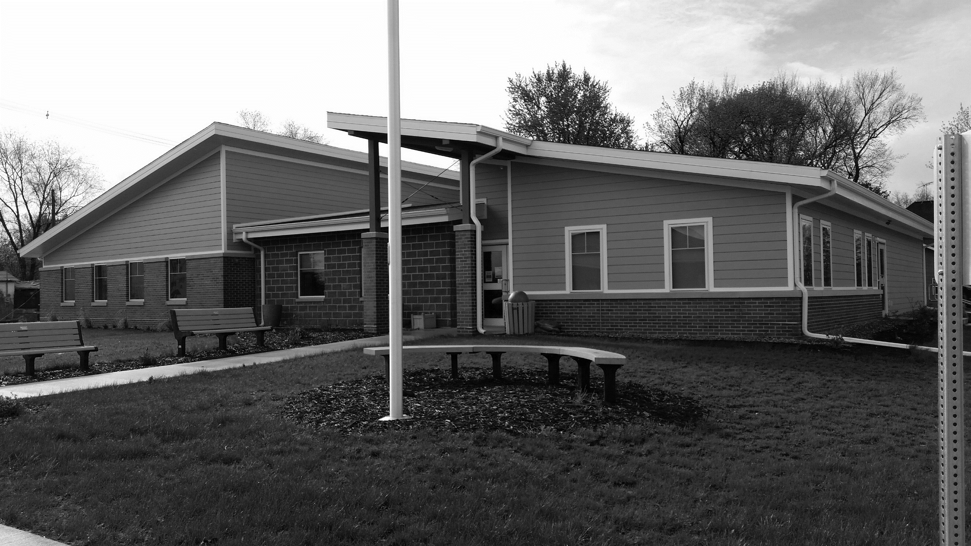
The GJ City Council has scheduled the town’s annual Trunk or Treat & Halloween Beggars’ Night for Tuesday, Oct. 30, from 5:30 to 7:30 p.m.
This safe Halloween event for kids 12 and under will take place along Main Street in Grand Junction and everyone is invited to join in for a fun evening.
Volunteers are needed to hand out treats. Set up will begin at 5 p.m. You can park your car (decorated if you want!) along either side of Main Street. Be sure to sign up so we’ll know you are coming. Call 515-738-2585 or email clerkgrandjunctionia@gmail.com to register.

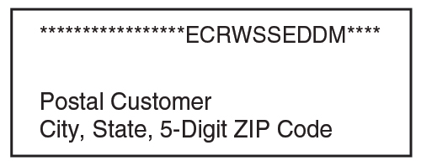
Also planned is the “Haunted Library.” Tours of the spooky space begin at 5 p.m. with hot dogs furnished for the kids afterwards. Come if you dare!
GJ150 Fundraisers Planned
The GJ150 Steering Committee (to celebrate 150 years of Grand Junction in 2019!) has set up fund-raising events for the next three months. All will take place at the Community Center.
- Tuesday, Oct. 23, will be a painting class with Jolene Peters (Art on the Fly) from 6–9 p.m. Cost is $40. Call or text at 515-370-2824 to reserve a spot.
- Wednesday, Nov. 7, will be a cake decorating class with Hummingbird Confections from 6:30–8 p.m. Price is $30.00. The cakes are pre-made and all the supplies to decorate a 6″ cake are provided. You can register for this class at www.hummingbirdconfections.net/classes.html.
- Monday, Dec. 10, will be a wreath decorating class with Fudges Flowers. Details on this class are yet to be determined. Look for information closer to the event.
The Fire Department will hold its annual Halloween safe house – always a big draw for kids – at the same time as Trunk or Treat.
The Community Center also will be open that evening for bathroom breaks.
Jingle Into Junction Scheduled for Dec. 2
Hometown Update
Message from the Mayor
We are making progress in cleaning up town. The house in north GJ that burned and the house by the Methodist Church will be torn down and the lots cleaned this fall. Council also okayed asbestos removal in the 220 and 224 Main St. buildings. When done, the Fire Department plans to burn those buildings.
We received a grant to get new lights for the basketball court and we have finished renovating the storage shed by the Community Center. In addition, we are working on sewer infrastructure solutions.
I appreciate your ideas and support to continue to improve our town. – Brock
Community Center Gets Stage, Carpet Installed
GJ Horizons received a grant from the Iowa Arts Council to purchase a stage for the Community Center. The stage can be set up in various ways according to needs and will be a standard fixture in the Lincoln Highway room.
Also, a donation by Roger & Ruth Underwood, also in memory of Wilbur & Gladys Teagarden and Homer & Alma Underwood, was designated for a Community Center improvement. Along with funds from the tree festival and Lions Club, it was used to buy and install carpet tiles in the Junction Room to help with the acoustics.
Thanks to all for continuing to care for our great Community Center!
Circle your calendars for Sunday, Dec. 2, and plan to attend Grand Junction’s annual Jingle Into Junction holiday celebration at the Community Center from 5–7 p.m.
GJ Horizons will again sponsor a soup-and-sandwich supper and silent auction. Also, the GJ Library will host Mrs. Claus’s bake sale and hold a drawing for its quilt raffle, the Fire and Rescue will host Santa, have cocoa and cookies, and give away turkeys, and the City of GJ will sponsor a display of trees, wreaths, and stockings, some of which can be purchased.
This community celebration is a great way to kick off the holiday season and a fun night for everyone in town to get together. Proceeds from the event will be used to fund upcoming community projects.
Library Holds Open House
Nearly 50 people attended the library’s Open House Sept. 18–20 when the facility showed off its new carpet and furniture along with new computers, acquired through grants and donations.
Attendees enjoyed homemade snacks and registered for door prizes. Congratulations to door prize winners Jim Rowles, Jolene Harvey, and Jayden Alrich, and thanks to all who came!

Contact City Hall at 515-738-2585 or grandjct@iowatelecom.net.
Office hours are Monday through Friday, 8 to 11 am or by appointment
www.grandjunctioniowa.org

