School Site Development Revisited
GRAND JUNCTION WINTER 2021 NEWSLETTER
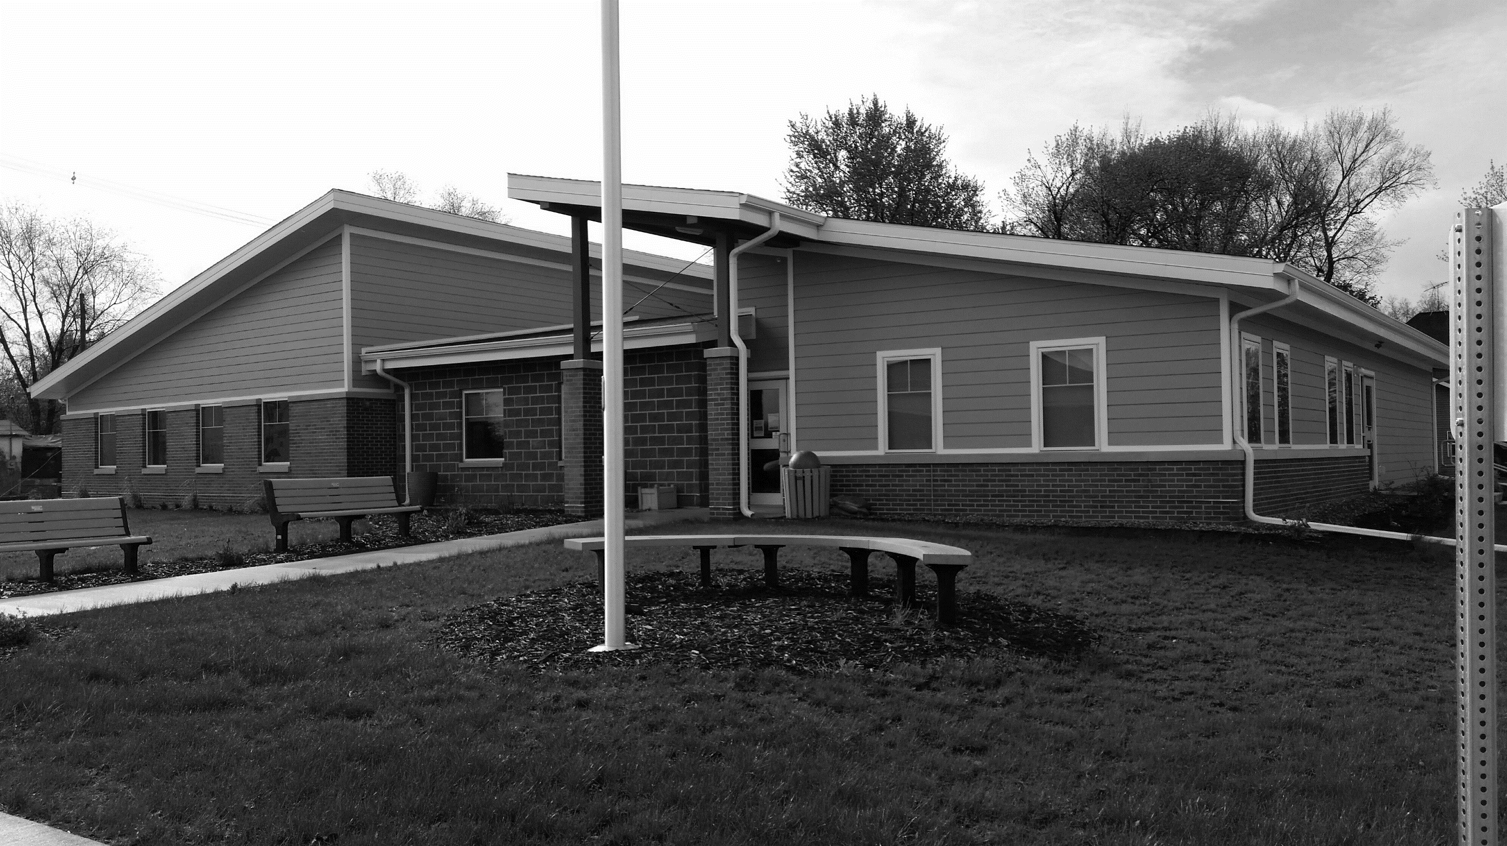

A class of Iowa State University students, sponsored by Horizons with the support of the GJ City Council, is once again undertaking a project to show potential development of the former school site.
A Community Planning Studio course led by Dr. Julie Robison aims to bring workable options for the town to consider in addressing a real need in Grand Junction of quality and affordable housing. Through a community housing needs assessment, students will seek to develop four concept design plans that provide affordable housing alternatives through creative solutions.
Interestingly, some of the students in this class are already familiar with Grand Junction and the school site since they were also in the Planning in Small Towns class that studied the site and developed options for park plans that were presented to GJ residents at Jingle Into Junction in December 2019.
Project plans will be shared with the community later this spring.
Friendly 2021 Reminders!
Get your dog license for 2021 for $5. Pet owners must register their pet every year. You need proof of current vaccination. Dogs must wear their tags and be under control (in a fenced yard, tethered to not reach sidewalks, or on a leash).
Get your 2021 Golf Cart/ATV permits for $15. These are required by state law. Please register your cart before you use it on Grand Junction streets in 2021.

ISU Students Seek Your Input at Community Meeting
Iowa State University students are hosting a community meeting to gather input on housing needs in the community. They are working with Grand Junctions Horizons on concepts to develop the site of the old school building into new housing. Join us on March 3 at 5:00 PM at the Grand Junction Community Center for a brief meeting to make your voice heard. We would appreciate mask wearing and appropriate social distancing.
Whether you can attend the community meeting or not, the students would greatly appreciate your responses to the enclosed survey.

Local Groups Seek to Improve Grand Junction
If this town learned anything last year – from the pandemic to the derecho – it was that when we work together we can do good things.
So let’s keep working together! One way is to join a local civic group to help GJ keep improving. Here are some groups to check out. For more information, call 515-738-2585.
Business Women’s Club
Though COVID-19 has slowed things down, the Business Women’s Club generally meets once a month on Tuesday for a potluck dinner, business meeting, birthday celebration, and card playing. The club focuses on filling needs for kids in our community, with things such as diapers and formula for babies and a couple of family pool passes each year. Funds come from Kash for Kans for Kids located west of City Hall. Membership is $3/year plus $1/month, and all are welcome to join.
El Carim Club
Organized in 1939, the club was named El Carim because it is “miracle” spelled backwards. The goal of the club is to serve the community, enjoy life, and have fellowship. The club meets April through December on the first Thursday of the month, and anyone is welcome to join. Currently meetings are on hold due to the pandemic, but members keep in touch through round-robin emails. Some of El Carim’s community projects are supporting Greene County Schools, the Food Pantry, and the GJ Fire Department.
Horizons
Formed in 2008, Horizons grew out of an extensive leadership training program aimed to help people make positive changes in small towns. Horizons has received numerous grants over the last 13 years that have been used to improve various aspects of the town, from planting trees to developing after-school programs to buying Main Street holiday lights. Their annual Holiday Food Box distribution project is funded by a local wind farm, and plans are being made to buy a handicapped swing for a playground. Horizons sponsors the annual “Jingle Into Junction” holiday event and has given monetary awards to high school graduates with the most volunteer hours. It encouraged the formation of the “Off the Track Players”, a community little theater group. In the past year, a Welcome Wagon program was begun to welcome new residents to the community. The group meets on the 4th Monday of each month.
Lions Club
Established in 1917, Lions Clubs International has one constant: service. Locally, our Lions Club has supported school projects, city projects, Christmas boxes, and statewide disaster aid. The club plans and hosts a car show the first Saturday of August. Through their primary fundraisers of a pancake brunch and breakfast at Spring Lake, they offer scholarships to graduating seniors, support camps for the handicapped, support guide dog training, and provide glasses and hearing aids to those who cannot afford them. Lion Tree Park, the walnut tree park located along Highway 30 east of town, is a Lions Club project as is the 150th anniversary Lions Club sign east of the Community Center.
Naked Ladies Garden Club
The Naked Ladies Garden Club meets the 3rd Tuesday of each month and works to beautify Grand Junction through nature. Among other activities, the Naked Ladies maintain Main Street and sports court planters, maintain the rain garden, offer volunteer service in community gardens, and sponsor fundraisers to help with projects. The club encourages Master Gardener status for all its members and works to improve the bio-psycho-social-spiritual life of GJ residents through Earth-friendly actions.

