30 Yard Line Now Open For Business
GRAND JUNCTION JANUARY 2020 NEWSLETTER
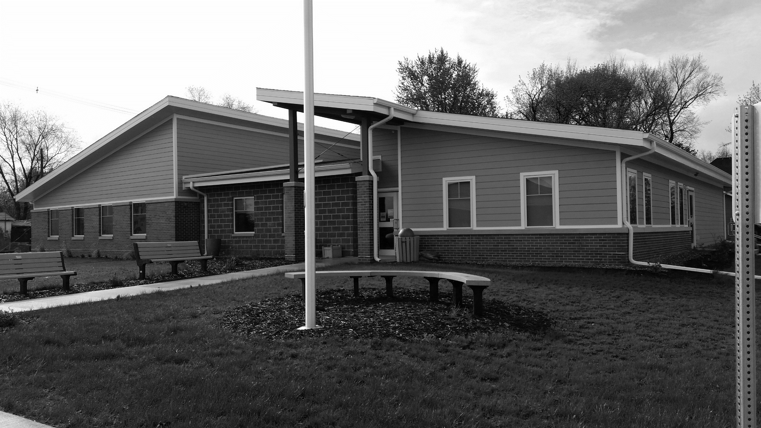
GJ’s newest business is the 30 Yard Line bar and restaurant, owned by Jeff & Regina Thorpe, Tony & Traci Beger, Bob & Jeni Ross, and Andy & Mandy Krieger.
Located on Highway 30, the 30 Yard Line has opened to rave reviews for atmosphere, food, and service and is a welcome addition to the town for dinner and/or drinks.
Menu items include a variety of appetizers, salads, burgers & sandwiches with specials planned in the future. Hours of operation are Sunday, 11 am-8 pm (kitchen 11 am-7 pm); Monday thru Thursday, 4 pm-Midnight (kitchen 5-9 pm); and Friday & Saturday, 4 pm-2 am (kitchen 5-10 pm).
Welcome to 2020!
- Winter Reminders: City code requires all vehicles to be moved off city streets and parking during snow emergencies. The snow ordinance emergency parking ban will take effect & last through the duration of a storm and for 48 hours afterwards. Residents also are required to clear property sidewalks to avoid being charged clearing costs.
- Dog licenses for 2020 are available for $5. Pet owners are responsible for registering their pet every January. Owners must provide proof of current vaccination. Dogs must wear their tag. All animals must be secured at all times, either in a fenced yard, tethered in a place so they cannot reach sidewalks or roadways, or on a leash with a person capable of controlling the pet holding the leash.
- Golf Cart/ATV permits are $15 again for 2020. These are required by state law. Please register your cart before you use it on Grand Junction streets in 2020.

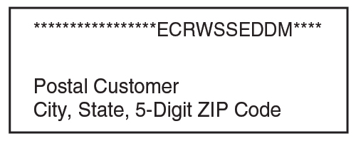
Recycling Reminder
Curbside recycling ended on Dec. 31, so take your recyclables to the city’s drop-off box on 12th Street north of Main.
Acceptable recycling items are glass jars & bottles, tin & aluminum cans, twist-top plastics with caps and yogurt & margarine containers, newspapers, magazines, catalogs, and flattened/broken down cardboard. All containers should be empty and clean.
ATTENTION: NO PLASTIC BAGS! Plastic shopping bags are not accepted at Boone County Recycling, but they can be taken to most grocery store chains and major retailers. For a list of acceptable items, go to https://www.boonecounty.iowa.gov/government/landfill-recycling-center/boone-county-recycling-center.

Jingle Into Junction Wrap-Up Report
Thanks to all who came to celebrate the season and get together with friends and neighbors at our annual Jingle Into Junction holiday celebration held at the Community Center on Dec. 8.
Between the soup supper and silent auction sales, GJ Horizons raised about $2,000 to be used for upcoming Horizons-sponsored community projects. Horizons also donated 200 red plastic food trays to the Community Center kitchen for general use.
Mrs. Claus’s Bake Sale netted the GJ Library about $230. Santa made his annual appearance sponsored by the Fire and Rescue team, which also gave away a dozen turkeys.
Proceeds from sales of the 4th Annual Trees, Wreaths & Stockings festival raised around $765 to go toward the 2020 Grand Junction celebration. _____________________________________________________________________________

Long-time City Worker Passes Away
Street Superintendent John Trucks, 58, passed away on Sunday, Jan. 19, after a brief illness.
At the time of his death, John had been employed by the City of Grand Junction for 16 years. A Celebration of Life was held for him on Sunday, Jan. 26, at the Community Center.
Caucuses to be Held At Community Center
The Democrat and Republican caucuses for Greene County’s East Precinct will be held at the Community Center on Monday, Feb. 3, starting at 7 p.m.
The Democrats will meet in the Lincoln Highway Room and the Republicans will meet in the Junction Room.
Only registered Democrats and Republicans will be allowed to caucus. Individuals can also
Contact City Hall at 515-738-2585 or grandjct@iowatelecom.net.
Office hours are Monday ─ Friday, 9 am to noon or by appointment
www.grandjunctioniowa.org
Contact City Hall at 515-738-2585 or grandjct@iowatelecom.net.
Office hours are Monday ─ Friday, 9 am to noon or by appointment
www.grandjunctioniowa.org
change political parties or declare to be a Democrat or Republican to caucus that night.
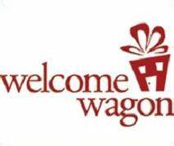
Welcome to GJ!
A number of folks have moved into our town in the last year. If this includes you, we’d like to welcome you to your new hometown!
Members of GJ’s Horizons would like to come meet and visit you at your home. They’ll bring welcome gifts and offer helpful information on where to go, who to call, and how to get things done around here.
If you’ve moved to GJ in the last year, please contact City Hall so we can set up a good time to meet and greet you!

