Additional Apply Your Skills 1.1
  - Create a New Worksheet, Enter Data, and Save
In this exercise, you will create a new worksheet, edit entries, and rename the worksheet.
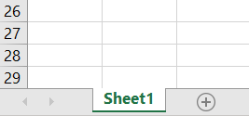
- Open AAYS_1E.
- Click the + sign at the bottom of the worksheet to open a new sheet.
- Create the worksheet shown in the following illustration.
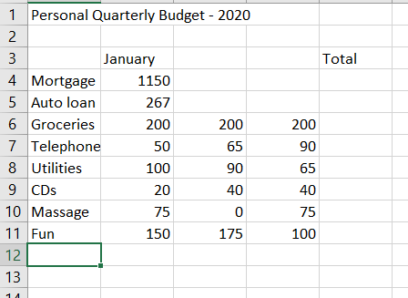
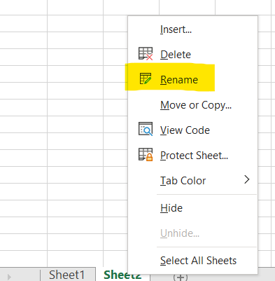
- Right click on the Sheet Tab and rename it to Budget Q1-2020.
- Replace the January value of Fun with 200.
- Replace the label Fun with Dining.
- Click on cell A1 and type your name.
- Cancel your data entry into cell A1 before entering it.
- Save the workbook and close the file.

Additional Apply Your Skills 1.2
  - Format, AutoFill, Simple Formula, and Column Widths
In this exercise, you will add formatting enhancements, create a simple formula, and use AutoFill. You will also adjust column widths and row heights.
- Open AAYS_1E
- Open Budget-2020 and rename it as Budget_Format 1.
- Format the range B4:E11 as Currency style with no decimals.
- AutoFill the remaining two months of the quarter.
- Apply italics and center alignment to the range B3:E3.
- Merge and center the title across the range A1:E1.
- Change the font size of the title to 16 pts.
- Apply bold formatting to the title, month, and expense-item labels.
- AutoFill the Mortgage and the Auto Loan values for February and March.
- Create a formula to add the Q1 values for Mortgage in cell E4 and then use AutoFill to copy the formula down to row 11.
- Adjust column A so none of the item labels are cut off.
- Adjust the height of rows 4 through 11.
- Enter today’s date (using the format MM/DD/YYYY) in cell G1.
- Add shading to the Total values using White, Background 1, Darker 15%.
- Compare your work to the screen shot on the next page. If necessary, correct any mistakes and then save and close your file.
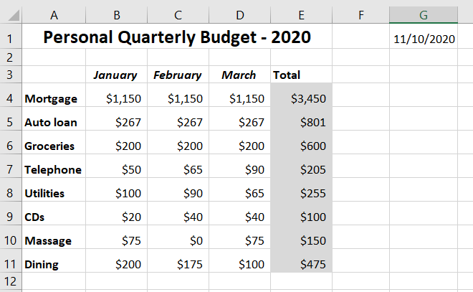

Additional Apply Your Skills 1.3
  - Use the BEDMAS Rule in Formulas
In this exercise, you will create formulas using the BEDMAS rule.
- Open the Ground Ship worksheet
- Follow these guidelines to complete the following worksheet:
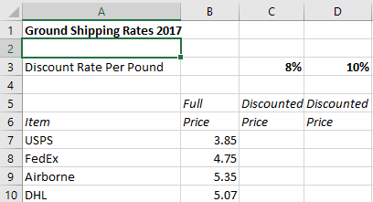
- Enter the text entries as shown. Enter the numbers in column B and the percentages in cells C3 and D3.
- In column C, beginning with cell C7, enter formulas for each row to calculate the discounted price using the discount rate per pound of 8 percent in cell C3. Your formula must subtract the discount rate in cell C3 from 1. The generic formula is Discounted Price =
Full Price * (1 - Discount Rate per Pound).
- In column D, beginning with cell D7, use a formula to calculate the discounted price for each row using the discount rate per pound of 10 percent in cell D3.
- Merge and center cells A1:D1.
- Apply a bottom border to cells A6:D6.
- Center the cells in the range B5:D6.
- Compare your work to the screen shot on the next page. If necessary, correct any mistakes and then save and close your file.
