Grand Junction to Celebrate 150 Years
GRAND JUNCTION WINTER 2019 NEWSLETTER
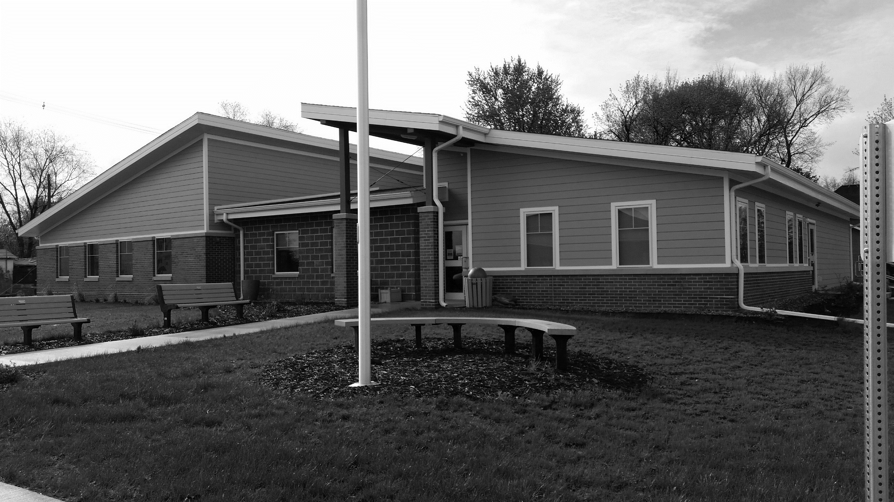
Grand Junction’s Sesquicentennial Celebration set for Aug. 2–4 will be the culmination of more than a year of planning by the GJ 150 Steering Committee.
The GJ 150 Parade is set for Aug. 3 at 11 a.m., featuring the Isiserettes marching troupe from Des Moines. Earlier that morning the GJ Library will host a breakfast at the community center.
The Lions Club annual car show will be held that day at City Park from 10 a.m. to 3 p.m. Dutton Park Ball Field will be the site of a beverage garden and live bands on both Friday and Saturday nights.
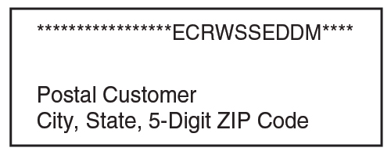
Historical presentations are planned for Aug. 2 and 4. The Greene County Historical Society will host its monthly meeting on Friday with a noon meal followed by a program at 1 p.m. On Sunday, GJ 150 and the Greene County Historical Society will co-sponsor a presentation, “Grand Junction: 150 Years of Transportation and Transitions.”
GJ Fire and Rescue Plans Expansion
In 2018, Grand Junction Fire and Rescue is pleased to report it acquired several new members; participated in multiple training opportunities, from controlled burns pump training, EMT continuing education, LUCUS device training, extrication training, and so on; and completed fire truck and fire station maintenance. Department members are grateful for the community’s support.
For 2019, the fire department is excited about plans to expand and improve the fire station. The department has received a generous grant but still needs about $15,000 to meet its goal. To help, department members are selling raffle tickets for Fareway grocery gift certificates, with amounts ranging from $25 to $100. Tickets are sold in $5 increments, so a $25 donation equals 5 drawing entries. Drawing entries are due Jan. 15, with the drawing Jan. 17. Contact Fire Chief Adam Hoffman (370-2959) for details.

The Centennial Time Capsule that was buried in front of the old Legion Hall during the Centennial Celebration in July 1969 will be opened, and activities for kids include carnival rides, inflatables, and concessions. Blank Park Zoo will have its popular petting zoo on Main Street on Saturday afternoon after the parade. Games are planned also at the sports court as well as kickball at Dutton Park Ball Field.
A complete schedule will be finalized soon. If you would like to help with our 150th anniversary celebration – either with a financial contribution or by volunteering – please contact a member of the Steering Committee: Melanie Frantz, Randy Frantz, Jacob Fester, Amber Richards, Jeremy Richards, Derek Kennedy, and Alan Robinson.
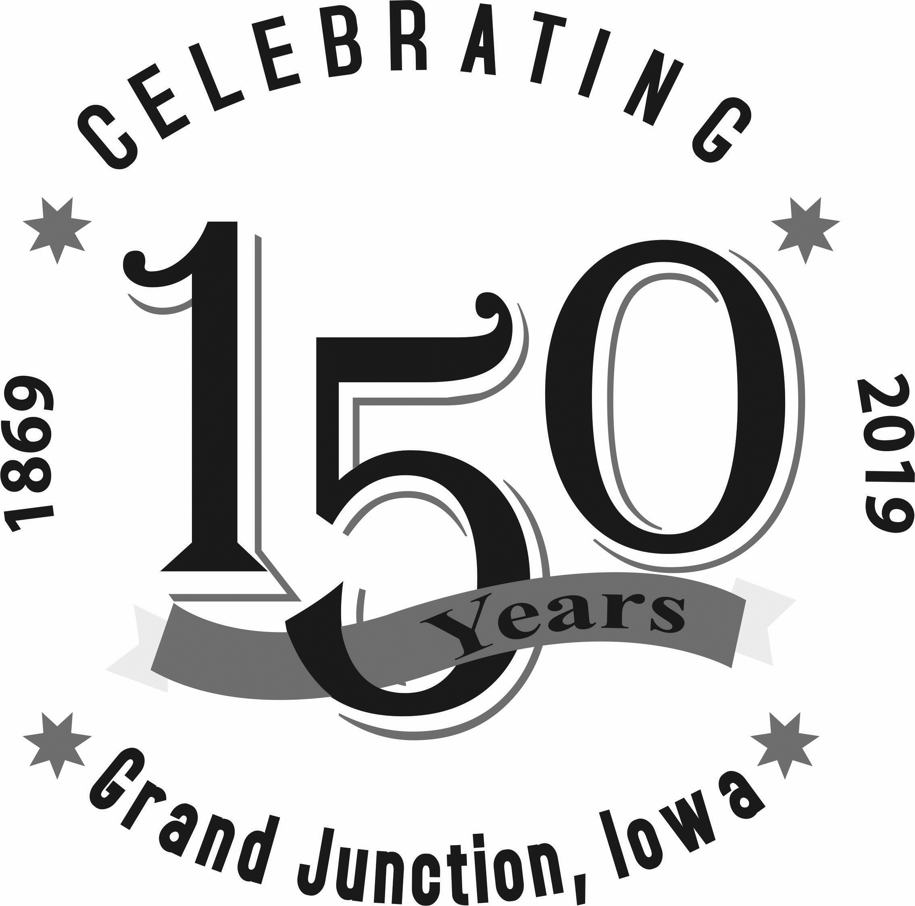
Near Record Turnout for Jingle Into Junction
Hometown Update
Message from the Mayor
In our ongoing efforts to improve our town, one of our goals this year is better enforcing our Rental Property Code. Over the past few months Council has heard presentations from a home inspector and the Boone Fire Chief on how to implement inspections and how they are conducted.
Our Code of Ordinances, which is on our website, includes a chapter on our Rental Code (Chapter 5 of Title III). It includes registration of rental premises with rental permits issued by the city and annual self-inspections of the properties. This year we will work to apply this Code as well as take steps to implement Council-designated inspections.
In addition, we are continuing to work on Main Street improvements and sewer infrastructure solutions.
Also, please take a moment to fill out the survey included with this newsletter. We value your input on our community needs as we move into 2019.
I appreciate your ideas and support to continue to improve our town. – Brock

Newsletter by Email
If you would like to receive this newsletter via email, please notify Melody or Barbara in the clerk’s office.
Wintry weather didn’t keep crowds from turning out for Grand Junction’s annual Jingle Into Junction.
A record number of tickets were sold for the soup-and-sandwich supper held by Horizons, raising about $1,200, and the silent auction featured some unusual gift opportunities, such as a climb up a wind turbine, raising around $800. These monies will be used for community projects in the coming year.
In addition, the GJ Library held a bake sale and raffled off a quilt, won by Dawn Higgins, and our GJ Fire and Rescue hosted Santa, shared cookies and hot chocolate, and gave away turkeys.
Plus, 15 individuals/businesses decorated or created colorful entries for the annual Festival of Trees, Wreaths, and Stockings. Proceeds from those that were for sale totaled $840 for the GJ 150 celebration.
Mark your calendars for the GJ 150 Celebration set for Aug. 2–4, 2019!
What Do You Think?
We appreciate your help on our first city survey a year ago. Now, as we continue to try to meet your needs while revitalizing our town, the City Council is asking for more detailed responses.
If you haven’t yet done so, please fill out the survey included with this newsletter. Return it to City Hall by Friday, Jan. 18; if the office isn’t open, you can leave your survey in the drop box outside the front entrance. Thanks in advance for your help!

Contact City Hall at 515-738-2585 or grandjct@iowatelecom.net.
Office hours are Monday through Friday, 8 to 11 am or by appointment.
www.grandjunctioniowa.org

