City Survey Results Support Council Improvement Goals
GRAND JUNCTION EARLY SPRING 2019 NEWSLETTER
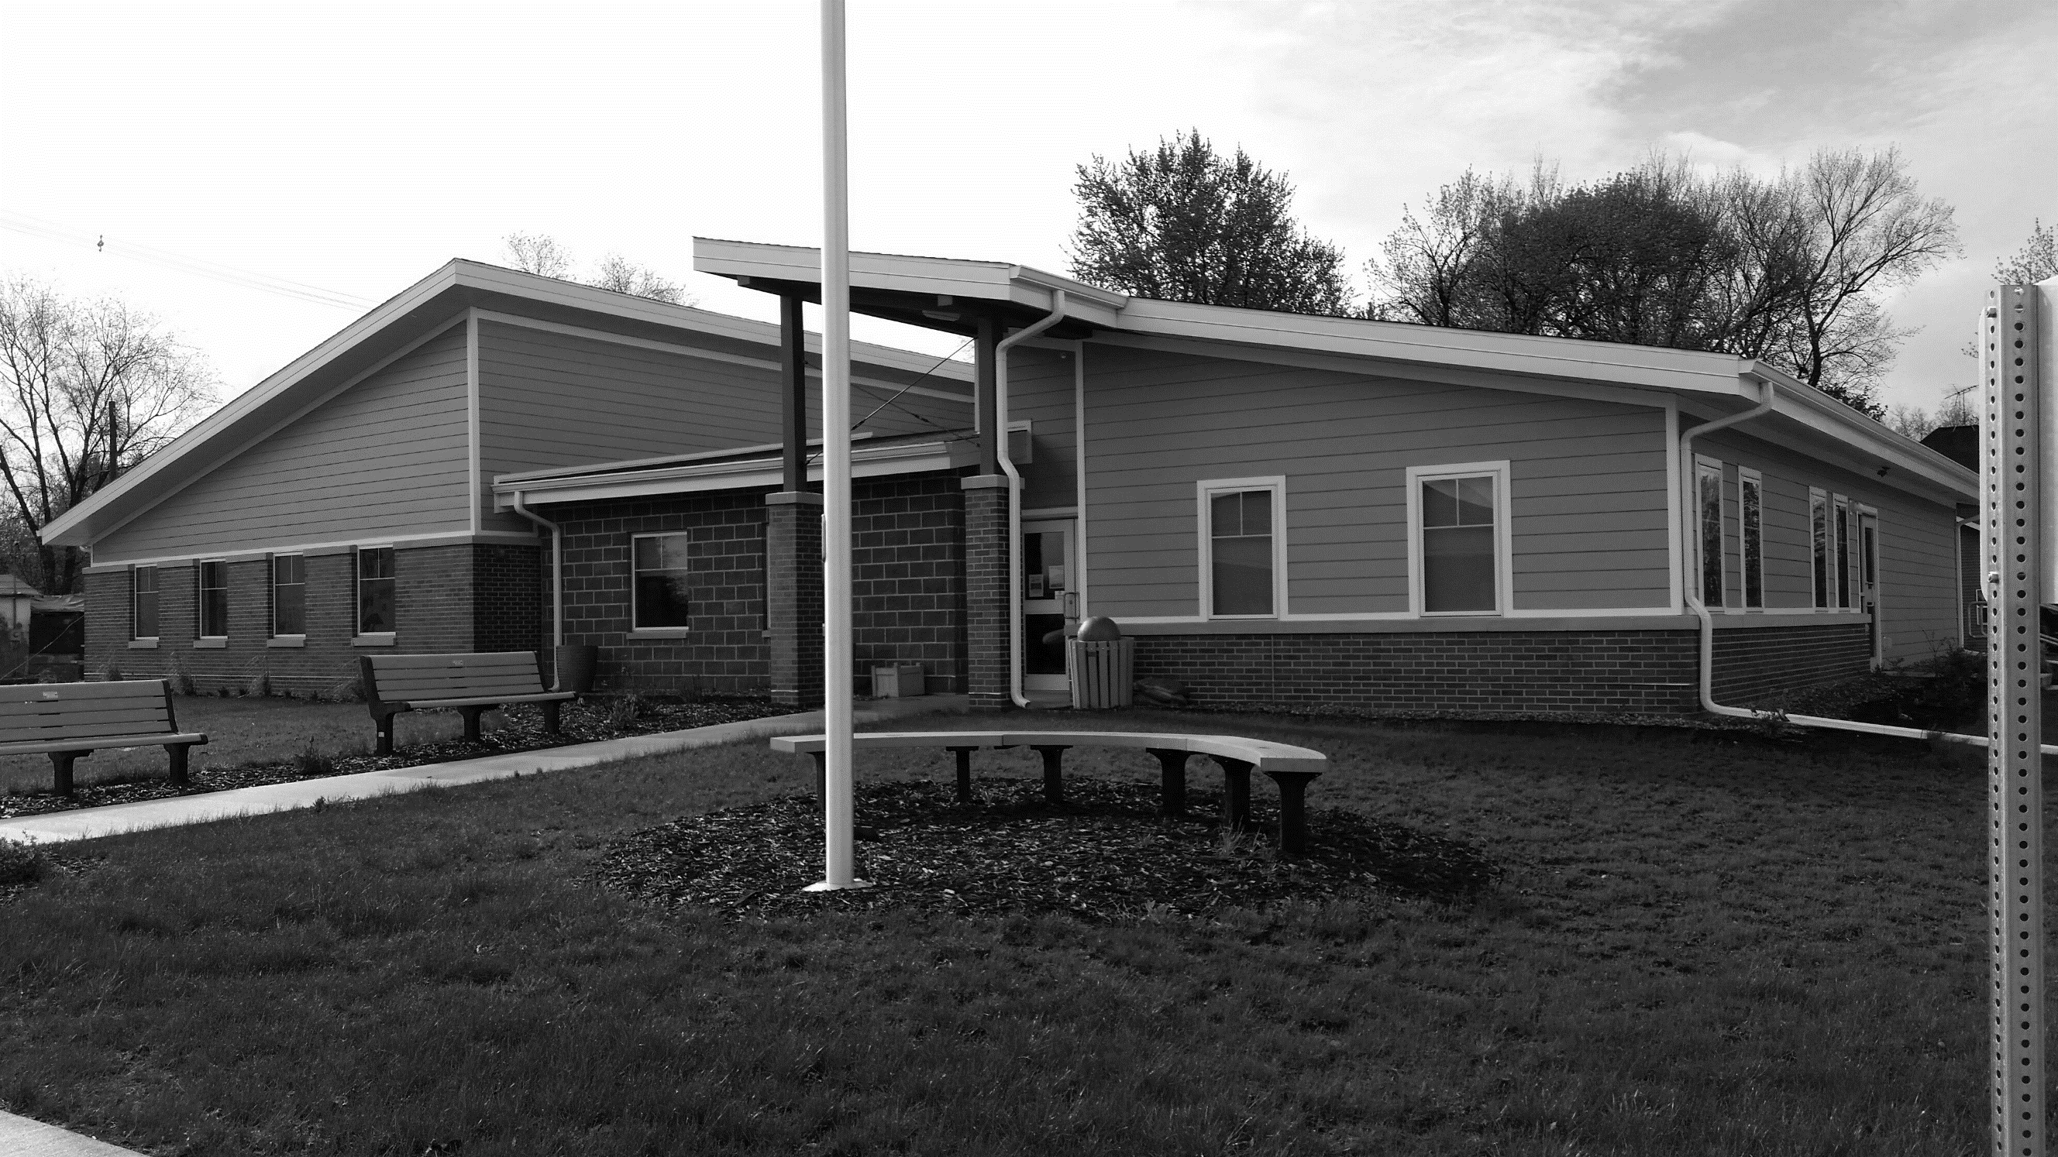
The Grand Junction Project Priorities Survey completed last month offered substantial support to the council’s goals of improving the community.
Of the 12 projects we were asked to prioritize, the seven top projects all involved improvements to town infrastructure and to cleaning up properties.
The main priorities were replacing and/or rehabilitating sanitary sewer lines, improvements to Main Street, and addressing dilapidated and nuisance residential and commercial properties.
Only after these seven areas were addressed did we consider other amenities, such as a café or community garden.
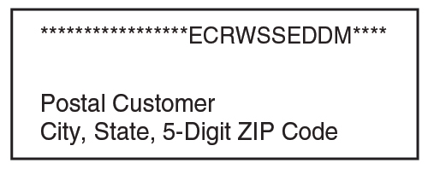
When it came to the empty lots on Main Street, we were split between giving the land away for free or
Remember to Get 2019 Dog Tags, ATV Permits
Grand Junction’s Code of Ordinances requires dogs to be licensed and the State of Iowa requires ATVs to have permits.
Permits for ATVs and golf carts are $15 again this year. Please register your vehicle in City Hall before you use it in 2019.
It is the responsibility of dog owners to register their pets. Dog owners must provide a current vaccination record and pay a $5 fee per dog to get a current tag. Unlicensed dogs will be impounded according to the city code. Dogs must wear their tag, and all animals must be secured at all times, either in a fenced yard, tethered out of reach of sidewalks and roadways, or controlled on a leash with the person holding the leash capable of controlling the pet.
building something for the city to rent out. One respondent wrote, “We are not a rich community, so let’s fix the sewer and water drainage problems first. I don’t think the city has the resources to maintain buildings they rent out, but also don’t think we should give land away free. I believe business will come if they see improvement of the town’s atmosphere.”
The council is researching grants through Region XII and other organizations to help pay for infrastructure improvements.
The 5-year visions we had for our town were as varied as we are, but primary among them were a clean, well-cared-for, and safe community to be proud of, with free cookies for everyone! Let’s make this happen!
City council members were encouraged by the numerous responses to the survey and appreciated the ideas that residents submitted. For a copy of the results, or to volunteer to help move our town forward, contact a city council member or City Hall at 515-738-2585 or grandjct@iowatelecom.net.
Community Groups Working Together for GJ 150 Event
Hometown Update
Message from the Mayor
First, major kudos go out to our great volunteer fire department, which had the difficult duty of fighting not one but two house fires in two weeks in extremely cold weather. Thankfully no one was injured, and many thanks go to all who helped in fighting these fires and keeping our neighborhoods safe.
Second, as council seeks to better enforce our Rental Property Code, we continue to study the best way to undertake these inspections.
We plan first to register rental premises and issue rental permits, which will let landlords do self-inspections before the city begins inspections aimed at enforcing the code.
We will hold a public hearing later this spring to share our plans and get your feedback.
The aim of code enforcement is compliance, not punishment. The impact that neighboring properties have on one another’s value and enjoyment means that building maintenance and safety becomes the business of everyone in the neighborhood.
I appreciate your ideas and support to continue to improve our town. – Brock

Newsletter by Email
If you would like to receive this newsletter via email, please notify Melody or Barbara in the clerk’s office.
The GJ 150 Planning Committee is working with local organizations to plan events for the 150th Celebration.
GJ LIONS CLUB: Sponsoring a car show at City Park from 10 a.m. to 3 p.m. The car show includes a lunch served by the Lions.
GJ LIBRARY: Hosting a breakfast at the Community Center Saturday morning and co-sponsoring the Blank Children’s Petting Zoo on Saturday afternoon and the Isiserettes performance during and after the parade on Saturday morning.
GJ HORIZONS: Sponsoring a play on Friday and a Box Lunch Picnic at the Community Center on Saturday. Among the history-related activities planned are a barbershop quartet, vintage quilt show, pie contest, and vintage hat contest. Horizons also hopes to offer hayride historical tours around Grand Junction with the GJ Fire Department.
GREENE COUNTY HISTORICAL SOCIETY: A Friday presentation on the history of movie theatres in Greene County and a Sunday discussion of Grand Junction’s transportation history.
GJ 150 PLANNING COMMITTEE: Sponsoring the parade, kickball tournament, and beverage garden and live entertainment on Friday and Saturday nights. Grand Junction’s very own Through the Darkness is featured Friday. Popular entertainer Jamie Kelly of Boone is the headliner Saturday.

Contact City Hall at 515-738-2585 or grandjct@iowatelecom.net.
Office hours are Monday through Friday, 8 to 11 am or by appointment.
www.grandjunctioniowa.org

