150th Celebration Countdown Is On!
GRAND JUNCTION SPRING 2019 NEWSLETTER
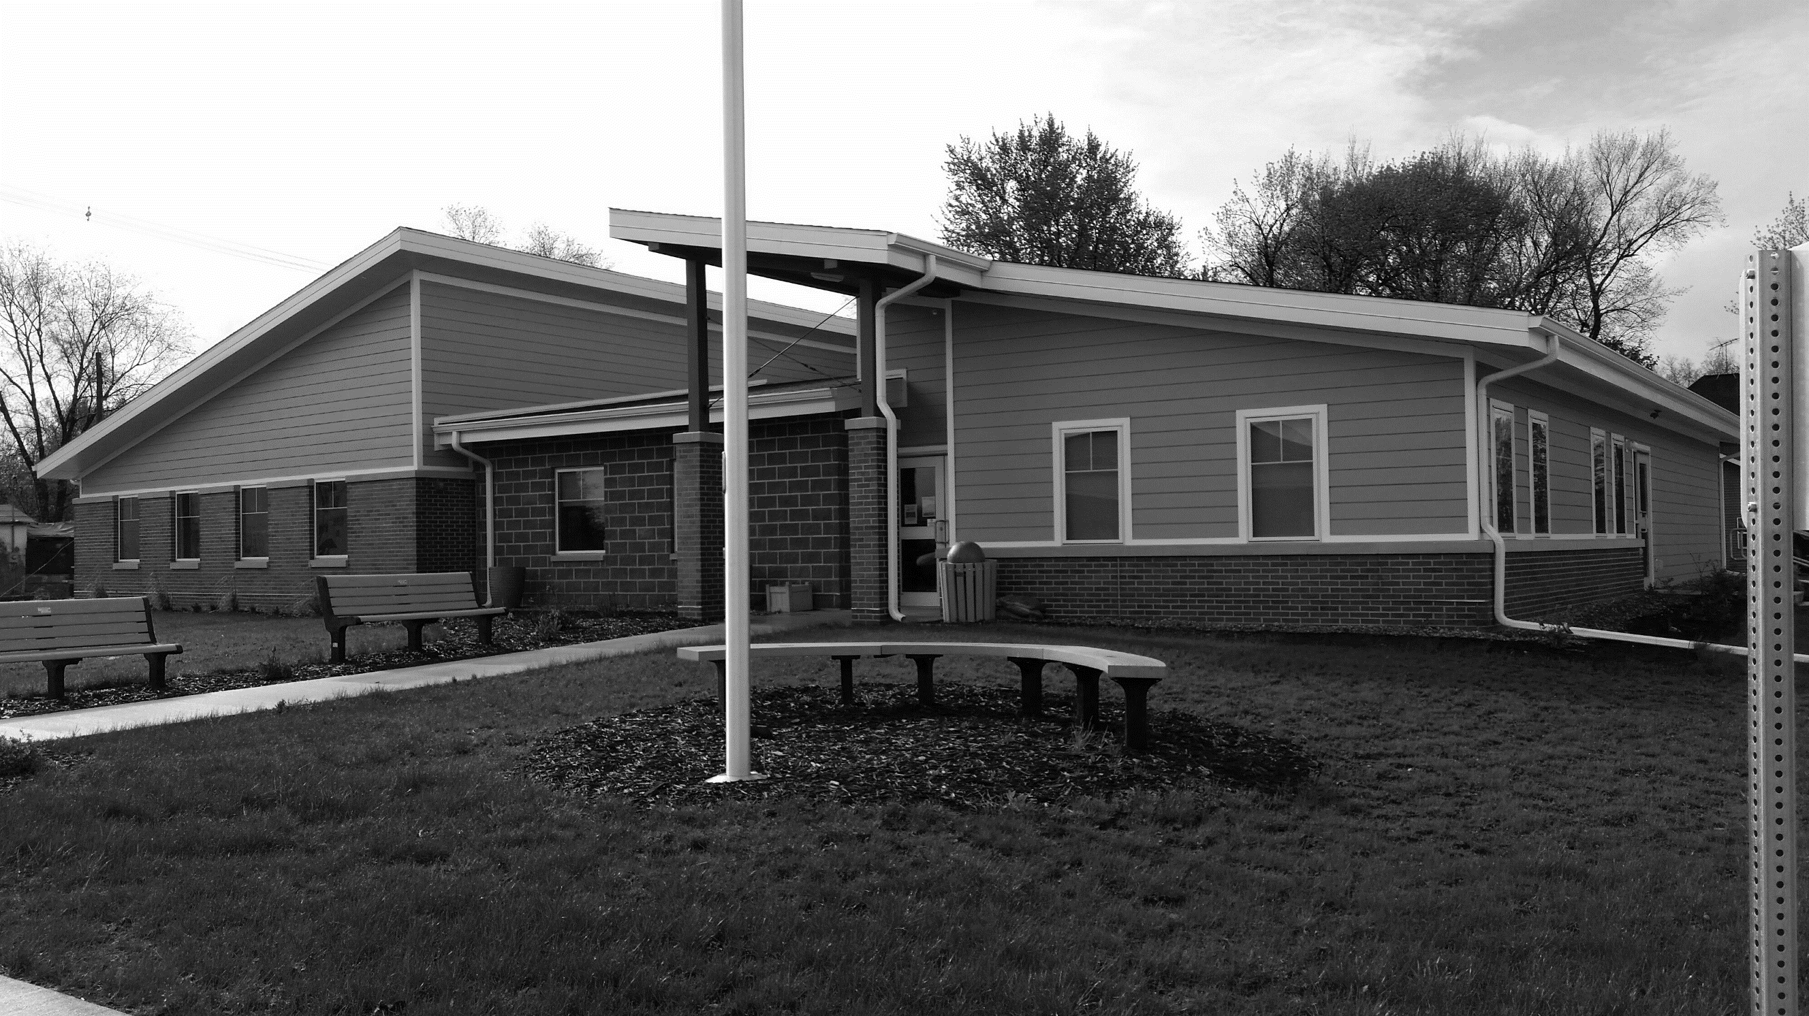
Grand Junction will hold its 150-year anniversary celebration this Aug. 2, 3, and 4 (Friday – Sunday). Following is a preliminary schedule of events.
Friday festivities begin with the Greene County Historical Society presenting a program on Greene County movie theatres at 1 p.m. It’s free and open to the public and follows a noon luncheon, which is $8 for members and $10 for non-members.
Then at 5 p.m. Grand Junction’s “Off the Track” players will present a play in the Community Center followed by an ice cream social. A beverage garden at Dutton Park (ball field) will open late Friday afternoon. “Through the Darkness,” a Grand Junction-based band, will perform at the ball park from 8–11 p.m.
On Saturday, the Grand Junction Library hosts a breakfast at 8 a.m. in the Community Center. The time capsule buried during the town’s Centennial Celebration in 1969 will be opened at 10 a.m. and the annual Lions Club Car Show at City Park runs from 10 a.m. until 3 p.m.
Sesquicentennial Contests Announced
Beard Contest – Categories as follows:
1. Longest 2. Fullest 3. Most Creative 4. People’s Choice for Most Attractive
Pie Contest – 1 or 2 crust; no cream pies; entries due by 10 a.m. Aug. 2
Trivia Contest – to be included in July newsletter!
Oldest Resident & Family with Most Generations Still Here – to be
honored in the parade
Our GJ 150 parade will begin at 11 a.m. The Isiserettes dance troupe of Des Moines is a featured entry and will perform after the parade in front of the Community Center.
Grand Junction Horizons will host a box lunch picnic at the Community Center from noon to 1 p.m. Horizons also plans an Artisan Arts and Crafts Show at the Community Center from 1– p.m. along with a vintage quilt display.
The Kennedy and the Lincoln Highway museums will be open from 2–5 p.m. and the library will host a Petting Zoo in the afternoon.
A kickball tournament is planned for the afternoon. The beverage garden will also reopen and a bags tournament will get underway. Jamie Kelley, a popular music performer from Boone, will entertain from 8–11 p.m.
On Sunday, a presentation on Grand Junction’s transportation history will be offered at 2:30 p.m. in the Community Center.
Throughout the weekend Amusement Associates will have a carnival with a full set of rides and a food/refreshment stand. Advance ticket sales for carnival rides will begin in the summer.
Citywide Cleanup Day
Message from the Mayor
Council Approves Road Repairs
After a rough winter and days of thawing and freezing, yes, our streets are in rough shape. At a special session, the City Council voted to contract with Sta-bilt Construction to repair parts or all of more than a dozen city streets. These repair services understandably are in high demand so we may not see them till later this summer but they are on their way.
New Fire Chief Named
The Grand Junction Fire and Rescue Squad has named Tom Launderville as its new Fire Chief effective May 2. Council approved Tom to replace Adam Hoffman at its April meeting. Many thanks go out to Adam for his efforts these past couple of years in leading our great fire and rescue volunteers.
Main Street Improvements
Thanks to the county, we no longer have a hole next to the Community Center! Thanks also to the Lions Club for the mural it had painted by Greene County art students to represent Grand Junction’s railroad history in time for our sesquicentennial this summer.
We also have replaced the evergreen tree by the Community Center. This is a Vanderwolf pine and a lot smaller than the first tree so we hope it’ll have a better chance of getting firmly established for good growth.
As always, I appreciate your ideas and support to continue to improve our town. – Brock
Is Saturday, June 1
With our 150th anniversary coming up, let’s clean up our town to get ready to welcome visitors!
As usual, nothing is to go on the curb till Friday, May 31. Cleanup starts at 7 a.m. Saturday.
Everyone can help! Meet on 13th Street between Main and Railroad on the north side of the tracks & bring gloves and wear shoes. Beverages and snacks will be provided.
Yard waste should be separated from other items.
REMEMBER: NO garbage, NO tires, NO batteries, NO paint, NO slate siding or shingles, NO oil or gas items, NO LP tanks, NO barrels.
East Greene Alumni Banquet Set
All graduating classes of East Greene High School are invited to attend the 2019 Alumni Banquet on Saturday, May 25, at the Community Center. The meal will be served at 6:30 p.m. and the 25, 40, 50, 55, 60, and 65-year classes will have reserved tables. RSVP by May 17 to attend this fun event.
Community Pool Opens June 7
Since school is letting out late, the GJ pool will open and be ready for fun beginning Friday, June 7. You can get early season pool passes at City Hall.
Get Dog Tags, ATV Permits
Grand Junction’s Code of Ordinances requires dogs to be licensed and the State of Iowa requires ATVs to have permits. Dog tags are $5 and permits for ATVs and golf carts are $15 again this year. Please register your dogs and ATVs in City Hall.

Contact City Hall at 515-738-2585 or grandjct@iowatelecom.net.
Office hours are Monday through Friday, 8 to 11 am or by appointment.
www.grandjunctioniowa.org
To receive this newsletter via email, please notify Melody or Barbara in the clerk’s office.

