The Circuit Writer
Volume 39 Issue 6

Someone asked me for directions to our church recently. When is the last time someone asked you how to get to church? This question gave me great pause. Do I live my life in such a way that someone would want to be involved with my church?

"Preach the gospel, and when necessary, use words." This quote is often attributed to St. Francis of Assisi although no one really knows it's origin and some experts maintain that Francis is misquoted in that phrase. However, it's worth some thought. Are we the body of Christ for the world?

This summer, I challenge you to preach with both the example of your life and through your words also. There are so many wonderful things happening at Monterey UMC--share them!

In May, we had the honor of sharing the sacrament of baptism with Holsten and Hadley Hayes, Sandi and Vince Vanacore's grandchildren. It had been 5 years since we had a baptism at Monterey UMC, and what a wonderful day it was to share this holy sacrament with this family! We look forward to nurturing them, doing everything in our power to increase their faith, confirm their hope, and perfect them in love!! It is a holy honor to take this journey together!

Church t-shirts are here. Artwork is courtesy of Susie Cournoyer. If you have not picked up your t-shirt, please stop by my office and do so, then go out wearing that t-shirt, and share the love of Christ with our community. Mark your calendar for the following:

June 23: Bible Fun Day
Sept 5: Fall Classes Begin
Sept 30: Jim Brady Trio, 6pm
October 2: Blessing of the Animals
October: Mission trip to Red Bird Mission (dates to be determined)
November: Ladies' Day Away Before the Holiday-- women's tea

Take Christ into the world, friends. . . and invite a friend into the wonderful life we share at Monterey UMC.

I will never stop giving thanks for you. . . remembering you in my prayers,
Denna

Monthly & Weekly Church Scheduling
Sunday School & Worship 9:45am & 11:00am
Youth Group Sundays 5:30pm – 7:00 pm
Monterey Hilltop Chorale Mondays at 6:00pm
Civitan Club 3rd Tuesday of each month at 6:00pm
Choir Rehearsal Wednesdays at 6:30pm
Cottage Ministry Friday & Saturday, 9am – Noon
Garden Club 2nd Tuesday of each month at 10:30am

May Worship Leaders
Liturgist Linda Jensen
Ushers Phillip & Sharon Choate
Acolytes Marcy & Keelan Milligan & Sophia

A Record of our faithfulness May 2018

MAY FINANCIAL RESULTS (Operating Funds)
05/01/18 BEGINNING BALANCE $ 16,850.04
TITHES AND OFFERINGS 13,027.68
EXPENSES (13.521.84)
5/31/18 ENDING BALANCE $ 16,355.88

Upcoming Meetings & Events

No Choir rehearsal June - July 4th.

The Monterey Garden Club will meet Tuesday, June 12th at 10:30 am in the Fellowship Hall.

Bible Fun Day Meeting: Monday, June 18th at 6 pm.

Bible Fun Day: Saturday, June 23rd - 9 am to 3 pm

Red Bird Mission
When is the last time you have been on a mission trip? Red Bird Mission in Beverly, Kentucky operates a thrift store to benefit the folks living in the Daniel Boone National Forest. This area is in the poorest county in our country.

Would you be willing to spend a couple of days helping Red Bird with their thrift store? Cost for the trip is minimal, everyone can participate regardless of mobility, and our trip will be in October which is prime leaf peeping season! Contact Pastor Denna if you are interested in learning more

FACT: The Community of Monterey
economically ranks 94% poverty.

The Cottage at MUMC has served as a mission in our community since 2004. It offers women’s clothing along with small household items at minimum cost. It is also a place of friendly atmosphere for all. Deborah Wolfe has sensed a need for food for many in our community. There is now a small pantry of non-perishable foods at The Cottage. We can contribute to this with food or money. Small pails were given on Mother’s Day to collect small change. You are invited to bring your change to my house, 505 W. Crawford Avenue on Saturday, June 16th at 10:00 a.m. We will enjoy Ralph’s Donuts , visiting with our church family and extending the mission of The Cottage. Wanda Balsley

The Cottage

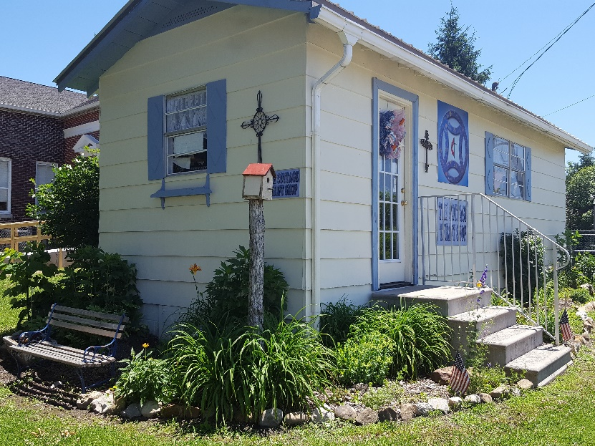

Your donations of women’s clothing, small household items, sheets, towels and food are needed and appreciated.

Monterey’s April Birthdays

1 Sandra Houston
3 Morris Stamps
10 Crystal Stewart
13 Ann Watson
14 Clarissa Webb
17 Len Durham
17 Karen Logsdon
18 Bob Coe
24 Bob Henley
24 Ken Walker
27 Wanda Balsley

MONTEREY’S APRIL ANNIVERSARIES

10 W.T. & Franny Ray
12 Carson & Linda Goddard
13 Bill & Kay Wiggins

There’s always something beautiful in the church garden.
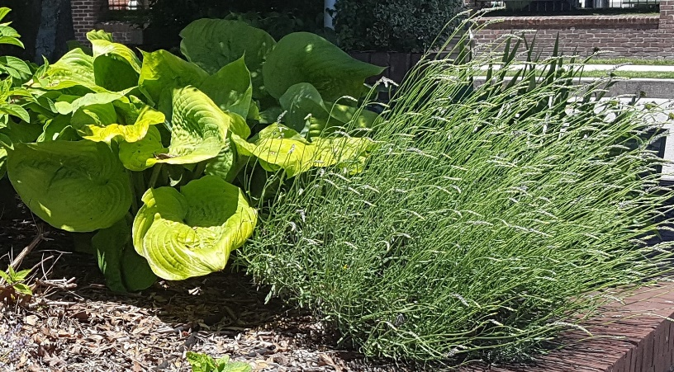

30
Monterey United Methodist Church
June 2018

Sun | Mon | Tue | Wed | Thu | Fri | Sat
 |  |  |  |  | 1 | 2
 |  |  |  |  | 9:00a-Cottage Ministry | 9:00a Cottage Ministry
3 | 4 | 5 | 6 | 7 | 8 | 9
9:45a Sunday School  11:00a Worship Service  5:30p Youth Group | 6:00p Monterey Hilltop Chorale | 10:30a Garden Club |  |  | 9:00a Cottage Ministry | 9:00a Cottage Ministry
10 | 11 | 12 | 13 | 14 | 15 | 16
9:45a Sunday School  11:00a Worship Service  5:30p Youth Group | 6:00p Monterey Hilltop Chorale | 6:00p Civitans |  |  | 9:00a Cottage Ministry | 9:00a Cottage Ministry
17 | 18 | 19 | 20 | 21 | 22 | 23
9:45a Sunday School  11:00a Worship Service  5:30p Youth Group  FATHER’S DAY | 6:00p Monterey Hilltop Chorale  6:00p Bible Fun Day Mtg |  | 6:00p Finance Meeting |  | 9:00a Cottage Ministry | 9:00a Cottage Ministry  9a – 3p Bible Fun Day
24 | 25 | 26 | 27 | 28 | 29 | 30
9:45a Sunday School  11:00a Worship Service  5:30p Youth Group  2:00p Rev. Denna leads worship at Standing Stone Care & Rehab | 6:00p Monterey Hilltop Chorale

