OFFICIAL PREMIUM LIST

NEWARK
TRACKING & TRAINING ASSOCIATES

CANADIAN KENNEL CLUB LICENSED TRACKING TRIALS
FORT ERIE, ONTARIO

HELD UNDER THE RULES OF THE CANADIAN KENNEL CLUB

TD & TDX UTD, UTDX CLASSES

SUNDAY SEPTEMBER 23, 2012

JUDGE – MARIE BABIN, 163 DELANEY DR., AJAX, Ont.

ENTRIES OPEN MON. AUG. 27th AND CLOSE MIDNIGHT SEPT 12TH OR WHEN THE LIMIT HAS BEEN REACHED

**ALL EARLY ENTRIES WILL BE RETURNED**

LIMITED ENTRIES: 6 TD, 3TDX & 2 URBAN & 1 URBAN X

THIS EVENT HELD UNDER THE RULES OF THE CANADIAN KENNEL CLUB
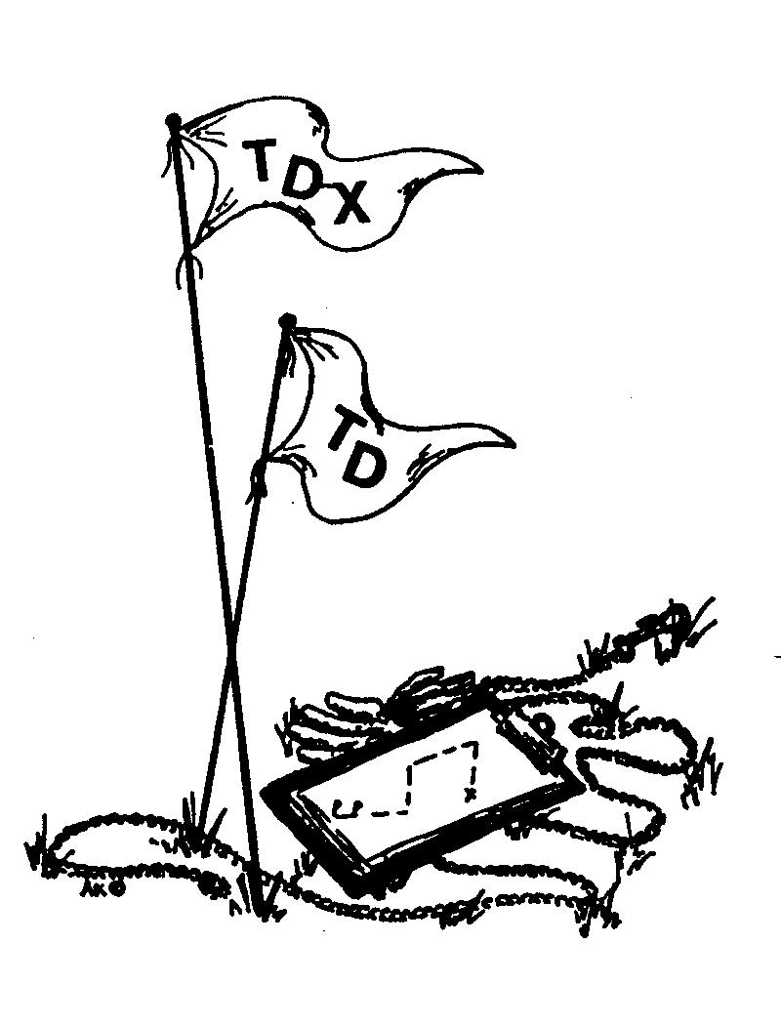
SEND ENTRIES TO: JERRY BURKE
3066 BOWEN ROAD,
STEVENSVILLE, ONT.
LOS 1S0
905-382-3087

TO COMPLY WITH INSTRUCTIONS ISSUED BY THE CANADIAN KENNEL CLUB WE WILL BE UNABLE TO ACCEPT, CANCEL, ALTER OR SUBSTITUTE ANY ENTRY REACHING US AFTER THE CLOSING DATE OR WHEN THE LIMIT HAS BEEN REACHED (OTHER THAN ENTRIES ON THE ALTERNATE LIST)

WHEN THE LIMIT HAS BEEN REACHED, ALL REMAINING ENTRIES SHALL BE ASSIGNED A POSITION OF THE ALTERNATE LIST IN THE ORDER RECEIVED. ENTRIES FROM THE ALTERNATE LIST MAY FILL ANY ABSENTEE SPACES UP TO ONE HOUR BEFORE THE TRACKING TEST STARTS. THE PERSON MAKING THE ENTRY SHALL BE NOTIFIED OF THEIR POSITION ON THE ALTERNATE LIST. ENTRIES WILL BE REFUNDED WITHIN 10 DAYS OF THE TRACKING TEST TO THOSE ON THE ALTERNATE LIST WHO DID NOT PARTICIPATE IN THE TEST.

ENTRIES MUST BE MAILED OR SENT BY COURIER TO THE POSTAL ADDRESS OF THE EVENT SECRETARY, FAXED, EMAILED OR HAND DELIVERED ENTRIES ARE NOT ACCEPTABLE. EACH ENTRY MUST BE MAILED IN A SEPARATE ENVELOPE.

ENTRIES MUST NOT REQUIRE A SIGNATURE FOR DELIVERY. IF THERE IS NO ONE TO SIGN, DELIVERY IS DELAYED, OR WE HAVE TO GO PICK THE ENVELOPE UP AND WE WILL NO LONGER DO THAT, AS IT IS SEVERAL MILES TO THE DEPOT.

T.D. CLASS WILL BE JUDGED FIRST, FOLLOWED BY UTD AND THEN UTDX and then TDX. T.D. DOG WILL GO ON THE TRACK AT 8:30. AM. (PLEASE NOTE - WE HAD PLANNED ON DOING URBAN ON SAT. & FIELD ON SUN. BUT MARIE SPECIFIED ALL TRACKING ON SUNDAY)

PRESIDENT JERRY BURKE
VICE-PRESIDENT DENISE M. PARKER-LANGEIGNE
SECRETARY/TREASURER IKENA HILMAYER

TEST SECRETARY JERRY BURKE

ENTRIES FEES: $100.00 FOR T.D.; $125.00 FOR T.D.X.& UTD and $150 FOR UTDX ATTENTION USA EXHIBITORS: PERSONAL DISCOUNTED CHECKS OR CHECKS MARKED “AT PAR” OR “PAYABLE IN CANADIAN FUNDS” WILL NOT BE ACCEPTED. (FEES INCLUDE GST)

A LISTING FEE AS ESTABLISHED BY THE CANADIAN KENNEL CLUB MUST ACCOMPANY THE ENTRY OF A DOG WHICH A CANADIAN KENNEL CLUB INDIVIDUAL REGISTRATION NUMBER OR EVENT ERN. NUMBER IS NOT SHOWN ON THE ENTRY FORM.

AN $8.00 C.K.C. LISTING FEE IS REQUIRED FOR ANY DOG NOT HAVING A C.K.C., ERN OR MISC. CERT. NUMBER (LISTING FEE AS SET BY THE CKC.)

A DOG THAT IS ELIGIBLE FOR A PEN NUMBER CANNOT BE ENTERED AS A LISTED DOG.

The CKC has instituted a Non-Member Participation fee for all CANADIAN residents wo participate in a CKC event but are not CKC members. In order to protect the awards/titles earned, the non-member will have a choice either to become CKC member or to pay the non-member participation fee. Failure to comply within 30 days of notification will cause all awards and titles to be cancelled. This applies to dogs wholly owned by non members resident in Canada does not apply to U>S> exhibitors nor CKC members or dogs co-owned with a CKC member.

THE CANADIAN KENNEL CLUB: EX. DIR. NANCY CAREY www.ncarey@ckc.ca

CKC TRACKING REP. JANE BOOK

A ROSETTE WILL BE AWARDED TO EACH DOG PASSING

ONLY THOSE DOGS REGISTERED INDIVIDUALLY WITH THE C.K.C. OR ELIGIBLE FOR INDIVIDUAL REGISTRATION, MAY BE ENTERED IN THIS TRIAL (ERN OR PEN NUMBERS ACCEPTED)

BITCHES IN SEASON WILL BE ALLOWED TO COMPETE. PLEASE NOTIFY THE TRIAL SECRETARY OR CHAIRMAN PRIOR TO THE START OF THE TRIAL. BITCHES IN SEASON WILL BE JUDGED LAST OR IN SUCH A WAY AS NOT TO BOTHER OTHER DOGS.

DOGS MUST BE KEPT ON LEASH AND UNDER CONTROL AT ALL TIMES

PLEASE KEEP THE TRACKING FIELDS AND ROADS CLEAN, DON’T LITTER

THE DRAW FOR THE TRACKS WILL BE HELD AT TIM HORTON’S 2780 STEVENSVILLE RD., STEVENSVILLE, ONTARIO. (information will be sent with the confirmations)

TNECANADIAN KENNEL CLUB: INTRIM C.E.O. LEILA BAHORIE, 200 RONSON DR. SUITE 400, ETOBICOKE, ONT.
MOTELS

COMFORT INN, 1 HOSPITALITY DR. FORT ERIE – 905-871-8500

PENINSULA INN & RESORT, NIAGARA FALLS – 905-354-8312
(ABOUT 20 MIN. AWAY, EXTRA CHARGE FOR DOGS)

BEST WESTERN FALLSVIEW, NIAGARA FALLS – 905-356-0551
(ABOUT 25 MINUTES AWAY – www.bestwesternfallsview.com)

CAMPING

KNIGHTS HIDE AWAY CAMPING AND TRAILER PARK 905-894-1911
(ABOUT 5 MINUTES AWAY FROM DRAW)

