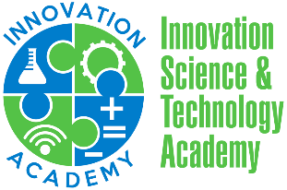

INNOVATION ACADEMY SCHOOL BOARD MEETING AGENDA 12/11/2020

Vision Statement
To develop globally conscious student innovators.

Mission Statement
Innovation Science & Technology Academy Charter School will develop talented student innovators using a cutting-edge curriculum with the collaborative support of staff, parents, and community. The collaborative culture and healthy school climate will foster personalized learning and ignite the power of imagination and creativity in our students, who will grow to be critical thinkers, problem solvers, and agents of change

Board Meeting Norms
(a) Be prepared, present, and open minded (b) Start and end on time (c) Treat each other with dignity & respect (d) Listen first to understand (e) Students first, student last (f) Be genuine with each other about ideas, challenges and feelings (g) Support and work as a team to achieve the school goals

Agenda Items

- Call to Order & Welcome

- Vision, Mission, & Norms

- Adoption of Agenda

- Approval of Board Minutes from October 9, 2020

- Conflict of Interest

- Financial Update

- NEO Observation

- Fundraising and Recruitment Ideas

- World’s Best Workforce (WBWF) Plan

- Executive Director’s Report

- Other Matters/Questions

- Upcoming Agenda

- Adjournment of Meeting

