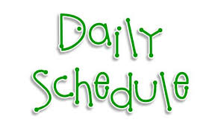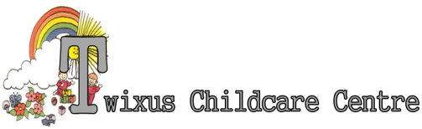
Morning | 7.00-  7.30 |  | 7.30-  8.00 |  | 8.00-  8.30 | 8.30-  9.00 |  | 9.00-  9.30 |  |  |  | 9.30-  10.00 | 10.00-  10.30 |  | 10.30-  11.00 |  | 11.00-  11.30 |  |  | 11.30-  12.00 |  | 12.00-  12.30 |  | 12.30-  13.00
Baby Unit  Room 1  &  Room 2 |  |  | Welcome – EYFS Free Play Inc. construction toys, soft toys, activity centres etc.  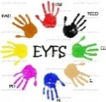 |  | Split into two groups for EYFS :-  Soft play, ball pond, slide, tunnels, messy play or craft, activity mats, soft balls, musical instruments and singing. Learning Journal work.  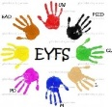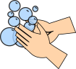Nappies. |  |  |  |  |  |  |  |  |  | Outdoor Play. Large equipment, car mats, messy play  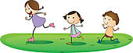 |  |  |  | Books.  Nappies.  Wash hands. |  |  | 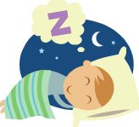 (depending on the child’s routine) |  | EYFS – Free Play
Toddler room |  |  |  |  | Split into two groups for EYFS :-  (as above) |  |  |  |  |  |  | Circle Time – stories and singing |  |  | Outdoor Play or soft play depending on weather. |  |  |  | Nappies. Wash hands |  |  | Sleep Time or Focused Activities Inc. EYFS Learning Journals, craft, stories etc.  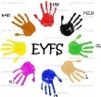
Afternoon |  | 13.00-  13.30 | 13.30-  14.00 | 14.00-  14.30 |  | 14.30-  15.00 | 15.00-  15.30 |  |  |  | 15.30-  16.00 |  |  | 16.00-  16.30 |  | 16.30-  17.00 |  | 17.00-  17.30 |  |  | 17.30-  18.00 |  | 18.00-  18.30 |  | 18.30
Baby Unit |  | Welcome PM children. EYFS Craft | Treasure Baskets and singing. Indoor play. Learning Journal work |  |  | Outdoor play in the baby room garden. |  |  |  | Wash  Nappies. hands. Tidy | 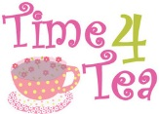 |  |  | EYFS play Inc. play food, small world, animals, cars, construction, ICT.  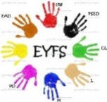 |  |  |  | EYFS Free Play. Key Person time with Learning Journal work. Group activities, Story time, singing, music.  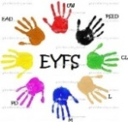
Toddler room |  | Welcome PM children. EYFS Craft and Free Play  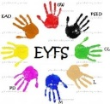 |  | EYFS Topic Work - Construction toys, puzzles, activity centres, home crafts. Focused Activity work with Key Person. |  |  |  |  | Circle Time.  Tidy.  Nappies.  Wash. |  |  |  |  | EYFS Guided Play Inc. shapes, colours, numbers, sharing. Indoor and Outdoor activities. |  |  |  | EYFS Free Play. Key Person time with Learning Journal work. Group activities, Story time, singing, music.
*The Individual routines of each child may vary, including eating, sleeping and toilet hygiene patterns.
Morning | 7.00-  7.30 | 7.30-  8.00 |  | 8.00-  8.30 |  | 8.30-  9.00 |  | 9.00-  9.30 |  | 9.30-  10.00 | 10.00-  10.30 |  |  | 10.30-  11.00 | 11.00-  11.30 |  | 11.30-  12.00 | 12.00-  12.30 | 12.30-  13.00
Nursery 1 |  | Welcome – Free Play Inc. construction toys, soft toys, activity centres etc.  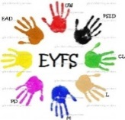 |  |  |  | Split into two groups for EYFS Circle Time & Activities. Crafts, stories, games. |  |  |  | Adult lead Focused Activities |  |  |  | Outside Play  Pirate Ship | Quiet Time Inc. Stories, washing hands etc. |  |  | Sleep Time (ST) or focused activities  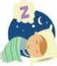 | (ST) or Soft play room / Key Person Time
Nursery 2 |  |  |  |  |  | Adult Lead (as above)  Relocate to the second floor  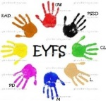 |  |  |  | Outside Play  Pirate Ship |  |  |  | EYFS – Free Play | Quiet Time Inc. Stories, washing hands etc. |  |  | Sleep Time or focused activities  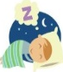 | (ST) or What’s in the box? Circle Time.
Afternoon | 13.00-  13.30 | 13.30-  14.00 | 14.00-  14.30 |  |  | 14.30-  15.00 | 15.00-  15.30 |  |  | 15.30-  16.00 | 16.00-  16.30 |  | 16.30-  17.00 |  | 17.00-  17.30 |  | 17.30-  18.00 | 18.00-  18.30 | 18.30
Nursery 1 | (ST) or Soft play room / Key Person Time | What’s in the box? Circle Time.  Group activities, Story time, singing, music. | EYFS Free Play. Key Person time with Learning Journal work |  | Outside Play or Soft Play Room  Back Garden or Woodland area |  |  |  | Story Time. Wash hands | 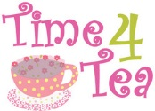 | EYFS Play Inc. shapes, colours, numbers, sharing, song bag, messy play, puzzles and games craft.  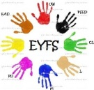 |  |  |  |  | Tidy up time.  Circle time learning. Story Time. Diaries. | Nursery 1 and 2 join and Relocate to Ground Floor. EYFS Free Play Inc. construction toys, soft toys, activity centres, singing and dancing etc.
Nursery 2 | (ST) Welcome PM children. EYFS Play | EYFS Free Play Inc. Role play, cars, small world, instruments, ICT. Key Person time with Learning Journal work. |  |  | Outside Play or Soft Play Room |  |  |  | Story Time. Wash hands |  |  | EYFS Guided Play Inc. Shapes, colours, numbers, sharing, song bag, messy play, puzzles and games craft. |  |  |  | Tidy up time.  Circle time learning. Story Time. Diaries.
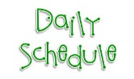
Morning | 7.00-  7.30 | 7.30-  8.00 |  |  | 8.00-  8.30 |  |  | 8.30-  9.00 |  |  | 9.00-  9.30 |  | 9.30-  10.00 | 10.00-  10.30 | 10.30-  11.00 | 11.00-  11.30 | 11.30-  12.00 | 12.00-  12.30 | 12.30-  13.00
Pre School 1 |  | EYFS Topics –Free Play Inc. construction toys, soft toys, activity centres, play food, small world, animals, cars, ICT etc. Key Person time with Learning Journal work. Group activities, Story time, singing, music. |  |  |  |  |  |  |  |  |  |  | Circle Time – Topics, Teaching from the interactive whiteboard, games and songs. Swimming |  | Free Play - Outside (weather permitting)  Observation recorded  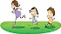  PS1 garden | EYFS Topics – Learning Journals, Key Person/ Focused  Activities. Craft  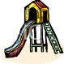 | Circle Time/  Sharing. Story. Wash hands |  | Free Play - Outside (weather permitting)  Observations recorded  Pirate Ship
Pre School 2 |  |  |  |  |  |  |  |  |  |  |  |  | Welcome – Circle Time – Topics, Teaching from the interactive whiteboard, games and songs. Swimming |  | Free Play - Outside (weather permitting)  Observation recorded  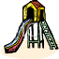 | EYFS Topics – Learning Journals, Key Person/ Focused  Activities. Craft.  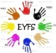 | Circle Time/  Sharing. Story. Wash hands |  | Quiet Time – Story/TV.  EYFS Free Play Inc. activity centres.  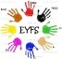
Pre School 3 |  |  |  |  |  |  |  |  |  |  |  |  | Welcome – EYFS Free Play Inc. activity centres. Swimming. 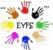 | 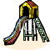 | EYFS Topics – Learning Journals, Key Person/ Focused  Activities. Craft | Free Play - Outside (weather permitting)  Observation recorded | Circle Time – Topics, games and songs. Wash hands |  | Quiet Time for Adult lead singing, stories & games.
Afternoon | 13.00-  13.30 | 13.30-  14.00 |  | 14.00-  14.30 |  |  | 14.30-  15.00 |  |  | 15.00-  15.30 |  |  | 15.30-  16.00 | 16.00-  16.30 | 16.30-  17.00 | 17.00-  17.30 | 17.30-  18.00 | 18.00-  18.30 | 18.30
Pre School 1 | Free Play - Outside (weather permitting)  Observations recorded  Pirate Ship |  | EYFS Topics – Learning Journals, Key Person/ Focused activities. Craft. Free Play Inc. construction toys, soft toys, activity centres etc.  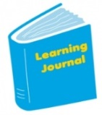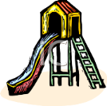 |  |  |  |  |  |  |  |  | Circle Time – Topics, Teaching from the interactive whiteboard, games and songs |  | Quiet Time – Story/TV.  EYFS Free Play Inc. activity centres. | EYFS Topics – Learning Journals, Key Person/ Focused activities. Craft. Free Play Inc. construction toys, soft toys, activity centres etc  Inside and Outside.  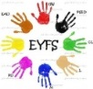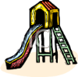 |  | Relocate to the main building for free play and collection |  | Close
Pre School 2 | Welcome PM children. EYFS Play. Indoors or PS2 garden  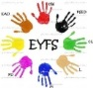 |  | Free Play - Outside (weather permitting) Observations recorded  Pirate Ship |  |  |  |  |  | Circle Time – Topics, Teaching from the interactive whiteboard, games and songs |  |  |  | then join with PS1
Pre School 3 | EYFS – Free play observations recorded. Woodland Area/Slide. Child Lead Activities. Free play Indoors if bad weather  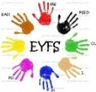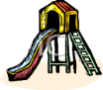 |  |  |  |  | Carpet Time - Close
Term Time
Morning | 7.00-  7.30 | 7.30-  8.00 | 8.00-  8.30 | 8.30-  9.00 | 9.00-  9.30 |  | 9.30-  10.00 | 10.00-  10.30 | 10.30-  11.00 | 11.00-  11.30 | 11.30-  12.00 | 12.00-  12.30 | 12.30-  13.00
Basement |  | Free Play - gaming, playroom and movies | Transported  to schools  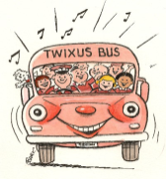
Afternoon | 13.00-  13.30 | 13.30-  14.00 | 14.00-  14.30 | 14.30-  15.00 | 15.00-  15.30 |  | 15.30-  16.00 | 16.00-  16.30 | 16.30-  17.00 | 17.00-  17.30 | 17.30-  18.00 | 18.00-  18.30 | 18.30
Basement |  |  |  |  |  | School Collections  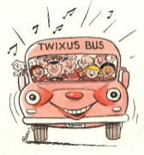 | School Collections | Welcome – Tea time then split.  Over 8 IN basement  Under 8 in Woodland  Choice of Activities Inc. Swimming, craft, computer games, toy room, sensory space room, feed the pets, pirate ship, super slide, woodlands.  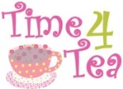 |  | All come together to tidy. Then quiet time – shared game or movie. | Relocate to Ground Floor for free play and collection

