4.1
  - Create a Worksheet and Embed a Column Chart
In this exercise, you will create a worksheet on which to base a chart, format the text and numbers, embed a column chart in the worksheet, and then prepare the worksheet with the embedded chart to be printed.
- Start a new workbook named: EX21-4.1-College Expenses
- Enter this data to set up your worksheet:
 | A | B | C | D | E | F
1 | Projected College Expenses
2 |  | Freshman | Sophomore | Junior | Senior | Total
3 | Room & Board | 3290
4 | Tuition & Books | 4850
5 | Clothes | 490
6 | Entertainment | 635
7 | Miscellaneous | 325
8 | Total
- Use formulas to calculate the expenses for the Sophomore, Junior, and Senior years based on the Freshman year amount plus 5%.
Hint: The formula for Sophomore Room & Board is =B3*(1+0.05).
- Use AutoSum to calculate the Total column and Total row.
- Set the widths for columns B–F to: 10.57
- Apply the Accounting number format to all numeric data and use dollar signs for rows 3 and 8 (but not rows 4 –7).
Hint: You can control the display of the dollar sign in the Format Cells dialog box.
- Set the title in row 1 to be 14 points, add bold formatting, and merge and center the title over columns A–F.
- Set rows 2 and 8 in bold formatting then add italic formatting to the range B2:F2 and cell A8.
- Select the data that will allow you to create a column chart that compares each expense category by college year.
Hint: Do not select Totals.
- Insert a 2-D Clustered Column chart; move the chart below the data and size to approximately the same width as the data.
- Change the layout to move the legend to the right; do not include a chart title.

- Preview the worksheet and the embedded chart on the same page.
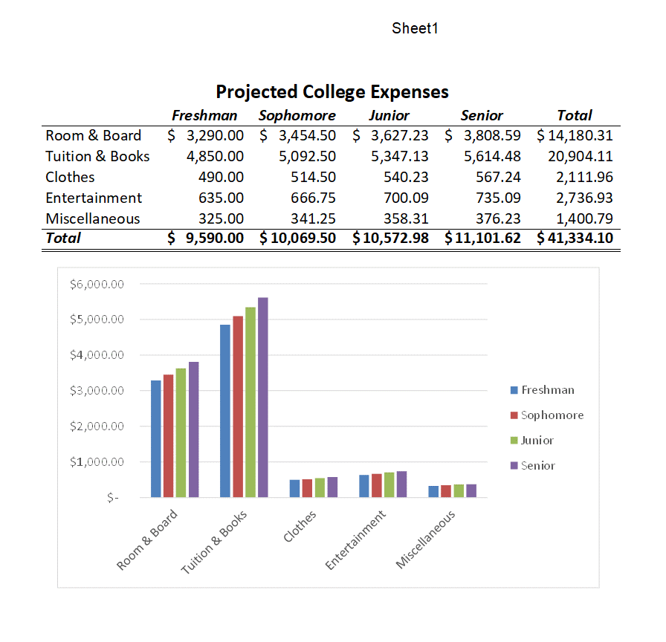
- Save and close the file.

