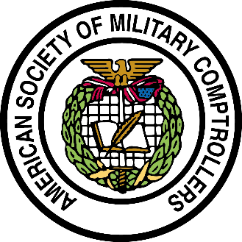
ASMC Community Service Event

September 14th 2018
11:15 AM – 3:45 PM
7th Annual Navy-Air Force Half Marathon and
15th Annual Navy 5 Miler
Washington, DC

Please join your fellow ASMC Washington Chapter members as we volunteer for the 7th Annual Navy-Air Force Half Marathon and 15th Annual Navy 5 Miler. The event is planned and organized by Joint Base Anacostia-Bolling Morale, Welfare and Recreation program. The race began in 2004 to celebrate the Navy’s birthday and has grown to over 10,000 runners.

The ASMC Washington Chapter is looking for 10 volunteers to assist on pre-race day, Friday, September 14, 2018. Volunteers will be assisting in distributing the race-day items to the runners from 11:15am to 3:45pm.

More logistics information will be given to the volunteers once received.

If you are interested in volunteering or have any questions, please contact David Adams at dmadams@kpmg.com by Friday, August 24.

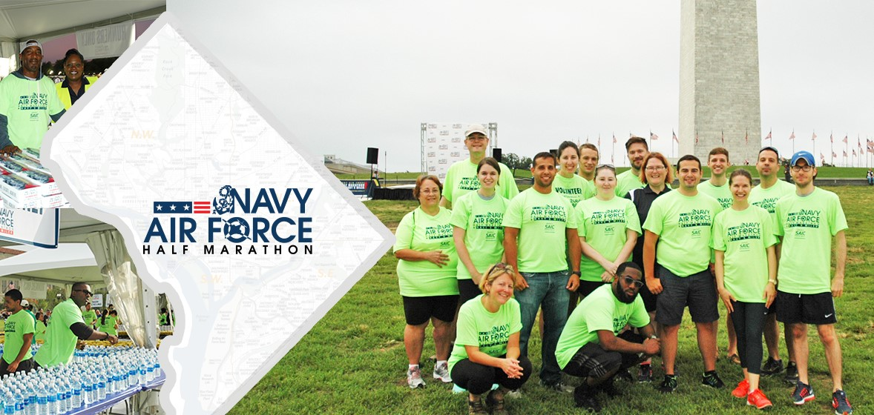
A previous year’s ASMC volunteer group was featured on the volunteer website!

