It’s Here (almost)!
GRAND JUNCTION SPECIAL 150th EDITION UPDATE
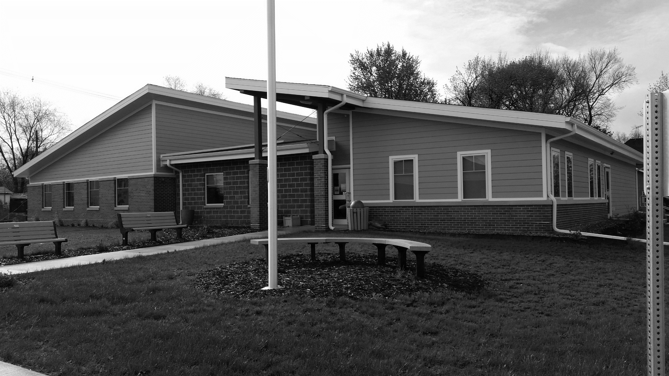
Grand Junction’s 150-year anniversary celebration is this weekend! On the back of this page is the revised schedule of events and locations. Some notable changes are:
The beverage garden will be held on Main Street by the Community Center on Friday and Saturday. Entertainment – Through the Darkness and Jamie Kelley – also will perform there.
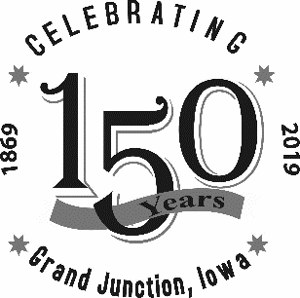
Our 11 a.m. parade begins at the bus barn and will travel 14th Street to Hager Street, then down Hager to 9th Street and south to the pool finishing up along Elizabeth Street. Parade marshal is Red Mount. The Isiserettes dance troupe of Des Moines will perform by the basketball court after the parade.
The Beef Producers will offer supper from 5‒7 p.m. Saturday on Main Street.
The open golf tournament will be held Sunday, Aug. 4, at Lakeside National Golf Club at 9 a.m.; register by Aug. 1.
Plus, the carnival will be on Main Street between 13th and 11th streets. Don’t forget you can buy 20 tickets for $15 in advance from Peoples Bank in Grand Junction until the carnival starts. After that, tickets are $1 each.
Contests! Contests! Contests!
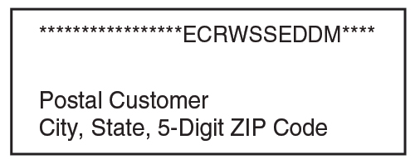
At 10 a.m. Saturday, Aug. 3, we’ll announce GJ 150 contest prize winners at the Community Center. Bring your longest, fullest, and/or most creative beard and then see who wins the People’s Choice for Most Attractive!
Winners of the pie contest will be announced along with the GJ Trivia Contest winner. Be sure to submit your trivia contest entries in the City Hall drop box (by the front door) by Aug. 2!
Nominations for Oldest Citizen and Family with the Most Generations Still Living in Grand Junction will be accepted at City Hall through noon, Aug. 2. Winners will be honored in the parade.
Contact City Hall at 515-738-2585 or by email at grandjct@iowatelecom.net.
Office hours Mon—Fri, 8 to 11 am, or by appointment.
Drop box located next to front door.
www.grandjunctioniowa.org

