GJ Awarded Grant
GRAND JUNCTION MARCH 2020 NEWSLETTER
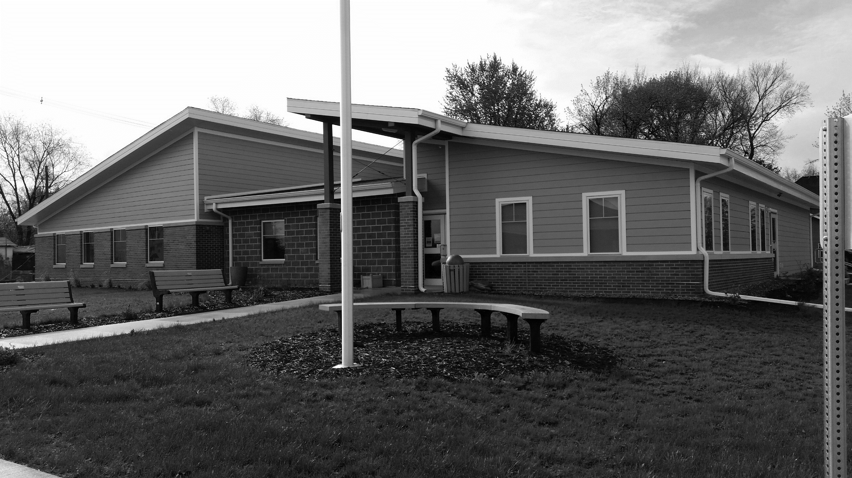
to Repair Sports Court
The City of Grand Junction has been awarded a grant of $24,500 from the Greene County Community Foundation to use toward resurfacing the 60+-year-old tennis/basketball/sports court at the corner of Hager and 12th streets.
Grants received previously were used to clean up the area, upgrade landscaping and lighting, install new backboards and poles, repaint lines, and power wash the concrete.
Nothing could be done about the court surface itself, which was cracked and broken.
Resurfacing the court with a new concrete slab will allow youth and adults to have a safe place to play basketball and other games.
In addition, the resurfaced court will enhance the overall appearance of the former school site as we make plans for the future development of that site.
Anyone who would like to help with this project can send your donation to City Hall.
Contact City Hall at 515-738-2585 or grandjct@iowatelecom.net.
Office hours are Monday ─ Friday, 9 am to noon or by appointment
www.grandjunctioniowa.org
The New Normal?
The spread of coronavirus has resulted in new rules on how we need to live for the time being, even here in Grand Junction.
These directions mean sacrifices, and they may make life difficult. We are all in this together, though, so let’s take responsibility for ourselves and our community and not expect someone else to fix things for us.
A strong sense of community means that people do things to support each other. When we think about how much worse things could be, we can see how fortunate our community is.
That said, all is not doom and gloom – the flowers will still bloom, the birds will still sing, the sun will shine, and we, maybe recognizing how much we have taken for granted, will go on.
So, order some take-out from the 30 Yard Line, grab a sub from the Coffee Corner, or get a pizza from Casey’s, smile and wave at each other from a distance, and consider being thankful for every day we have.
Remember to Do the 5:
1 HANDS: Wash them often
2 ELBOW: Cough into it
3 FACE: Don’t touch it
4 FEET: Keep at least 3 feet apart
5 FEEL sick? Stay home!

Council Hires Street Superintendent, Appoints New Member
The City Council has hired Bret Kersey as its new Street Superintendent effective March 10. Bret previously was employed as a Highway Technician Associate for the Iowa DOT where he worked on asphalt patching, snow removal, and concrete pouring, among other duties. Bret replaces the late John Trucks, who worked for the city for more than 15 years until he passed away this last January.
A vacant seat on the city council resulted after the resignation in January of long-time council member Pierre Kellogg. At its March 9 meeting, the city council appointed Lori Kennedy to fill out the remaining two years of Pierre’s term. Lori was sworn in that night to begin her council duties.
NOAA Radio Recommended
It’s that time of year again, and in talks with the City Council on emergency preparedness, Region XII recommends that residents have on hand a NOAA Weather Radio (NWR).
The NWR is a nationwide network of radio stations broadcasting continuous weather information directly from the nearest National Weather Service office. NWR broadcasts official Weather Service warnings, watches, forecasts and other hazard information 24 hours a day, 7 days a week.
NWR is an “All Hazards” radio network, making it your single source for comprehensive weather and emergency information, such as national security statements, natural disaster information, and environmental and public safety statements (such as an AMBER Alert) sourced from the Emergency Alert System.
Grab-and-Go Lunches
Beginning March 23, Greene County Schools will provide a Grab and Go Sack Lunch program open to children living in Greene County ages 0–18 and Greene County School students. The program will run in GJ at the Community Center from 11:30 am–1 pm Monday–Friday for three weeks during the current closure.
Citywide Cleanup Day to Be Held Saturday, June 6
The GJ City Council has initially approved Saturday, June 6, as Citywide Cleanup Day. Specific cleanup details will be provided later, but this is our chance to get rid of the extra and unused stuff we have squirreled away in our garages, basements, and attics, and everyone can pitch in to help!
East Greene Alumni Banquet Cancelled
The decision has been made to cancel the 2020 East Greene/Grand Junction High School Alumni Banquet. Scholarships will still be awarded to seniors from monies available in the alumni scholarship fund.
“Blessing Box” Available
“Take what you need, give what you can.”
Since November, Affinity Homecare has had a “Blessing Box” located at 201½ Main St. E in Grand Junction. The items in the box have been donated for those who have need of them. Boxed or canned foods, toiletries, clean blankets and clean socks are good items to donate. If you have items you would like to donate, please message Mel Frantz or put the items in the Blessing Box.

