FULL MEMBERSHIP APPLICATION FORM

FULL NAME ...…………………………………………………………………………………………….

ADDRESS & POSTCODE ……………………………………………………………………………....

……………………………………………………………………………………………………………….

TELEPHONE NUMBER ………………………………………………………………………………….

EMAIL ADDRESS (please write clearly)

……………………………………………………………………………………………………………….

INTRODUCED BY (Name) ……………………………… Membership No. ………………….
(Full Member)
(Signed) ………………………………………………………………………….

SECONDED BY (Name) …………………………… Membership No. …………………..
(Full Member)
(Signed) ………………………………………………………………………….

Please provide details of the activities you have been involved in during your time as a social member and which have benefitted the Club (continue overleaf)

I fully agree with the Club’s Objects

SIGNED ……………………………………………………... Date …………………………………
Glossop Labour Club

Est. 1906
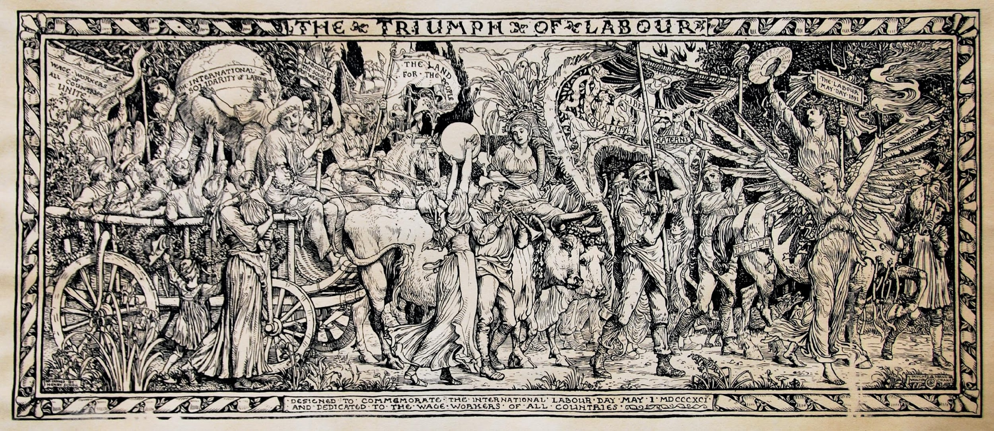

‘The Triumph of Labour’

11-13 Chapel Street, Glossop, Derbyshire, SK13 8AT

Objects of Glossop Labour Club

To encourage the development and promotion of democratic socialist principles, in Glossopdale and further afield, and to build the political awareness of its members through educational, social, cultural, political and other activities.

To provide for individuals and groups a social environment which welcomes people from diverse backgrounds and is free of expressions of discrimination whether based on race, colour, gender, sexual orientation, religion, social origin, or any other prejudice.

To co-operate with social, economic and political organisations which promote the ideals of mutual aid, environmental and economic sustainability, human rights, cultural diversity, internationalism and other principles within the democratic socialist tradition.

To advance by educational means the ideas and ideals of the national Labour Party and to further the candidature of selected persons for, and on behalf of, the national Labour Party, for the House of Commons and for every kind of Local Governing Authority.

To encourage all members to participate in the activities of the Club and to manage the premises of the Glossop Labour Club to facilitate the achievement of the above objects.

