WE CAME ON THE BUS…
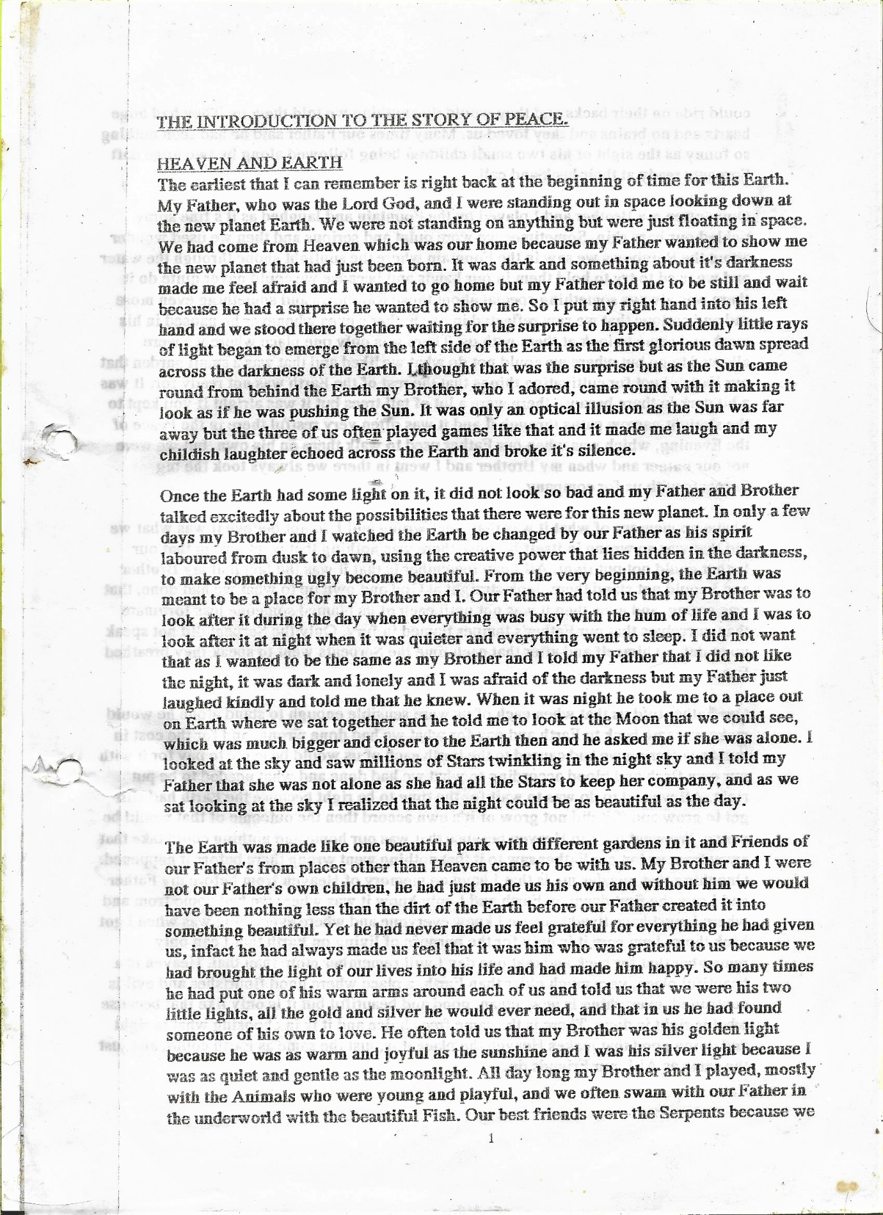
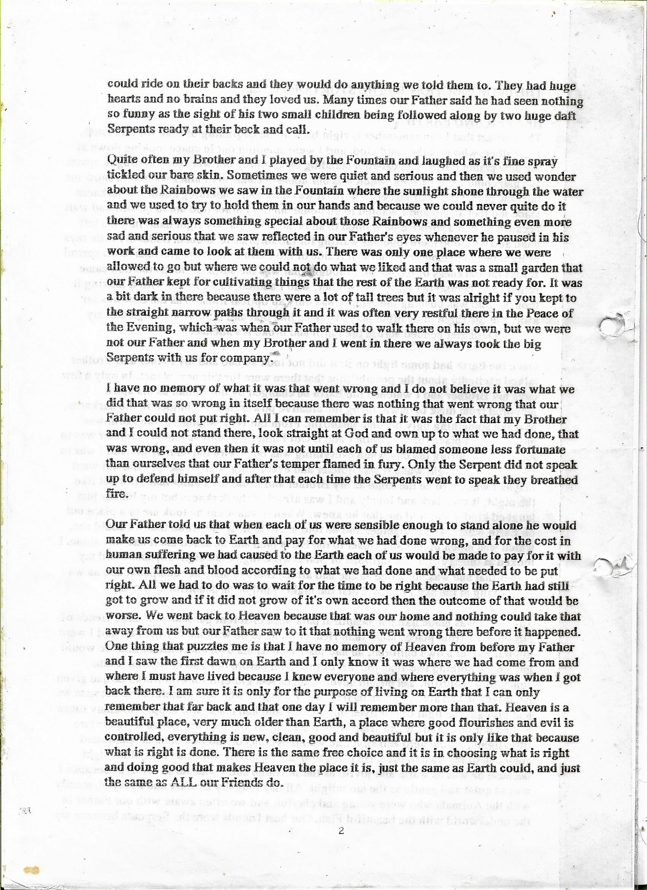

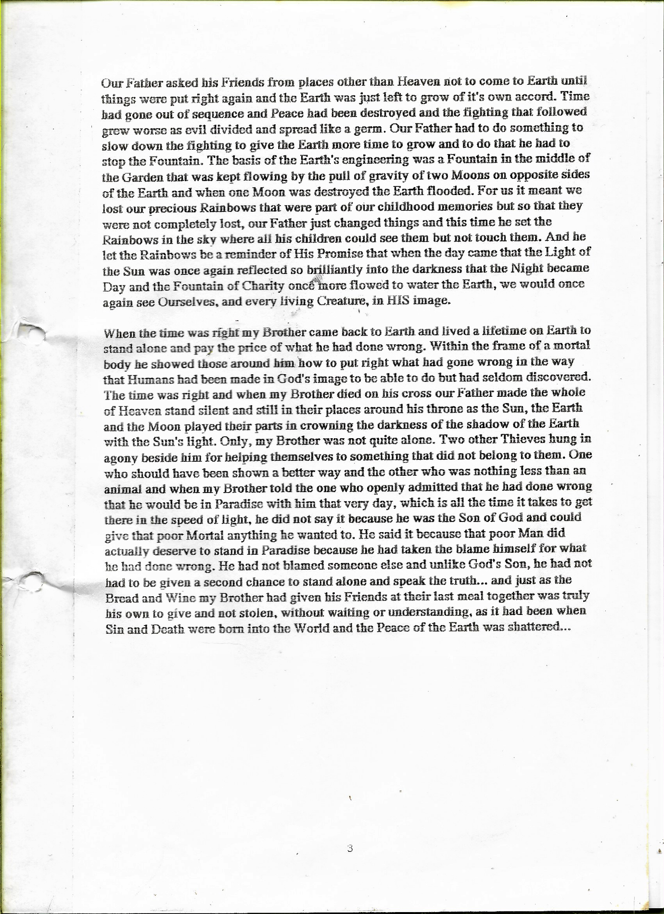
From the day Our Father changed Earth so that the fountain no longer flowed, and Earth had only one Moon, the planet had to swing on its axis to keep cool. Every time it happened, and there was another flood, The Lord God sent someone from Heaven to be on Earth when the time was right. Each time was different, once the way to safety was over the waters in an Ark, another time it was over the mountains, and once a whole nation passed right through the middle of the waters. The time before my brother came back to Earth, there was a meeting of the Gods. ‘Earth is warming up’ said one. ‘Yet again? my Lord’ remarked another. ‘That’s Earth!’ replied the Lord God kindly. He looked around for someone to send but nobody wanted to go. ‘Shall I take my turn now?’ asked my brother. ‘You are not ready for Earth’ replied the Lord God. ‘Shall I pass ahead of my Brother, and take my turn now, my Lord?’ I asked. The Lord God laughed and said ‘And Earth is not ready for YOU yet!, but I am going to ask some of your friends to help’. I smiled at him, and that time it was whales to the rescue.
My turn came when Earth learnt to talk. We were in the control room, where we watch Earth on a huge screen, when we heard, many times, the crackling words ‘This is ‘the baby see’ in London’ coming from Earth. There was war, fear, and deprivation. People on Earth asked if The Lord God was sleeping but he was sitting in Heaven with tears running silently down his cheeks at what they were doing on Earth, and he turned his head towards my Mother and said ‘It is time for us to send our baby, to say hello to Earth, this is Heaven, and we have been looking after you for a very long time’ as if it was a time he had dreaded happening. Very soon after that, a man on Earth called Joseph Mengele began to try to be God and horrifically mutilate The Lord God’s creation. Women, children, TWINS!. In his terrible anger the Lord God called his own twins, and as we ran to him, he swiped his arm through the air and pointed in a direction not many of us wanted to go, and uttered the word not many of us wanted to hear, as said ‘Earth!’, and not long after that the two of us came to Earth together. It just took me 67 years on Earth to work out where exactly my brother was on Earth. We came on the bus. People on Earth occasionally see a spaceship. They are usually circular because the fastest way to travel long distances in space, and Heaven is a very long way away, is to spin a disc shaped craft the distance, rather than boom up a rocket, but for us it is just a modern-day bus. We just have to wait for the planets to be in the right places and come in to Earth carefully between two of them, before we create a cloud and hide behind it ready to be beamed down into a human body and be born.

