Save the Date:

ASMC & AGA Annual Golf Tournament
Sept 15, 2021

Ft. Belvoir Golf Club
We have both the Woodlawn and Gunston Courses

The event begins with a shotgun start at 0800 and concludes with a catered lunch at the clubhouse.
The format is Captain's Choice (Scramble).

ENTRY FEES: (includes catered lunch, cart, greens fee & prizes)

Individual Golfer Registration:
$50 for current government/Military Personnel
$110 for Corporate/Retiree participants.

Foursome Golfer Registration:
ALL Current Government/Military: $180 ALL Corporate/Retiree: $400

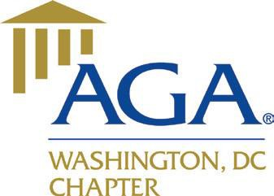

2021 Tournament Online Registration link:
https://secure3.rhq.com/ireg/public/index.cgi?evid=R21-09-15-ASMC

This event is organized by the ASMC/AGA Washington Chapters:
http://www.washington-asmc.org

For event or sponsorship information, please contact:
Conrad Symber (conrad.symber@sehlkeconsulting.com) / 732 397 8925 or
Matthew Hunt (matthew.hunt@sehlkeconsulting.com) / 434 774 7930

