Will Your Retirement Nest Egg Last?
By Austin Pryor | 04/01/12 |
It's the paramount financial question of every retiree: Will my lifetime savings be enough to last through the years ahead? Unfortunately, it's a question not easily answered. Our hope is that this discussion will stimulate you to examine this critical issue while it's still early enough for you to make any necessary adjustments to your saving/investing plan.
After a lifetime of working hard, living simply, saving regularly, and investing wisely, Jack and Sara Rogers arrive at age 65 with their home paid for and $800,000 in their retirement accounts. Financially speaking, most people would be happy to trade places with them. It appears they easily have enough money to get through their senior years. Enough to have a comfortable lifestyle and not have to worry about the bills. Enough to know that their health care needs will be met. Enough to be generous with their children and the Lord's work. They weren't trying to accumulate a fortune; they just wanted their money and their lives to run out at about the same time. You know… just have enough. I suspect you may feel the same way.
As it turns out, $800,000 may not be enough. Usually, retirement planning articles focus on the "accumulation" phase—determining (1) how much you need to save in the decades before retirement, and (2) how best to invest what you save in order to have a sufficient amount on hand when you reach age 65 (or thereabouts). In this article, we're looking at what comes next.
You've retired, and you've got your nest egg. Now it's time to "draw down" and begin tapping your assets to provide the income you need, in lieu of the salary that's no longer available. We'll view Jack and Sara's retirement years through their eyes and come to a better understanding of the financial decisions retirees face. You'll learn of some pitfalls that, if not avoided, can give a false sense of security and wreck your financial future.

Estimating your annual need
The major decision facing the Rogers is this: How much can they safely withdraw from their retirement account each year? The final decision will be a balancing act between their desire to have lifestyle comforts now versus financial security later. Let's walk with them through the process.
First, Jack and Sara need to estimate how much is needed from their account to support their current lifestyle. One of the principal reasons Jack and Sara were able to save $800,000 was they followed a disciplined spending plan and tracked their expenditures for many years. Based on their recent budgets, they know that with the kids grown and the house paid for, they can live comfortably on about $54,000 a year. That doesn't include their 10% tithe, so $6,000 has to be added ($54,000 divided by .9 = $60,000 - $54,000 = $6,000). That brings the new total to $60,000, on which they'll tithe $6,000, leaving them $54,000 cash in hand. Finally, they need to allow for state and federal taxes, which, after deductions and Social Security exemptions, they expect will run approximately 20% of their gross income. This adds another $15,000 ($60,000 divided by .8 = $75,000 - $60,000 = $15,000).
So, their initial guesstimate as to their total income requirement is $75,000 for their first year. That amount will need to be adjusted upward for inflation in future years to protect their purchasing power. Fortunately, their retirement investments don't bear the full burden of producing that much annual income. Their first year, Social Security benefits will total about $19,000, plus Sara will receive pension benefits of $4,000 from a job she once held.

Estimating a "safe" withdrawal amount
So, that leaves $52,000 to be supplied from their retirement account during year number one. Further, they hope to increase that draw-down amount by 3% per year to allow for inflation. Can they do so without running an undue risk of depleting the account during their lifetimes? The calculation is complicated by three factors:
- They don't know how long they'll live. They may need the money to last only a relatively few years, or they may need it to last decades. Life expectancy tables say that a man who reaches age 65 is expected to live 17 more years, a woman 20 more years. But the Rogers can't build their plan around those numbers. They're just averages—half the people die sooner, half later. Which half will the Rogers be in? No way to know.
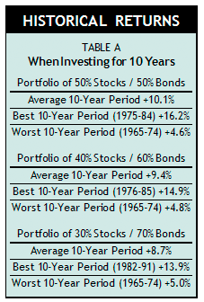
- They don't know the rate of return they'll earn. The Rogers intend to initially invest their portfolio so that 50% of the account is invested in stock funds (divided equally between stocks of large and small companies) and 50% in intermediate-term government bonds. They will maintain that allocation until they reach age 75, at which time they'll lower their risk somewhat by reducing the stock portion to 40% of the portfolio. Finally, at age 85, they'll lower risk again by cutting the stock allocation back to just 30%.
What level of return can the Rogers expect from such allocations? To get a rough idea, I looked at every 10-year period since WWII for each of the three ways of dividing up a portfolio. Table A shows the average 10-year period, best 10-year period, and worst 10-year period for each allocation. A portfolio divided 50/50, for instance, returned 10.1% annually over the average 10-year period. Of course, there were periods that did far better and far worse, and there's no way for the Rogers to know what their experience will be.
- They don't know the sequence of returns. As if the rate-of-return assumption wasn't enough of a shot in the dark, they must also consider another unknowable, but crucially important, factor. This is a subtle point that escapes many investors. When you are regularly adding to an investment account (as in dollar-cost-averaging during your accumulation years) or withdrawing from an account (as you do during retirement), it is of great importance whether you start off the first few years with strong vs. weak results.
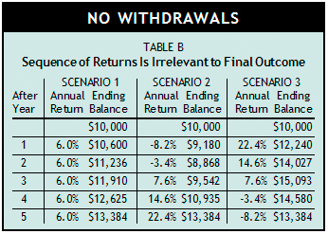
Let me illustrate. In Table B, I compare the growth of three portfolios, each of which grew at the same 6.0% compounded rate over a five-year period. Note that there were no additions or withdrawals at any time. Although the three portfolios grew at different annual paces, they arrived at the same destination. Their final account balances are identical. The sequence of returns made no difference in the end result. This is because there were no additions to or withdrawals being made from the account.
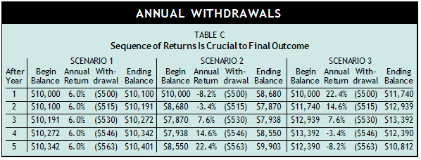
Now look at Table C. Everything is the same except a withdrawal is made from each portfolio at the end of every year. It begins at $500 and increases by 3% (to adjust for inflation) annually. Again I show the same three scenarios, and again the only difference between them is the sequence in which the returns occur. Had an investor known in advance that his investment return would average 6.0% annually, he would expect to have about $10,400 in his account at the end of five years—as indicated by Scenario 1. However, if his experience was that shown in Scenario 2, he would be in for an unpleasant surprise. Even though he did, indeed, average a 6% annual return, nevertheless he's $500 short. So, you see how the sequence in which the returns occur during retirement can alter the ability of a portfolio to sustain a series of annual payouts and continue to build wealth.

The emerging popularity of Monte Carlo simulations
How are these three unknowns dealt with? The life expectancy question is the easiest—just assume you'll live a really long time. Although it seems a shame to forgo current pleasures to make your assets stretch into the distant future, how can you prudently do otherwise? If the money must provide for both spouses, it's best to assume that at least one of you will live into your 90s. To be conservative, the Rogers use age 95 as their fund's projected termination date. Since they are currently 65, this means they have a 30-year time horizon for their investments.
But what average return can they expect to earn on their investments over that 30-year period, and what will the year-by-year numbers look like? To answer this question, financial planners turn to a technique developed by academics called "Monte Carlo" simulations. Monte Carlo analysis recognizes that long-term rates of return may be relatively predictable (e.g., stocks tend to return 10% over time), but the year-to-year results are not. So it makes hundreds (or thousands, depending on the software you use) of projections where the year-to-year returns are randomly changed, but in such a way that the average long-term returns come out right. When the analysis is finished, you're presented with a long list of potential outcomes. By studying the list of outcomes, you can assign a probability to each.
So, using Monte Carlo analysis, the Rogers could put their plan through a series of tests to see how it would perform in various imaginary financial futures. Their plan is to invest $800,000, initially in a 50/50 portfolio as outlined above, and to withdraw $52,000 the first year, increased by 3% each year thereafter. Will it work? Or, to put the question in Monte Carlo terms, if the Rogers lived a thousand lifetimes using this strategy, how many times would it be successful?
That depends—there are many Monte Carlo software simulation programs on the market, and they sometimes arrive at quite different conclusions. That's because the armies of PhDs who developed the software hold different views of how randomness in the markets works. They also have differing assumptions about investment returns. These views and assumptions are hard-wired into the programs. Also, the on-line software I've seen typically assumes you have one portfolio allocation that goes unchanged throughout the entire retirement period; yet, most people typically reduce their stock portion as years go by. So don't be too impressed with the apparent sophistication of the process; it's good to keep in mind that the software is still just guessing. Monte Carlo simulations are not predicting the future. They're merely a good way to evaluate your financial plan under more realistic conditions. They offer a helpful, objective way of comparing likely outcomes and discussing how to adjust your plan to give you an acceptable comfort level. The result is likely to be that you will select a more conservative approach than you otherwise would.

A historical alternative
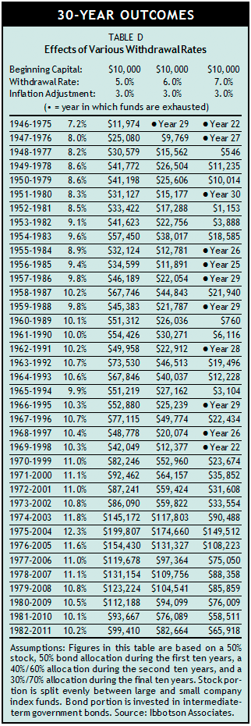
Having said that, I prefer to leave you with a simpler tool. You're welcome to investigate Monte Carlo simulations with a financial planner (or even buy your own software that's been designed for consumers rather than professionals). It will likely be an eye-opening experience that helps you get more serious about a disciplined saving and investing strategy. But until then, I give you Table D.
My thinking in creating Table D went something like this. Monte Carlo does its work by creating new imaginary randomly-generated scenarios. We already have on hand old randomly-generated scenarios. That's what historical performance is. I know the Monte Carlo pros will say the future will be different from the past. And, of course, they're right. But how different? Who's to say that the old patterns, grounded in a wide range of economic realities over a half century, aren't close enough? Table D shows the average annual returns for every 30-year period since WWII assuming an account was invested as the Rogers wish to invest theirs (see Table D assumptions).
It also shows the value after 30 years of investment portfolios that start with $10,000 and experience various withdrawal rates. The $10,000 is not significant; it's the ending value in relation to the $10,000 that's significant. For instance, if the ending value is 8.6 times greater than the beginning value (see 1973-2002 with 5% withdrawal rate), that would be true regardless of the amount in the account at the outset. By the same token, if the account runs out of money before the 30-year period is up (say, in the 22nd year—see 1969-1998 with 7% withdrawal rate), that would have happened even if the account had millions in it to start.
I don't need Monte Carlo software to tell me that the Rogers are likely to be fine using a 5% withdrawal rate with a 3% annual inflation-adjustment. Just look at the third column. In all this time, there's never been a 30-year period when a portfolio invested like the Rogers' even came close to being emptied by such a withdrawal strategy. Does that mean it could never happen? Of course not, any more than a strategy with a Monte Carlo-approved 95% probability is bullet proof—there would still be a 5% chance it wouldn't unfold as hoped. But it comforts me that, at the end of 30 years, the worst case (1946-1975 period) still had more than it started with. In the best case, the account had almost 20 times the capital it began with (1975-2004).
Some might be comfortable with a 6% withdrawal rate. In the worst case, the Rogers' account did not run out of money until the 29th year. It just barely missed lasting the full three decades.
However, and this is a big factor, we must consider that while the stock market has had its share of bull and bear markets since 1946, the bond market has (for the most part) been in a gigantic once-in-a-lifetime bull market since 1981. Thus, the healthy bond returns during the post-1981 period, which are included (at least to some degree) in a majority of the 30-year periods shown in Table D, have boosted the overall results. I think the bond market is unlikely to treat retirees as well going forward, so I'd be inclined to err on the conservative side and stay with the 5% withdrawal rate.
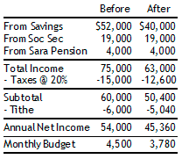
Let's put all this together and see how the Rogers reach a final decision on their withdrawal strategy. Given their key assumptions (30-year time horizon based on expectation that at least one of them will live into their 90s and $800,000 in starting capital invested in a 50/50 portfolio), they would need to withdraw 6.5% initially in order to reach their $52,000 goal ($52,000 divided by $800,000 capital). Based on Table D, they decide that 5% is the most prudent course, at least in the early years. That means they can only take $40,000 out the first year ($800,000 times 5%), not the $52,000 they originally hoped for. Working back through the numbers (table nearby), we find that the Rogers will need to reduce their monthly budget by $720 to make their spending line up with their expected investment income.
Even with all this effort, setbacks are still possible. As we've discussed, you might get off to a very poor start (like the folks who retired in early 2008 just prior to the devastating bear market that accompanied the Great Recession) and need to significantly reduce your withdrawal rate. Also consider—your annual adjustment is based on 3% inflation: what if it's higher? Or, your after-tax income needs are calculated based on current tax law: what if taxes go up? And there's nothing in here for calamitous health care costs, so Medigap and long-term health care policies are a must; are they part of your budget? You can see why it's important to run the numbers annually and make changes as necessary to keep your long-term plan on target. To be effective, this must be an ongoing process.
What about folks entering retirement with needs similar to the Rogers' but whose nest egg isn't quite so hefty? They can use the lessons in Table D to help them make the necessary adjustments. If they have $600,000 in capital, using the 5% rate the Rogers chose would generate just $30,000 per year, not the $52,000 they would like. Even pushing the bounds of prudence and using a 6% rate only gets them up to $36,000. Obviously they are going to need to make some lifestyle adjustments to get their spending down to a level that can be supported by their retirement capital. Once you're at retirement's door, it may be too late to overcome an inadequate nest egg. That's why this kind of planning should be an annual event before retirement. This gives you time to make decisions—such as saving more or working more years—that can increase the amount of capital you have as you enter retirement.

Remember your limitations
With all this emphasis on how to provide sufficiently for your future, I'd be remiss if I didn't close with a reminder that our heavenly Father is our treasure and security. Planning is to be commended and tools can be helpful, but far be it from us to rely primarily on them. Our God has already considered our individual needs, and here is His advice: "If you want favor with both God and man, and a reputation for good judgment and common sense, then trust the Lord completely; don't ever trust yourself. In everything you do, put God first, and he will direct you and crown your efforts with success.… Have two goals: wisdom—that is, knowing and doing right—and common sense.… With them on guard you can sleep without fear…for the Lord is with you; he protects you" (from Proverbs 3, LB).

