Excel Chapter 4
  - Organizing Large Amounts of Data
Name: _______________________________________________________
Class: _______________________________________________________
Date: _______________________________________________________
- Sarah spends a lot of time cutting and pasting titles and headings and adjusting the formatting each month to create a report for her boss; Sarah would be better off creating a template for herself.
  - True
  - False
- Freezing Panes allows you to view four different areas of your worksheet at once.
  - True
  - False
- A filter can be applied to the following list to show only guests whose names start with J to obtain the result shown.
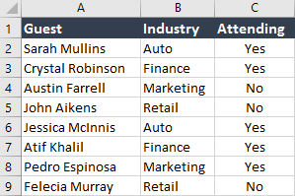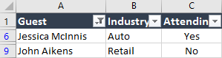
  - True
  - False
- The IF Function is useful in situations in which there are two, three, or four possible outcomes.
  - True
  - False
- Data Validation sets out the criteria for a cell or cells, which limits the possible entries in
that cell.
  - True
  - False
- If you have a large list of employees sorted by department, and you want each department to print on a separate page, you should go to Page Break Preview and insert Page Breaks between the departments.
  - True
  - False
- Once you insert a table, you cannot convert the table back to a range because you will lose all of your data.
  - True
  - False
- What is a character such as a comma, space, or tab that is used to specify a boundary between fields in a data file called?
  - Parameter
  - Delimiter
  - Unlimited
  - Decliner
- Greg imported his data, but it does not look right, as shown here. Greg made the following mistake when importing his data.
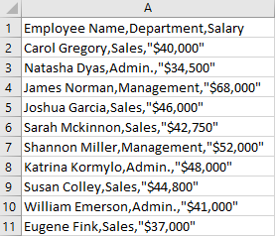
  - He did not import the right file.
  - He did not choose the right cell.
  - He did not choose the right column format.
  - He did not select the correct delimiter, the comma.
- What view allows you to view and edit margins, headers, and footers?
  - Page Layout view
  - Page Break Preview
  - Normal view
  - Print Preview
- The following Guest list was filtered to show Guests who responded Yes to Attending and also sorted by Industry. Which figure shows the correct result?
  - 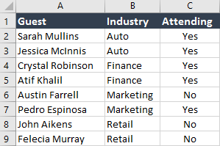
  - 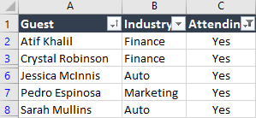
  - 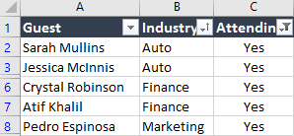
  - 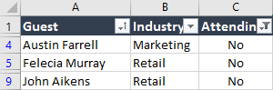

- Jessica wants to determine the amount of raise to give each of her employees. Employees with the company longer than 10 years get a 4% raise, and everyone else gets a smaller raise. If the formula for Sarah was written =IF(D3>10,B3*4%,B3*2%), what would Felecia’s raise be?
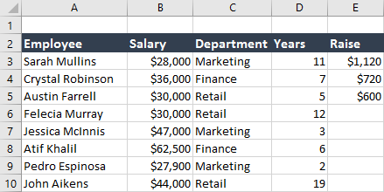
  - $300
  - $3,000
  - $1,000
  - $1,200
- If the following Data Validation rule were created, which value would NOT be an acceptable entry?
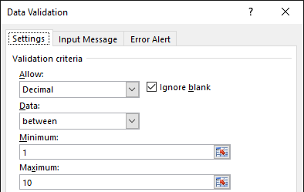
  - 3
  - 7.5
  - 0
  - 10
- If Samantha has a workbook that is four pages long, and she wants to print the headings in row 3 at the top of each page, which feature should she use?
  - Print Titles
  - Print Area
  - Breaks
  - Scale to Fit

