**Everybody in the Pool!**

Our wonderfully refurbished Community Swimming Pool will open for the summer on Friday, May 25, weather permitting.

Weekday pool hours will be 1 to 8 p.m. with Adult Swim set for 5 to 6 p.m. daily. Weekend hours will be 1 to 6 p.m.

Admission will be $3.50 per person. Family season passes are available at City Hall for $75 until May 25, $100 after that.

You also can reserve the swimming pool for a family or business event. Please call City Hall at 515-738-2585 to check on dates and times available.

**RAGBRAI to Roll Through GJ**

Thousands of bicyclists will pedal through town Tuesday morning, July 24, as this year’s Day 3 RAGBRAI route travels from Jefferson to Grand Junction along Old Highway 30 and then north on Highway 144 to Dana. Cyclists will then turn east on County Road E26 and continue to Boone County.

**Grand Junction 150 Seeks Volunteers**

“GJ 150” is the umbrella for planning and developing events and activities to celebrate Grand Junction’s upcoming sesquicentennial in 2019. A steering committee is being formed with Alan Robinson, city council member, as chair. To participate as a committee member or volunteer helper for activities to support GJ 150, contact City Hall at 515-738-2535.

**GJ Receives Grants**

The GJ Fire & Rescue Department and the GJ Public Library each received grants from the Greene County Community Foundation on March 19. A $16,500 grant will equip fire and rescue members with new coats, pants, boots, helmets and gloves. The library received $12,811 to replace flooring and furniture.

The City of Grand Junction’s 2018 grant from Grow Greene County was presented April 3. The city earmarked part of its $34,599 allocation to rehab the small gray building east of the Community Center for use as a storage facility for the center.

***Clean-up Day Set June 2***

Our annual Clean-up Day is set this year for Saturday, June 2. Volunteers will meet at 7 a.m. at the staging area provided by Neese Inc. north of the railroad tracks on 13th Street North to canvass the community.

Please put items to be picked up on the curb **no sooner than** Friday evening, June 1. If you need help removing large items for pickup or need more information about cleanup day, please call the GJ Municipal Utilities at 515-738-2726 or GJ City Hall at 515-738-3525.

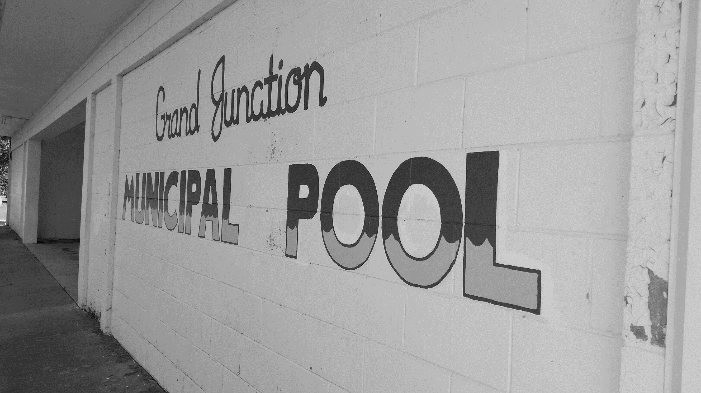

**Did You Remember?**

ATV permits and dog licenses are required by the city Code of Ordinances.

ATV and golf cart permits are only $15 again this year. Please register your vehicle in City Hall before you use it in 2018.

Dog owners must provide a current vaccination record and pay a $5 fee to get a current dog tag. Dogs must wear their tag, and all animals must be secured at all times, either in a fenced yard, tethered out of reach of sidewalks and roadways, or controlled on a leash.