Celebrate 150 Years With Us August 2–4!
GRAND JUNCTION SUMMER 2019 NEWSLETTER
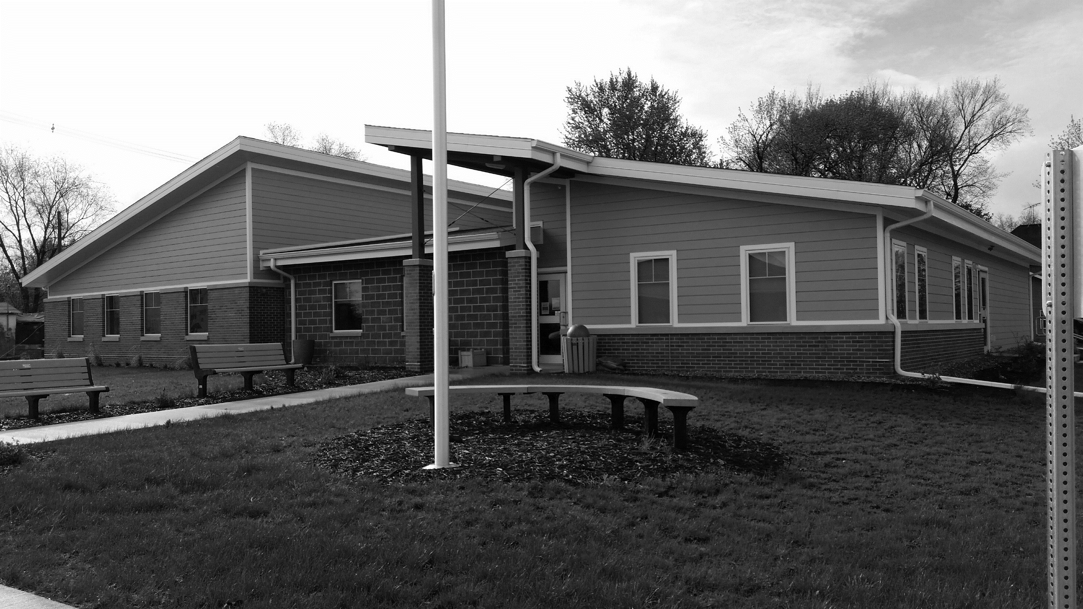
Grand Junction will hold its 150-year anniversary celebration this Aug. 2, 3, and 4 (Friday – Sunday). Plan to come join in the fun!
A full slate of events is planned, from Friday afternoon through Sunday afternoon. Following is the most up-to-date schedule of activities.
A free Greene County Historical Society program on Greene County movie theatres kicks things off at 1 p.m. Friday. The program follows a noon luncheon ($8 for members, $10 for non-members; contact GCHS for lunch tickets by July 31).
The Kennedy and Lincoln Highway museums will be open Friday from 2-5 p.m. and Saturday from noon-5 p.m. Narrated hayride history tours may be offered both Friday and Saturday afternoons.
At 5 p.m. our own “Off the Track” players will present a Readers’ Theatre in the Community Center followed by an ice cream social at 6 p.m.
A beverage garden at Dutton Park (ball field) will open at 5 p.m., and from 7-10:30 p.m. “Through the Darkness,” a Grand Junction-based band, will perform there.
On Saturday the Grand Junction Library will host a breakfast in the Community Center beginning at 8 a.m. At 9 a.m., an open golf tournament will be held at Lakeside National Golf Club; register by July 31. Plus, the annual Lions Club Car Show at City Park runs from 10 a.m. to 3 p.m.

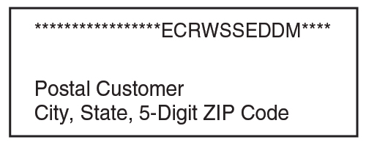
At 10 a.m. we’ll open the Centennial Time Capsule and announce GJ 150 contest results. Our parade begins at 11 a.m. with The Isiserettes dance troupe of Des Moines, which will perform in front of the Community Center after the parade.
From noon to 1 p.m. a box lunch picnic will be available. An Artisan Fair is set for from noon–3 p.m. in the Lincoln Highway Room and vintage quilts will be on display in the Junction Room. The Greene County Singers will perform at 1 p.m. Kids’ face painting and kids’ games will be offered from 1-3 p.m. From noon to 5 p.m. the library will host the Blank Park Zoo.
Kickball and bags tournaments are planned for the afternoon. The beverage garden will reopen at 3 p.m. and the Beef Producers will offer supper from 5-7 p.m. Jamie Kelley, a popular music performer from Boone, will entertain us from 8–11 p.m.
On Sunday, a presentation on Grand Junction’s transportation history will be offered at 1 p.m. in the Community Center. Refreshments will be provided!
Plus, Amusement Associates will have a carnival with a full set of rides and food stands all weekend long. You can buy 20 tickets for $15 in advance from Peoples Bank in Grand Junction until the carnival starts. After that, tickets are $1 each.
Calling All Artisans!
Regardless of the medium you work in – paint, clay, chalk, metal, wood, stone, textiles – you are invited to show and/or sell your handcrafted creations at our Artisan Fair on Saturday, Aug. 3, from noon to 3 p.m. in the Community Center.
There is no booth fee for this fair. Call 515-738-5119 or 738-2608 for information and to reserve your space.
This unique artisan event is sponsored by Horizons as part of the GJ Sesquicentennial Celebration.
Parade Entries Welcome!
Sesquicentennial Contests Will Be Judged Aug. 3
Winners of these contests will be announced before the parade and prizes will be awarded!
Beard Contest: – Enter Aug. 3 to win for
1. Longest
2. Fullest
3. Most Creative
4. People’s Choice for Most Attractive (chosen by audience from among first 3)
Pie Contest: Entries due by 10 a.m. Aug. 2
1 or 2 crust; no cream pies; include your name and type of pie
Trivia Contest:
See attached sheet!
Oldest Resident & Family with Most Generations Still Here:
Send your nomination for these 2 awards to City Hall. These winners will be honored in the parade!
We’re having a parade to help us celebrate our 150th anniversary and you’re invited to join in!
Grab your group, bring your business, corral your club, harness your horse, partner up with your pals and come march down Main Street with us!
Prizes may be awarded for best decorated bikes, fancy floats, snazzy vehicles, and clever costumes.
Call 515-738-2585 to enter today!
Contact City Hall by calling
515-738-2585 or email grandjct@iowatelecom.net.
Office hours are Monday through Friday, 8 to 11 am or by appointment.
www.grandjunctioniowa.org

To receive this newsletter via email, please notify Melody or Barbara in the clerk’s office.
Meet Grand Junction’s New Compliance Officer
Rick Scheuermann has been hired as Compliance Officer for Grand Junction to help make sure we understand and follow our Code of Ordinances.
Code compliance is an important part of maintaining the appearance, functioning, and property values of a neighborhood. The impact that properties have on one another’s value and enjoyment means that maintenance and safety are the business of everyone in the neighborhood.
In addition to code enforcement, Rick will provide information on resources to help with compliance..

