**NOVEMBER AFTERSCHOOL ACTIVITIES SCHEDULE 2020**

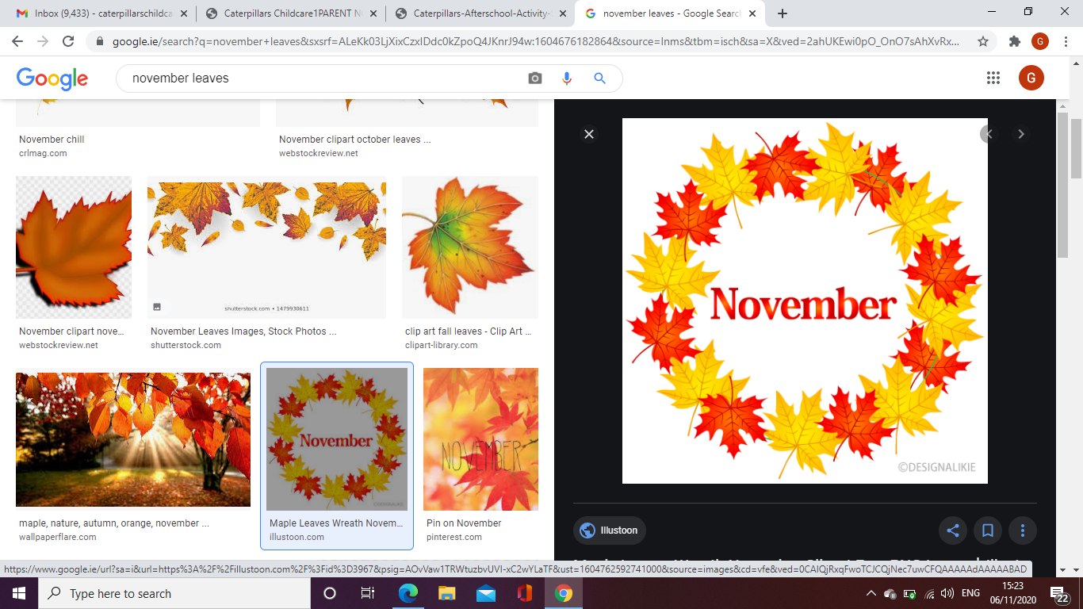

All activities begin after homework is completed, dinner served, and clothes changed.

|  |  |  |  |  |
| --- | --- | --- | --- | --- |
| **2nd**  Card Games | **3rd**  Board Games | **4th**  Bingo & Construction Building | **5th**  Soccer Games | **6th**  Movie & Treats |
| **9th**  Bingo | **10th**  No Bake  Cookies | **11th**  Card Games | **12th**  Science Experiment – Lemon Volcano | **13th**  Technology Day |
| **16th**  Table Quiz | **17th**  Magic Show | **18th**  Bingo | **19th**  Board Games | **20th**  Technology Day |
| **23rd**  Sports Games | **24th**  Thanksgiving arts and crafts | **25th**  No Bake Flapjacks | **26th**  Mystic Meg | **27th**  Technology Day |
| **30th**  Table Quiz |  |  |  |  |