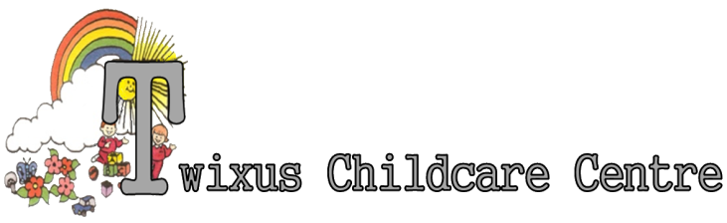
Baby Unit for 0 – 2 year old children
Day Nursery for 2 – 5 year old children
Before and after School Holiday Care for 5 – 16 year old children
Primary School Holiday Care for 5 – 16 year old children

Fire Risk Assessment Policy

Current fire safety legislation for the majority of workplaces in England and Wales requires the responsible person to ensure a Fire Risk Assessment (FRA) has been completed. Where the organisation employs 5 or more persons this assessment must be recorded.

The attached fire risk assessment and action plan takes into account the hazards identified in and around Garland Hill House, an assessment of risk and associated control measures to reduce or eliminate risk from fire within the premises.

This involved the process of looking reflectively at Twixus operation in relation to fire safety, following guidance, at our activities and everything we do within the Twixus operation and in a comprehensive way.

We looked at:

1. Hazards (People/Activity/Physical)
2. Understand what risk if any is posed by the hazards we identified i.e. boxes left by radiators
3. Define the likelihood of risk by the hazard i.e. what is the likelihood of fire breaking out
4. Agreed what needed to be done to reduce or remove the risk that had been identified, through the development of the Fire Safety Action plan at the end of this document.
5. Recorded the significant findings.

By the HAZARD we mean

- People/Activity/Physical we mean an item (ineffective storage of combustible items)
- Article (the combustible item left within range of an ignition resource i.e. radiator/faulty socket)
- Substance (cleaning materials that would feed a small ignition) person (not following the safety procedures within the risk assessment) that, if left, has the potential to cause harm.
- Environment (trip and slip hazards, clear stairs and walkways, adequate lighting)
- By a risk we mean the measure of probability or likelihood of the hazard causing harm by fire.
- We understand that it is not expected in legislation that we will eliminate all risk but within the fire safety legislation we reduce the risk to limit the level of unacceptable risk as far as is reasonably practicable.
- Our nominated persons responsible for carrying out risk assessments are Marilyn Beal/Garrick Beal/Ben Beal.
- Risk assessments are reviewed annually or as legislation requires.

- We have in place all the documentation and procedures to meet the requirements of the risk assessment policy and associated fire safety precautions
- We cascade risk assessment information to all staff
- This risk assessment policy linked to all other policies in relation to fire safety
- We have an annual review although triggers for early review may be in the event of an incident/accident or following the advice from the fire safety team or change in legislation.

Fire Safety Action Plan Risk Identified/Action Required | By Whom | Frequency
As Fire risk is increased during maintenance work, all visitors are monitored and commissioned workers are checked to ensure they are skilled to complete work and any machinery is suitably PAT tested and within date. | Owner | On EACH occasion prior to any on site work being authorised, without this in place NO WORK is authorised.
At the beginning of the working day, it is essential to check that all routes of escape are working adequately and are free form obstruction of any kind, to ensure that fire safety arrangements for employees, members of the public and any contractors remain effective. At the end of the day a check should be made to ensure that all risks of fire have been removed or adequately controlled. | Manager | Daily upon opening and prior to closure
Flammable materials identified during any maintenance work, such as adhesives, cleaning materials or paints should be either removed from the premises or securely stored in a well-ventilated area when not in use and kept separate from other materials. Rooms of storage of such materials shall be ventilated and free from any sources of ignition. Smoking and the use of naked flames are prohibited. | Manager | Daily duty to maintain safe environment
Acceptance and Application of Terms: The Management and Staff at the Twixus Childcare Centre has agreed (by signature) to uphold the legislative terms and working practices of this policy. This policy will be reviewed annually and/or when legislative terms or practical application requires amendments.

