“Summerfest” Set for July 28
GRAND JUNCTION SUMMER 2018 NEWSLETTER
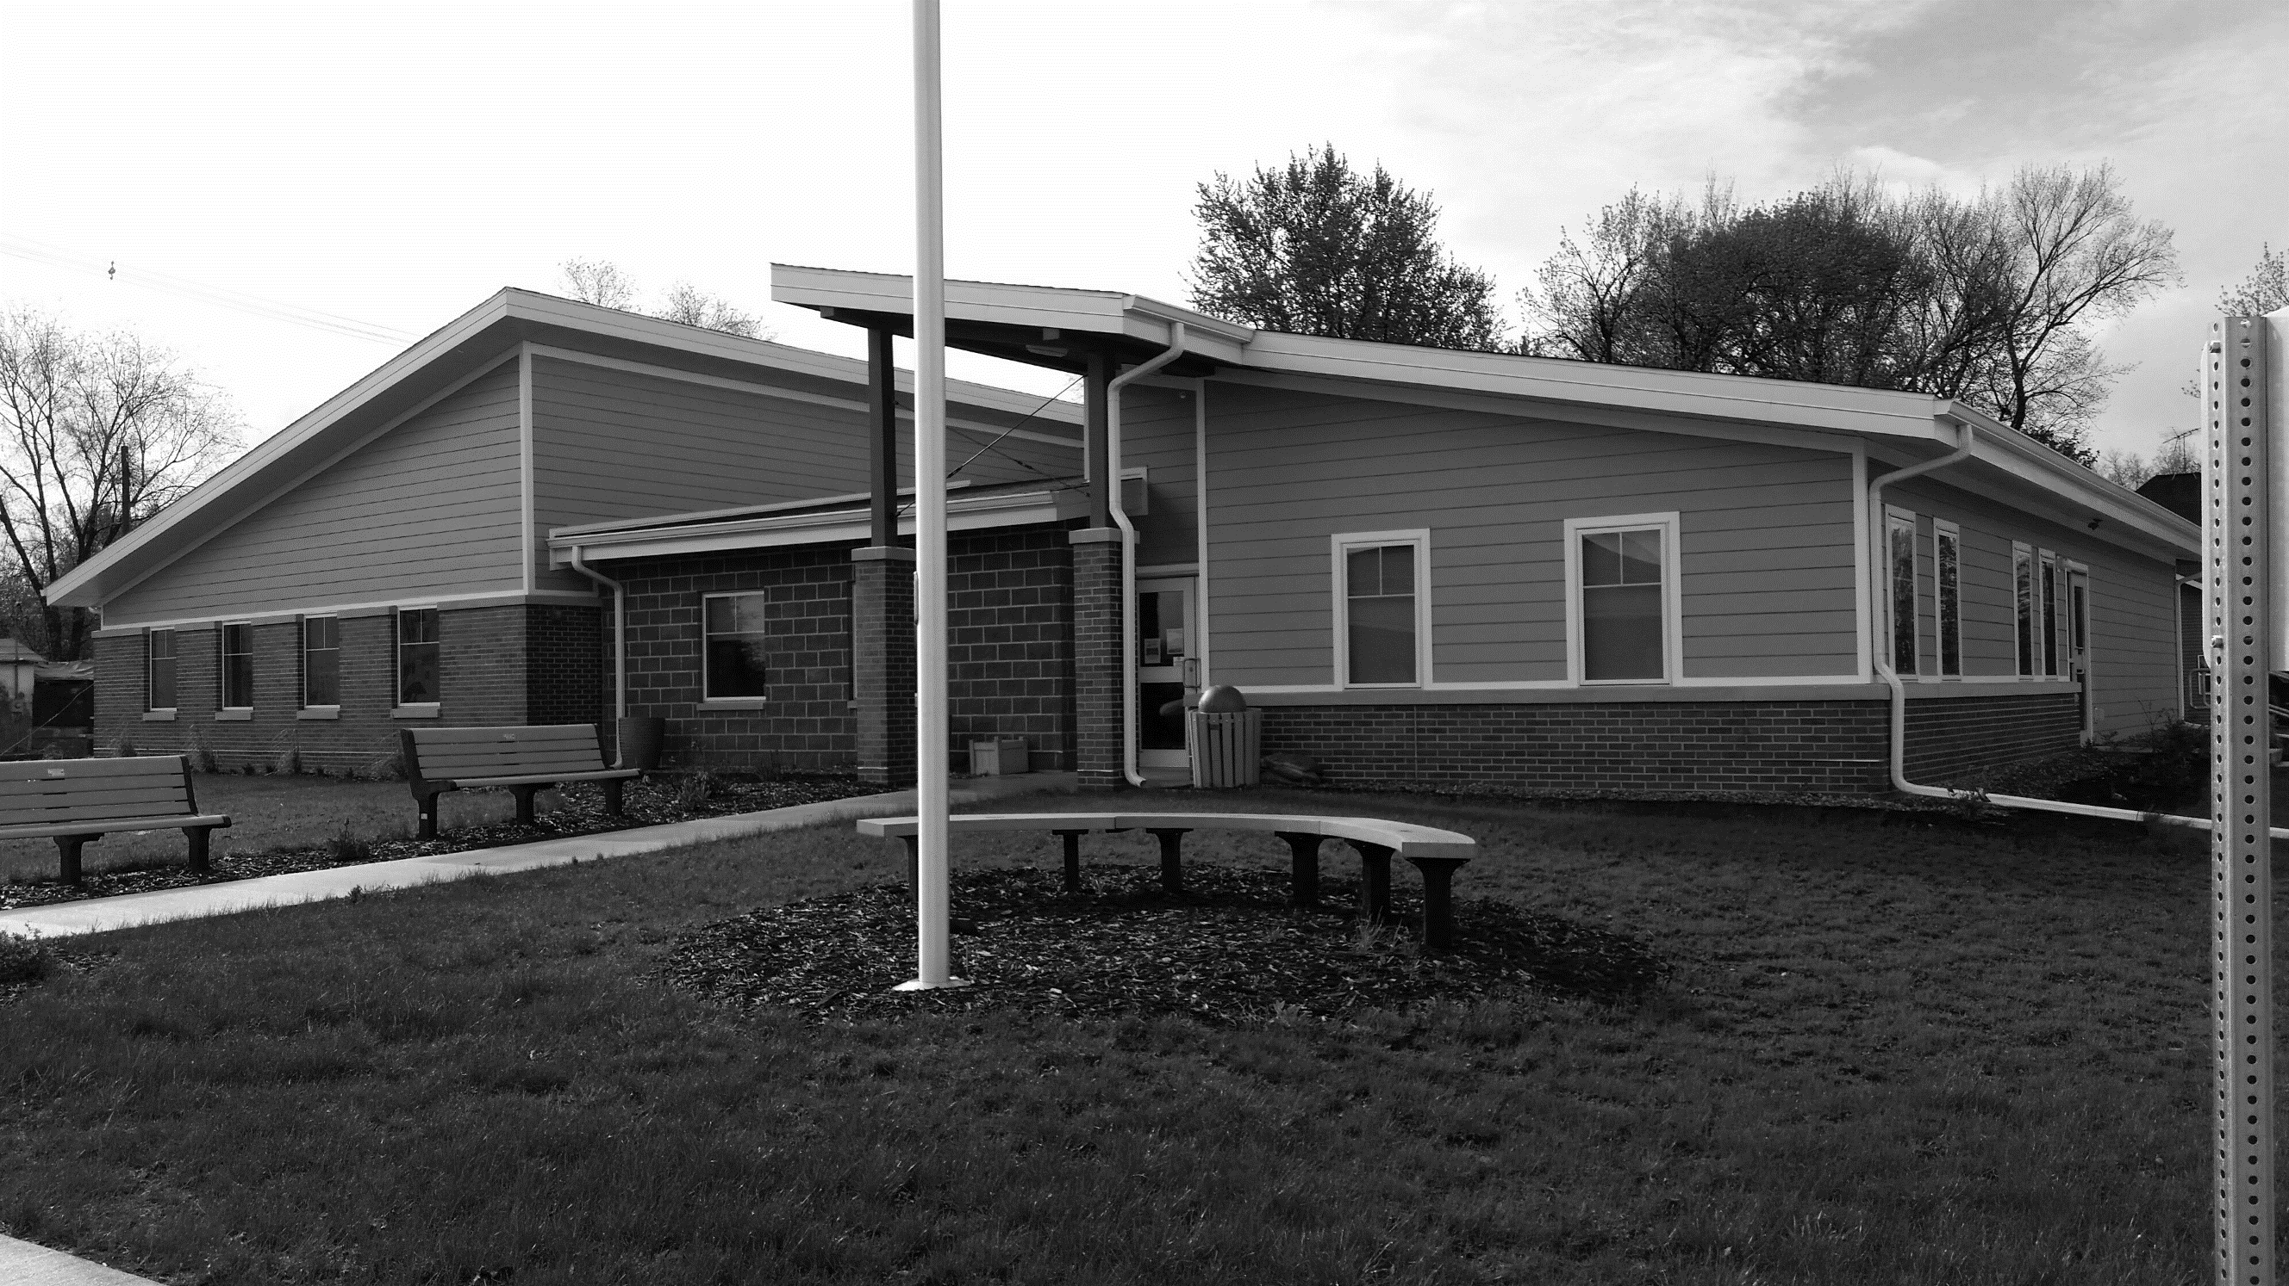
The GJ 150 group planning activities to celebrate Grand Junction’s 150th anniversary in 2019 has organized a festival this summer to get us ready for the events to come.
The “Summerfest” celebration is scheduled for Saturday, July 28. A parade at 11 a.m. will kick off the day. Following the parade, the Greene County Pork Producers will be on hand to provide a meal at the softball field.
The afternoon will feature a kickball tournament. Teams are being formed and are open to anyone aged 8 and older (youth under 18 must play with a parent/guardian). Sign-up sheets are available at City Hall, the library, Peoples Bank, and online and must be turned in by July 13.
Library Gets New Look, Plans Open House
New flooring and furniture have been purchased and installed in the Grand Junction Library, thanks to a Greene County Community Foundation grant. The library invites everyone to an open house – date TBA – for snacks and fun events and to see the new look. While you are there, be sure to check out the books – new ones arrive every month!
Also, a big thank you goes to our local businesses who donated supplies and prizes to our Summer Reading Program: Neese Inc., Dustin Fouch, Hoskinson Tree Service, Rueter’s, Peoples Bank, and Thorpe Auto.

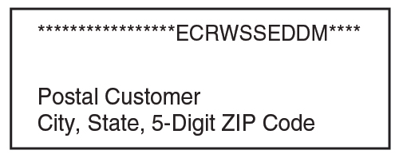
Other activities in the works include a bags tournament, musical entertainment, vendor fair, beer tent, outdoor movie, pool party, and a glow-run through town.
Sign-up sheets for the glow-run are also available at the locations listed previously. Cost to participate in the glow-run is $20 per person and includes a T-shirt.
This event replaces our traditional Lincoln Highway Days this year. To volunteer to help or for more information, contact Alan Robinson at 515-370-5029 or City Hall at 515-738-2535. More details to come!
Fire Department Plans Pancake Breakfast
The GJ Fire Department will have a pancake breakfast on Saturday, July 7, from 6 to 10:30 a.m. in the Community Center.
Cost for the breakfast will be $5 for adults, $3 for ages 5 to 12, and under 5 free. All are invited to come chow down!
Pool Has Busy June
Our pool has seen lots of activity so far this summer! The hot weather has brought in good crowds, and free swimming lessons were offered sponsored by Peoples Bank. Some 30 participants took advantage of the lessons given the week of June 25 to 29. Classes were taught by our own Red Cross-certified lifeguards.
Also, the Beta Tau Delta sorority has donated $300 to our pool. The money will be spent on new lights for the pool. Beta Tau Delta raises funds through various events with all proceeds donated to activities that benefit youngsters in Greene County.
In addition, the family of Jay Herrington has donated two benches to the pool in his memory to mark the 50th anniversary of his work as pool manager and swim coach in 1967. Linda Herrington Ross, Susan Herrington Freeman, and Michael Herrington thank the city for investing in the community by keeping the pool updated and operating.
The pool will close for the summer in late August. Thanks to everyone who has supported the pool this summer!
Hometown Update
Keeping It Clean
Our Clean-up Day was a big success with more volunteers than we’ve had in years. Some 11 loads totaling more than 31 tons went to the landfill. That’s a lot of clean up!
A big “Thanks!” goes to all who helped pick up items left curbside AND to those who took advantage of the day to empty out closets, attics, basements, and garages to help keep our town clean. Let’s keep things looking good for RAGBRAI riders in July!
Fireworks Update
Fireworks are legal and allowed in GJ with a free permit through July 8. Get your permit from City Hall Monday through Friday from 9 a.m. to 1 p.m. Fireworks must end by 10 p.m. except on Wednesday, July 4, when they may be shot off until 11 p.m.
City Hall Closed
The City Hall office will be closed on Wednesday, July 4, in observance of Independence Day. City Hall also will be closed on Monday, July 23, so that the clerks may attend training sessions.
Enjoy the summer, everyone!

Contact City Hall at 515-738-2585 or grandjct@iowatelecom.net.
Office hours are Monday through Friday, 9 am to 1 pm
www.grandjunctioniowa.org

