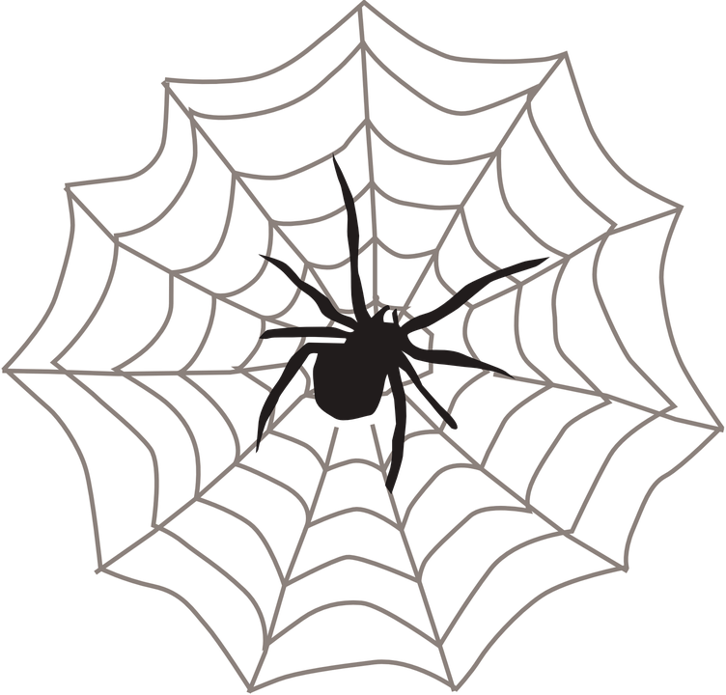
October Half Term
26th October – 2nd November
Friday  26th Oct  Training Day | Monday  29th Oct | Tuesday  30th Oct | Wednesday 31st Oct | Thursday  1st Nov | Friday  2nd Nov
Pumpkin  Picking  *At Orchard Trees Day Nursery | Trip  Please enquire for details  Extra charges apply | Gross Science | Halloween Party  Feel free to dress in your scariest outfits! | Sand Art | Film Fest
The Pavilion, North Duffield Playing Fields, York Road, North Duffield
Prices from £22 per day with long days available 7am-6.30pm
Call 01904 449800 for more details or to book a day

October Half Term
26th October – 2nd November
Friday  26th Oct  Training Day | Monday  29th Oct | Tuesday  30th Oct | Wednesday 31st Oct | Thursday  1st Nov | Friday  2nd Nov
Pumpkin  Picking  *At Orchard Trees Day Nursery | Trip  Please enquire for details  Extra charges apply | Gross Science | Halloween Party  Feel free to dress in your scariest outfits! | Sand Art | Film Fest
The Pavilion, North Duffield Playing Fields, York Road, North Duffield
Prices from £22 per day with long days available 7am-6.30pm
Call 01904 449800 for more details or to book a day

