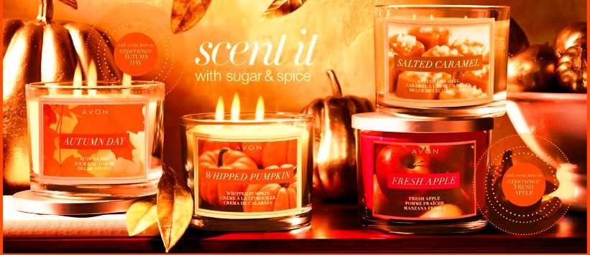

***Fall Candle Party***

***$9.99 Each***

***Burn Time is 30 Hours Per Candle***

***Fill your home with these wonderful fragrances:***

***Autumn Day, Whipped Pumpkin,***

***Salted Caramel and Fresh Apple***