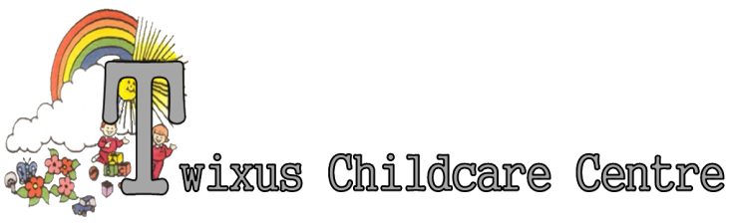
Baby Unit for 0 – 2 year old children
Day Nursery for 2 – 5 year old children
Before and after School Holiday Care for 5 – 16 year old children
Primary School Holiday Care for 5 – 16 year old children

MEDICINE POLICY

MEDICATION

Medicines will only be accepted into the nursery when essential; that is when it would be detrimental to a child’s health if the medicine were not administered during the nursery day. Medicines may only be administered with the prior written consent of the parents.
We accept medicines that have been prescribed by a doctor, dentist, nurse or pharmacist. An emergency nursery supply of fever relief (Calpol) and anti-histamines (Piriton) will be stored on site. Aspirin will not be accepted unless prescribed by a doctor. Non-prescription medicines will be accepted. Individual Health Care Plans will be completed for any medical condition that has been diagnosed by a doctor – requiring medication for more than a short term illness.

Should a child become ill at the setting the Manager, Deputy Manager, Officer in Charge, Deputy Officer in Charge or Senior Nursery Nurse will contact the child’s parents immediately. The Manager or Deputy Manager will notify the Health Protection Agency and all other relevant persons immediately of any suspected outbreak of a notifiable disease.
Parents only need to complete one written permission sheet for the child’s medication (this
applies to long term medication only). Further permission is required if there is a change of prescription or condition of the child.

MEDICAL NEEDS

The nursery need to be informed by the parents about any particular medical needs before a child begins attending, or as soon as the child develops a medical need. A Health Plan will be completed for children with specific medical needs, involving the parents and relevant health professionals.

STORAGE OF MEDICINE

Medicines must always be provided in the original container as dispensed by the pharmacist and include the prescriber’s instruction for administration. Medicine MUST be stored strictly in accordance with product instructions (paying particular note to temperature) and in the original container in which dispensed. Medicine MUST be
stored in the medicine box in the kitchen or if the medicine requires refrigeration MUST be stored in a locked, labelled container in a fridge. Staff will ensure that the supplied container is clearly labelled with the name of the child’s name and dose of the medicine and the frequency of administration. Where a child needs two or more prescribed medicines each MUST be in a separate container.

Emergency non prescribed medications provided by Twixus Child Care will be stored in the First Aid box located in the Kitchen. Non-prescribed medication that requires refrigeration MUST be stored in the container in a fridge. Staff MUST ensure that the supplied container is clearly labelled with the child’s name.

All emergency medicines, such as asthma inhalers and Epi-pens will be stored with the child’s name visible. This container will be inaccessible to children, but in a location that is known and visible to staff.

WHO MAY ADMINISTER

Where written consent has been provided only the Officer in Charge and the Deputy Officer in Charge or Senior Nursery Nurse may administer the medicine in accordance with the Parental instructions. Witnesses to administering medicine must be a Level 3 or above. If there are any issues or discrepancies with the medicine or dosage required please refer to the Office prior to administration.
In circumstances where a child has complex medical needs the authorised person may be a person who has been appointed as the keyworker for that child.
An approved staff member MUST ensure that a second senior staff member is present as a witness during the administration of medicines. This staff member should also sign the Medicine Form.(Appendix 1). The Medicine Form (Appendix 1) MUST be completed and parents MUST sign the Medicine Form at the end of their session to acknowledge that medicines have been administered

ADMINISTRATION
Prior to administering any medicine the approved staff member MUST check the following
against the container and the Medicine Form
- Name of child
- Name of medicine
- Dose
- Method of administration
- Time/frequency of administration
- Side effects
- Prescription date (prescribed medication)
- Expiry date

For non-prescribed medicines the frequency and dose will be strictly limited to the
manufacturers instructions as per labelling on the container.

Approved staff MUST wash their hands prior to administering medicines.

Only staff who have been medically trained can administer medicines such as Epi-pens which MUST be given in accordance with the child’s individual Health Plan. This training MUST be attended prior to the child attending the setting.

MEDICINE FORM

A medicine form must be completed to show the date, time, name of medicine and the amount administered, who administered it and who witnessed the administration. This must be recorded at the time of the administration of the medication. When the child is collected the parent / carer must sign the medicine form to tell them when and how much medicine the child has been given during the day. The medicine must be returned to the parent at the end of each day unless specifically provided for Nursery use. The setting will request written confirmation to retain the medicine at the Setting. (ie Asthma Pumps)

KEEPING A CHILD OFF / NOT GIVING MEDICATION

If a parent signs in non-prescribed medication and at the designated time for administration there is no evident health reason for the child to receive the medication the Manager (Deputy Manager in their absence) may reserve the right to not allow the administration of the medication but MUST inform the parent of this decision immediately e.g. Calpol would not be administered to a child with no signs or symptoms of fever or pain unless advised otherwise by a medical professional.

Children who are taking antibiotics should be admitted to nursery for the first 24 hours of the course treatments. The first full dose of any medicine MUST be given to the child at home e.g. if antibiotics are to be administered three times a day then these three doses MUST be given before the child returns to nursery. If a child is taking antibiotic eye drops they may return to nursery after the first administration of drops.

The administration of non-prescribed medication for pain or fever relief MUST be restricted to 2 consecutive days. If symptoms persist beyond 2 days duration then parents should consult a doctor and the child may be excluded from nursery.
For longer term inflammatory conditions, requiring regular treatment, a doctor’s letter advising the regular use of a non-prescribed medication, beyond 2 days will be required.
If a child refuses to take medicine staff MUST not force them to do so but MUST note this on the Medicine. Parents MUST be informed of the refusal immediately for
prescribed medications.

HIGH TEMPERATURE
If a child develops a high temperature (normal temperature usually ranges between 36.5 to 37.5 degrees Celsius) they MUST be monitored. To record a temperature the average of three temperature readings MUST be taken. During this period of initial monitoring a member of staff MUST attempt to cool the child by:-
1. Giving the child a cool drink of water
2. Removing all clothing except for the child’s vest/T-shirt and undergarments.
3. Using a warm flannel to sponge bath the child
4. Refrain from cuddling the child too closely
5. If a child has recently woken from sleep and appears feverish their temperature monitoring should commence 15 minutes after the child has been fully awake.

If after 30 minutes the child has maintained a high temperature of 38 degrees Celsius or above and the parent did not sign in any fever relief in the morning the Manager, or in their absence the Assistant Manager, MUST contact the child’s parents and :-
1. Inform the parent of their child’s temperature
2. Ask the parents if they have administered any fever relief prior to the child arriving in
nursery that day.
3. If the parent has not administered any fever relief before nursery or if four hours have passed since the last dose then ask the parent for verbal consent to administer Calpol from the emergency nursery supply. The fever relief should be administered as directed on the manufacturer's dosage guidance.
4. If the parents are not contactable and the child has been in nursery for four hours or
more then the Manager, or in their absence the Deputy Manager, can authorise the authorised person to administer fever relief. The fever relief should be administered as directed on the manufacturers dosage guidance.
5. The parents must be asked to collect their child

If a child's temperature reaches the following a parent must be called to collect the child. If this is not possible an ambulance must be called.

3-6 month old baby: 39 degrees
Baby/child over 6 months old: 40 degrees

ANAPHYLAXIS
If the child shows any signs of anaphylaxis an ambulance MUST be called immediately and a qualified first aider MUST administer first aid.

Signs and symptoms of anaphylaxis include:-
Swollen eyes, lips, genitals, hands, feet and other areas
Itching
Changes in heart rate
Unconsciousness
Vomiting or diarrhoea
Nausea and fever.
Refusing Medication

In the event of a child having an allergic reaction to medication or a staff member
administering the wrong medicine to a child the following procedures MUST be followed:
• Immediately notify the most senior member of staff on duty.
• The child MUST remain supervised at all times. The emergency procedures on the
child’s Health Plan (where there is one in place) MUST be followed.
• Seek medical advice.
• Contact the parents.

STAFF MEDICATION

Staff who are taking any medication MUST inform the Manager of the medication and the
procedures for administration. Staff who require regular medication or have complex medical needs MUST complete a Health Plan, a copy of which should be kept in their personnel file and knowledge of this will be passed to the Officer in Charge and Deputy Officer in Charge of the room. The plan will include emergency procedures and the name and contact number of a next of kin. Where staff are taking medication which they believe may affect their ability to care for children, they MUST seek medical advice, and only work directly with the children if the advice is, that the medication is unlikely to impair their ability to look after the children. Arrangements for storing staff medications are the same as for children’s medications.

Acceptance and Application of Terms: The Management and Staff at the Twixus Childcare Centre has agreed (by signature) to uphold the legislative terms and working practices of this policy. This policy will be reviewed annually and/or when legislative terms or practical application requires amendments.

Appendix 1
Individual Health Care Plan
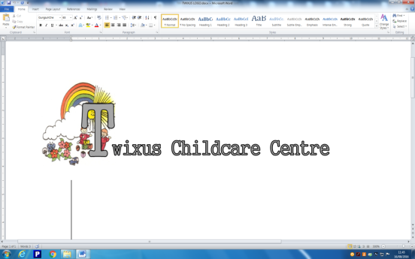
Name of Child:
Date of Birth:
Medical Diagnosis or Condition:
Describe Medical Needs and Details of Child’s Symptoms:
Describe Any Possible Causes/ Triggers
Daily Care Requirements: (e.g. before sport, at lunch time)
Describe what constitutes as an emergency for the child and the action to take if this happens:
Medication
Name of medication
Dosage
When to administer
Special Instructions (storage, training etc.)

Consent and Agreement - Signed by Parent:
I agree to the staff of Twixus Childcare Centre taking responsibility and administering prescribed medication as shown above, as required, either on a regular basis or in the event of a medical incident/emergency.
I understand that it is my responsibility as a parent to supply the necessary prescribed medication and to ensure that supplies are adequate in quantity and do not exceed the expiry date shown. Medication should be supplied in its original packaging, with the pharmacy label showing child’s name and dosage still attached
Parent Signature
Print Name
Date
*This Individual Health Care plan is to be introduced at every induction and reviewed at each Key Person/Parent meeting, whenever the child progresses to a new department or whenever changes occur (i.e. medication/condition etc.).
Appendix 2 – Daily Medical Forms
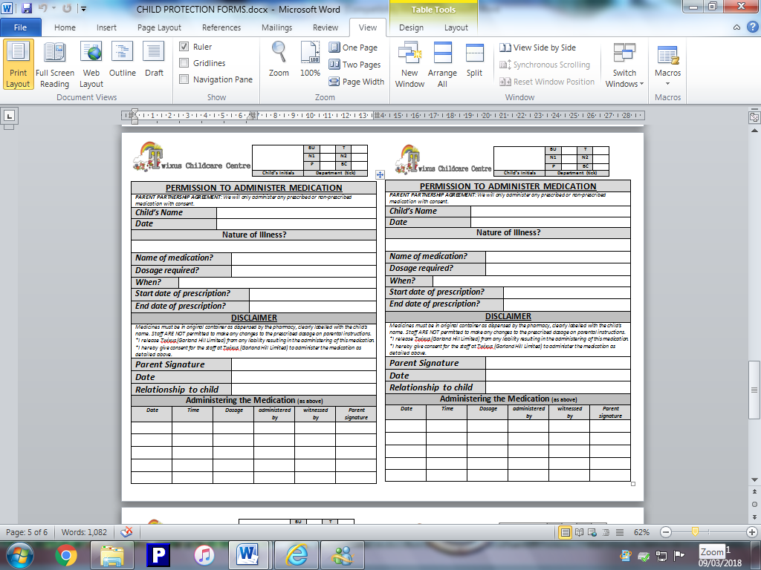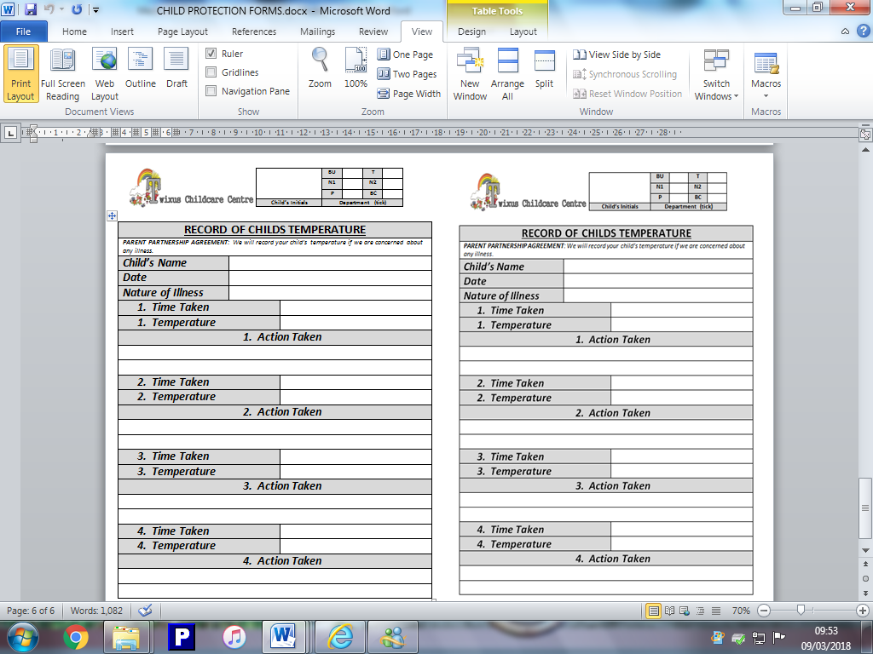
Appendix 3 – Medical Checks
Approved Non-prescribed Medicines List
Creams
E45
Aqueous Cream
Oilatum
Diprobase
Sudocrem
Drapolene
Vaseline
Any over the counter barrier or moisturising creams
Temperature Control
Calpol
Own Brand
Nurofen or other Ibuprofen
Mild Allergies
Piriton
Teething Gels
Calgel
Parsons and Johnsons
(Teething Powder)
Bonjela Teething Gel
Digestive aids
Gripe Water
Infacol
Eye drops
Any over the counter eye drops
for minor inflammations &
infections
Saline drops for children aged
2 years & over
Non-prescribed aspirin MUST NEVER be authorised for administration within the nursery
List of Notifiable Diseases  Diseases notifiable (to Local Authority Proper Officers) under the Health Protection (Notification)  Regulations 2010:  • Acute encephalitis  • Acute meningitis  • Acute poliomyelitis  • Acute infectious hepatitis  • Anthrax  • Botulism  • Brucellosis  • Cholera  • Diphtheria  • Enteric fever (typhoid or paratyphoid fever)  • Food poisoning  • Haemolytic uraemic syndrome (HUS)  • Infectious bloody diarrhoea  • Invasive group A streptococcal disease and scarlet fever  • Legionnaires’ Disease | • Leprosy  • Malaria  • Measles  • Meningococcal septicaemia  • Mumps  • Plague  • Rabies  • Rubella  • SARS  • Smallpox  • Tetanus  • Tuberculosis  • Typhus  • Viral haemorrhagic fever (VHF)  • Whooping cough  • Yellow fever

Appendix 2 – Twixus Parent Medical Information Publication

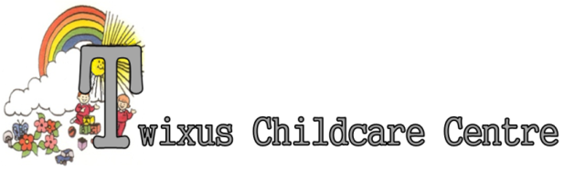

Common Childhood Illnesses
We can only give you a brief introduction to some common health problems that children often experience when they start going to nursery and school. Please ask a member of staff about any health concerns you may have regarding your children at the nursery.
If there is an outbreak of any infectious illness there will be information posted on the Parent's Noticeboard within the Nursery.

Basic management of any acute infection:
- Do not attend nursery or school
- Inform Nursery or School so that they can alert other parents
- Keep child comfortable, warm and well hydrated
- Use tepid sponging, change of clothes and appropriate medicine to keep child's temperature normal.
- Follow guidelines for specific infectious illness
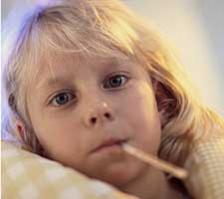
- Contact GP if you are concerned
- Avoid re-infection or cross infections by keeping basic hygiene standards high.
  - Wash hands.
  - Take care to remove and wash infected clothing, towels, sheets immediately
  - Clean sinks, toilets and door handles frequently.

Chickenpox
Chickenpox is caused by a virus called the varicella-zoster virus (varicella is the medical name for chickenpox).
Chickenpox is a mild, but highly infectious disease that most children catch at some point. It is most common to catch the disease between March and May. It takes 10-21 days for the symptoms to show after you have come into contact with the virus. This is called the 'incubation period'. Chickenpox spreads in tiny droplets of saliva and nasal mucus, by sneezes and coughs from an infected person. The virus is already in these droplets, which is why it spreads so fast.
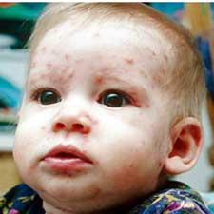
Chickenpox is most common in children who are between 2-8 years of age, although you can develop chickenpox at any age.You are infectious from about two days before the rash appears until roughly five days after. Therefore, you, or your child, should stay at home until all of the blisters have fully crusted over, and this usually happens 5-7 days after the first blister appears.
Exclusion: Until the last blister has burst and crusted over.
Very important !
Please keep infected or potentially infected children away from elderly, immuno-suppressed or pregnant people. These people are vulnerable to 'shingles' caused by the virus herpes zoster, and should contact their GP immediately if they contract the virus.

Conjunctivitis
Conjunctivitis is most commonly caused by infection. Almost any germ, whether a bacterium or a virus, may be responsible. The common cold may cause conjunctivitis, spreading from your mouth and nose to your eyes. Conjunctivitis caused by the common cold is very infectious and can spread rapidly between people.
The most common cause of allergic conjunctivitis is hypersensitivity to pollen (hay fever). The pollen irritates the eye and can cause the conjunctiva to swell. Occasionally this can lead to extreme swelling and bulging of the eye membrane.
Symptoms may include:
- Reddening of the affected eye - this happens as a result of the irritation and widening of the tiny blood vessels in your conjunctiva,
- watering eyes - the conjunctiva contains thousands of cells that produce mucus and tiny glands that produce tears. Irritation causes these to become overactive, so they water and leak mucus,
- scratchy, gritty feeling in the eyes,
- swollen eyelids,
- sticky feeling - it may be hard to open your eyes in the mornings,
- slight soreness
Although not all 'sticky eyes' fit with the clinical definition of conjunctivitis Nurseries are advised by NHS Grampian to follow the Guildelines for Exclusion for conjunctivitis. If a child has sticky eyes they should be examined by their GP resulting in either:
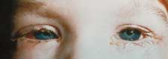
1. The GP considering medication is not required – Accordingly the child should stay away from Nursery until the symptoms have settled.
2. The GP prescribing an antibiotic. The child may return after 24 hours of treatment.
Exclusion : until symptoms settle or treated with topical antibiotic for 24 hours.

Diarrhoea and Vomiting

Symptoms can range from slightly watery stools and a brief upset tummy, to longer-term extremely watery stools and cramp.
Common symptoms include:
- Crampy tummy pains
- Nausea or vomiting
- Fever
- Headache
- Loss of appetite
Many organisms can cause diarrhoea (with or without vomiting). However viruses commonly circulate in the community and can cause acute onset diarrhoeal illnesses. Although diarrhoeal illnesses caused by viruses are usually short lived unfortunately individuals may continue to excrete the virus n their respiratory secretions for at least 48 hours after the symptoms settle and they are well.
The NHS Grampian guidelines advise that children who have an acute onset diarrhoeal illness lastng for more than a couple of days should be seen by their GP and a sample of stool tested for a bacterial infection.
It is unusual for a child to develop an acute onset vomiting illness that is not infectious. Accordingly any child with and acute onset vomiting illness will be sent home and excluded from Nursery.
Exclusion: until 48 hours after symptoms have settled.

Ear infections
Inner ear infections are often caused by the common cold, which spreads through the tube that connects your ears and nose (the Eustachian tube). They can also be caused by common childhood illnesses such as measles.
The signs and symptoms of acute otitis media (middle ear infection) may range from very mild to severe:
- The fluid in the middle ear may push on the eardrum, causing ear pain. An older child may complain of an earache, but a younger child may tug at the ear or simply act irritable and cry more than usual.
- Lying down, chewing, and sucking can also cause painful pressure changes in the middle ear, so a child may eat less than normal or have trouble sleeping.
- If the pressure from the fluid buildup is high enough, it can cause the eardrum to rupture, resulting in drainage of fluid from the ear. This releases the pressure behind the eardrum, usually bringing relief from the pain.
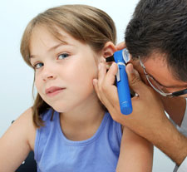
Fluid buildup in the middle ear also blocks sound, which can lead to temporary hearing difficulties . A child may:
- not respond to soft sounds
- turn up the television or radio
- talk louder
- appear to be inattentive at school
Other symptoms of acute otitis media can include:
- fever
- nausea
- vomiting
- dizziness
Exclusion: until symptoms subside.

Hand, foot and mouth disease
This illness is caused by the Coxsackie Virus and usually presents with sudden onset of sore throat, fever and greyish lesions on the mouth, fingers, palms and soles of feet and occaisionally the genitals.
The incubation period is 3-6days and the symptoms usually last a few days, up to 1 week.
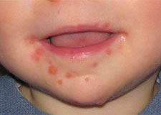
Treatment is general management of infectious illness.
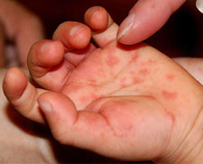
Exclusion: until child is well enough to attend nursery.
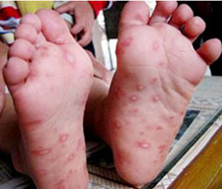

Head Lice
Always be open if your child or someone you know has been infested with Head lice.
We want children to know that Head lice infestation is a normal part of school life. There is no shame and there should be no secrets.
Remember, as adults how we handle these situations paints your child’s view of the world.
A more detailed information sheet is available in Nursery.
Facts about Head lice
Head lice are small 6 legged wingless insects that live in the hair close to the scalp where it is warm and easy for them to feed.They are pin-headed size when they hatch, less than match-headsize when fully grown and difficult to see in the hair. The eggs are glued individually to hairs near the scalp. Unhatched eggs are dull in colour and hard to see, but after the lice have hatched the empty egg sacs –called nits- are white and easier to see. Many people mistake the empty egg sacs or nits for head lice when they are actually evidence of a previous infestation of head lice..
Head lice infestation is common. Anyone with hair can get them, but children, tend to get them more as they put their heads together often.

Detection
Head lice cannot be prevented but regular checking and brushing of hair ensure that any present in the hair are detected and can be treated.
The best method of detection is wet combing.
Children’s hair should be checked weekly during hair washing.
Wet combing: You will need, shampoo, conditioner, normal comb and fine tooth comb.
Treatment
There are two methods of treatment: Insecticide or Bug Busting
Discuss with Doctor, Nurse or Pharmacist.
All children receive free treatment and the Pharmacist can advise on best method for your child.
Always tell the Nursery Staff if your child h as been in contact with anyone infested with Head Lice.

Influenza
Influenza, commonly known as "the flu," is a highly contagious viral infection of the respiratory tract. Although the flu affects both sexes and all age groups, kids tend to get it more often than adults. The illness even has its own season — from November to April, with most cases occurring between late December and early March. The flu is often confused with the common cold, but flu symptoms are usually more severe than the typical sneezing and stuffiness of a cold.
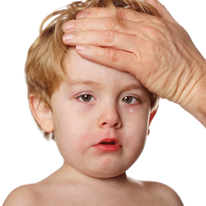
Symptoms of the flu may include:
- fever
- chills
- headache
- muscle aches
- dizziness
- loss of appetite
- tiredness
- cough
- sore throat
- runny nose
- nausea or vomiting
- weakness
- ear pain
- diarrhoea
Spread by virus-infected droplets that are coughed or sneezed into the air, the flu is contagious. People infected with the flu are contagious from a day before they feel sick until their symptoms have resolved (usually about 1 week for adults, but can be up to 2 weeks for young kids).

Impetigo
Impetigo is a highly contagious bacterial infection of the skin, most common in children, normally occurring between the ages of two and four. The rash typically appears 4-10 days after you have been infected with the bacteria. Small blisters develop at first. You may not see the blisters as they usually burst to leave scabby patches on the skin. Sometimes only one or two patches develop. They often look like moist, golden crusts stuck on to the skin. An area of redness (inflammation) may develop under each patch. Sometimes affected skin is just red and inflamed - especially if the 'crust' is picked or scratched off.
The face is the most common area affected but impetigo can occur on any part of the skin. Patches of impetigo vary in size, but are usually quite small - a centimeter or so to begin with. Smaller 'satellite' patches may develop around an existing patch and spread outwards.
Impetigo will normally resolve without the need for treatment within two to three weeks. Antibiotic creams are normally used to treat the infection, to minimise the risk of the condition spreading.
Impetigo is normally not serious, though it is important to take precautions to avoid spreading it to other people, especially newborn babies. These include carefully washing hands after touching the affected areas of skin and not sharing towels or bed linen.
Most people will no longer be contagious after 48 hours of antibiotic treatment or once their sores have dried up and healed.
Exclusion : until 48 hours of antibiotic treatment or once their sores have dried up and healed.
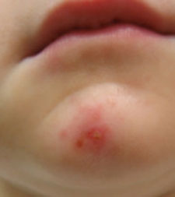

Slapped Cheek disease
Slapped cheek syndrome is a virus that only affects humans. It is also known as Erythema Infectiosum or Fifth disease , because it is the fifth most common disease caused by a rash in children. Slapped cheek syndrome is caused by a virus called parvovirus B19.
The symptoms of slapped cheek syndrome can vary from a minor illness, possibly with headache, mild fever and sore throat, to erythema infectiosum, which produces a typical rash that appears on the cheeks, hence its name 'slapped cheek'.
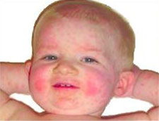
It is thought that 60% of all adults in the UK have been infected with parvovirus B19 at some point. It usually affects people when they are children, between the ages of 4-12 years old. An increase in the number of infections occurs every 3-4 years, usually in schoolchildren.
Once you have had the infection, it is likely you will be immune to the virus.
Exclusion: until child well enough to attend nursery or school.

Threadworms
Also known as pinworms, they are tiny parasitic worms that hatch eggs in and infect the large intestine of humans. They are the most common type of worm infection in the UK, and they are particularly common in young children, infecting up to half of all children under the age of 10. Threadworms are white and look like a small piece of thread. You may notice them around your child's bottom or in your or your child's stools (poo).
You can treat threadworms yourself with medication available at pharmacies. However, treatment does not kill the eggs hatched by threadworms. Good hygiene is the only way to prevent the eggs from spreading and causing further infection.
See your GP if you think that you or your child has threadworms and:
- You're pregnant or breastfeeding.
- Your child who has threadworms is under the age of two.

How are threadworms spread?
Threadworms are spread from person-to-person as a result of poor hygiene. If one member of a household is infected, there is a high risk that other members will also be infected.It is therefore necessary to treat the entire household and to practise particularly thorough hygiene for six weeks (this is how long the worms live) to prevent re-infection.
Threadworms can be prevented from occurring by always maintaining good hygiene. Children should wash their hands regularly, particularly after going to the toilet and before mealtimes. Encouraging your children not to scratch the affected area around their anus will help prevent re-infection and help to avoid a skin infection.
As itching is worse at night, wearing cotton gloves while sleeping may help.
My child has threadworms – should they be allowed to go to Nursery?
A threadworm infection should be treated as soon as it's identified, but the Health Protection Agency advises that it is not necessary to stay off work or school.
At Nursery we follow good hygiene practices to limit the spread of infection. These will include:
- cleaning toys and equipment
- encouraging children to wash their hands regularly

Urinary Tract infections
Signs and symptoms of UTIs vary depending on the child's age and on which part of the urinary tract is infected. In younger children and infants, the symptoms may be very general. The child may seem irritable, begin to feed poorly, or vomit. Sometimes the only symptom is a fever that seems to appear for no reason and doesn't go away.
In older kids and adults, symptoms can reveal which part of the urinary tract is infected. In a bladder infection, the child may have:
- pain, burning, stinging sensation when urinating
- an increased urge to urinate or frequent urination (though a very small amount of urine may actually be produced)
- fever (though this is not always present)
- frequent night waking to go to the bathroom
- wetting problems, even though the child is toilet taught
- low back pain or abdominal pain in the area of the bladder (generally below the navel)
- foul-smelling urine that may look cloudy or contain blood
Many of these symptoms are also seen in a kidney infection, but the child often appears more ill and there is more likely to be fever with shaking chills, pain in the side or back, severe fatigue, or vomiting.

Acceptance and Application of Terms: The Management and Staff at the Twixus Childcare Centre has agreed (by signature) to uphold the legislative terms and working practices of this policy. This policy will be reviewed annually and/or when legislative terms or practical application requires amendments.

