Excel Chapter 4
  - Organizing Large Amounts of Data
Name: _______________________________________________________
Class: _______________________________________________________
Date: _______________________________________________________

Start a Workbook from a Template
- A template is a previously saved file that has existing data in it. You must remove the old data before you can use the new.
  - True
  - False
- There are a few hundred templates available online.
- True
- False
- Roger has finished creating a template he plans to use for his monthly sales figures, and he wants to name it Monthly Sales. He’s opened the Save As window and is ready to save. Consider this image. If Roger clicks Save, will his template be saved properly? If not, what is he missing?
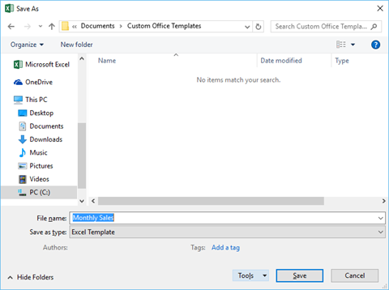
  - No. Roger needs to change the selection under Save as Type.
  - Yes.
  - No. Roger needs to change the save location.
  - No. Roger needs to change the entry for File Name.
- In the image shown, identify the different parts of the Excel starting screen.
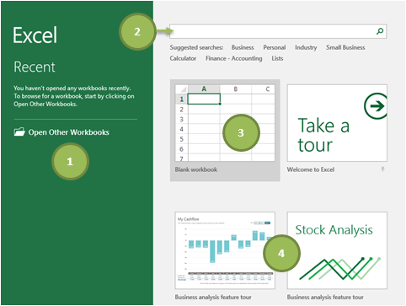
A. | Open a new Blank Workbook
B. | Open an existing workbook
C. | Search for online templates
D. | Open a new workbook based on a template from the starting screen

Import and Export Data
- The comma separated value, or CSV, format is one of the most commonly understood file types across a variety of programs.
- True
- False
- The user has no control over formatting when importing a delimited file.
- True
- False
- Any character used to specify a boundary between separate regions is called a what?
- A comma
- A separator
- A splitter
- A delimiter
- A field

- Consider the image shown. Which character is being used as a delimiter?
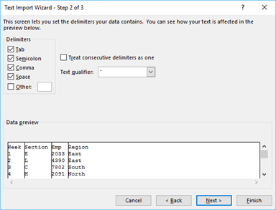
- Tab
- Semicolon
- Comma
- Space
- Any of these options are possibilities

Change Worksheet View Options
- Page Layout view helps the user see how the spreadsheet will look when printed.
  - True
  - False
- Page Layout view is not compatible with Freeze Panes.
- True
- False
- Ted is working with a large worksheet, and he’s constantly scrolling to the top and bottom to find information. He’d like to be able to see part of his worksheet at the top of his screen and another part at the bottom and still be able to scroll within both. Which tool should Ted use, and which cell should he select before using it?
- He should select a cell in column D and use the Split tool .
- He should select cell B2 and use the Freeze Panes tool.
- He should select a cell in column A and use the Split tool.
- He should select cell A1 and use the Freeze Panes tool.
- Which of the following images is a spreadsheet with Freeze Panes applied?

- 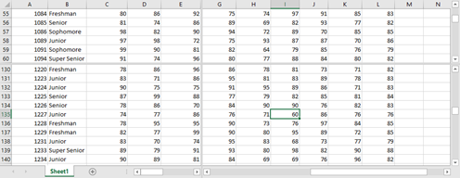
- 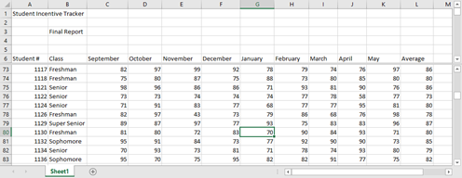
- 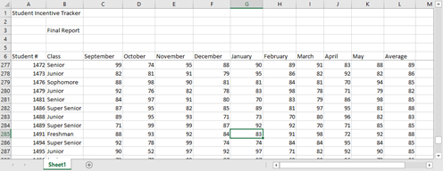
- 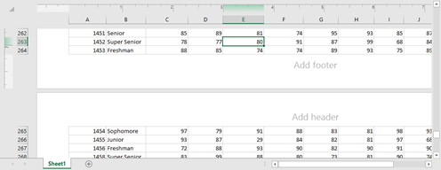

Sort and Filter Data
- Sorting your data allows you to narrow down your data to focus on certain parts of it. Filtering your data gives you the ability to rearrange your data in the way that makes the most sense for your purpose.
  - True
  - False
- The user can sort OR filter a range of data, but they cannot sort AND filter a range of data.
- True
- False
- Kathy is working on a customer contact spreadsheet, and she’d like to organize it in a way that helps her work more effectively. She’d like to see customer states in alphabetical order, then customer cities in alphabetical order, and then any phone numbers she’s highlighted in yellow first. Which of the following images best shows the leveled sort Kathy should use?
- 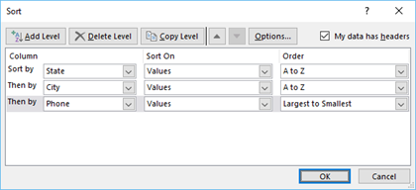
- 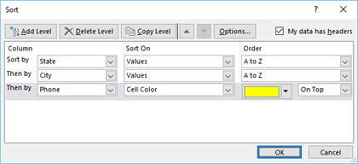
- 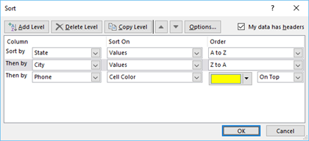
- 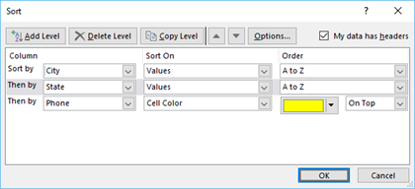
- In the image below, which, if any, of the following filter options is/are NOT available with this spreadsheet?
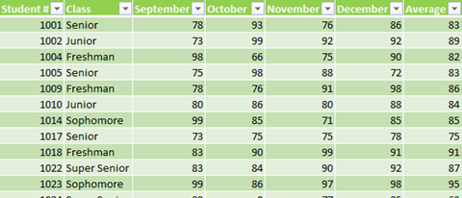
- Freshman Class
- Any Average above 80
- Light green or dark green cell color
- Student #1022
- All of these are available as filter options

Create IF Functions
- In an IF function, the logical test must be a yes/no or true/false question.
  - True
  - False
- Which of the following will work as a Value If True or Value If False argument?
- “Yes”
- G4*10
- $1,000
- 0
- All of these options

- Cryss owns a small business that provides office supplies to retail stores. She is working on a spreadsheet to track her sales, which is shown in the image. She would like to use an IF function that returns the word Yes or the word No in column F to indicate which of her products are making over $450,000 in total profit. Which function would provide Cryss with the results she needs?
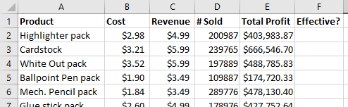
- =IF(E2>450000)(“Yes”)(“No”) in cell F2 and then autofill to the rest of column F.
- =IF(E2<450000,Yes,No) in cell F2 and then autofill to the rest of column F.
- =IF(E2>450000,”Yes”,”No”) in cell F2 and then autofill to the rest of column F.
- =IF(E2>450000,Yes,No) in cell F2 and then autofill to the rest of column F.
- =IF(E2<450000,”Yes”,”No”) in cell F2 and then autofill to the rest of column F.
- Match the IF functions in the image shown with the correct Insert Function dialog boxes.
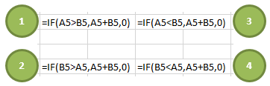
A. | 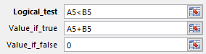
B. | 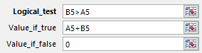
C. | 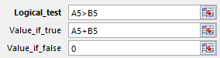
D. | 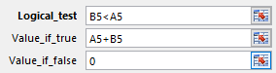

Apply Data Validation Rules
- If the user applies data validation to a cell containing existing data, Excel will instantly warn the user if the existing data does not meet the existing criteria.
  - True
  - False
- By default, the data validation List option includes an in-cell drop-down list containing the specified criteria.
- True
- False
- Jessica has a spreadsheet she plans to distribute to her employees who survey customers. In order to prevent as many mistakes as possible, she’d like to use data validation to restrict the entries in certain cells. In column E, she wants to make sure that only whole numbers between 1 and 10 can be entered. Which of the following shows the settings Jessica needs?

- 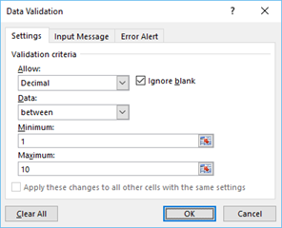 | - 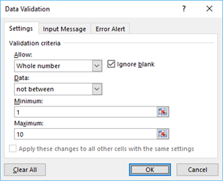
- 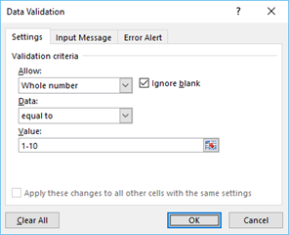 | - 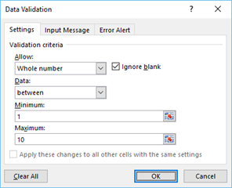

- Jessica has a spreadsheet she plans to distribute to her employees who survey customers. In order to prevent as many mistakes as possible, she’d like to use data validation to restrict the entries in certain cells. In column F, she wants to make sure that only the letters A, B, C, or D can be entered. Which of the following shows the settings Jessica needs?

- 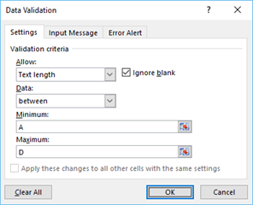 | - 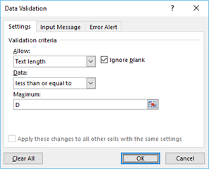
- 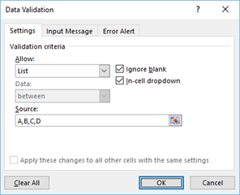 | - 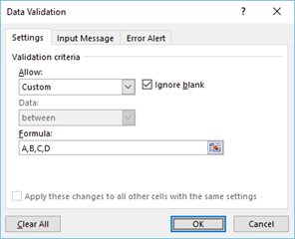

Use the Scale to Fit Options
- The Print Titles option allows the user to print only a specific area of the worksheet.
  - True
  - False

- Nadir is working on a spreadsheet for one of his graduate school assignments, and he’d like to add page numbers to the top center of each page. Which print option will do this?
- 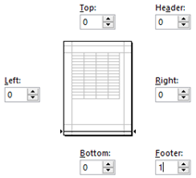
- 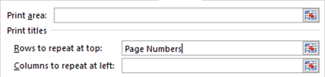
- 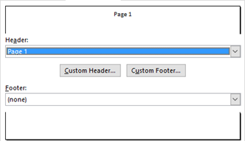
- 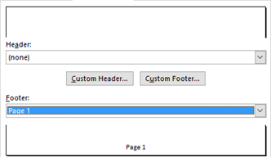

- Brian is getting ready to print the spreadsheet he has built for his music class, and he would like to have rows 1 through 4 print at the top of every page. Which of the following shows the correct formatting and data for Brian to get the result he needs?

- 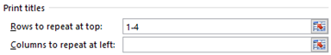
- 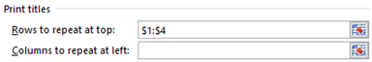
- 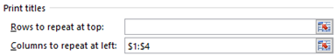
- 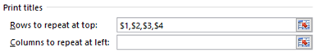
- The blue lines in the image shown are indicative of which Excel view?
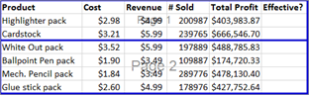
- Page Break Preview
- Page Layout
- Normal
- None of these options

Create and Modify Tables
- Banded rows (alternating colors) cannot be removed from an Excel table.
- True
- False
- Entering a formula in one table cell will automatically copy the formula to all cells in that table column.
- True
- False

- Rosie has compiled a list of programs she thinks will most effectively serve her customers. She has created a table and typed the words Yes or No next to each product, and she would like the table to show only the Yes products. Which of the following table header drop-down menu options should Rosie use to get the desired result?
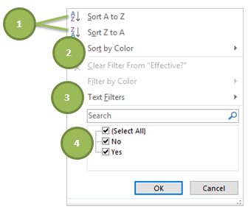
- 1
- 2
- 3
- 4

