Sherwood Massage  74 Sherwood Terrace NW  Calgary, AB, T3R 1M9  Doris Cieslak-Verheyen  Clinic phone: 587 227 4238  Email: sherwoodmassage@gmail.com  Website: www.sherwoodmassage.ca |  |  |  |  |  | Original Date:
 |  |  |  |  |  | Dates Revised:

HEALTH HISTORY QUESTIONNAIRE

All questions contained in this questionnaire are strictly confidential and will become part of your medical record.
Name (Last, First, M.I.): |  |  |  |  |  |  |  | M F
Street: |  |  |  |  | Email:
City: Postal code:
Date of birth: |  | Occupation:
PHONE Home: |  | Cell: |  |  |  |  | Work:
Doctor’s Name: |  |  | Doctor’s Phone:
Emergency Contact: |  |  | Emergency Contact Phone:

Is this your first therapeutic massage Yes No

Where did you hear about my clinic?

Medical Information

Allergies: Yes No If yes, please describe:
Medical Problems: | High Blood Pressure |  |  | Low Blood Pressure |  |  |  | Headache
 | AIDS/HIV positive |  |  | Muscle Cramps |  |  |  | Tingling
 | Cancer |  |  | Numbness |  |  |  | Infectious Illness
 | Varicose Veins |  |  | Edema |  |  |  | Joint Pain

List any other medical problems that are not included above:

List any medication you are currently taking:

Are you pregnant? Yes No If yes, due date?

Why do you come in for massage? Tension Stress Pain Other
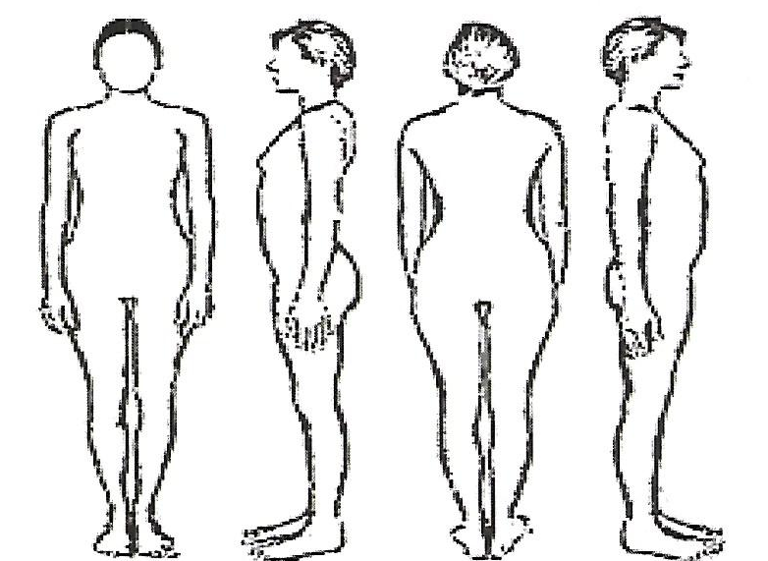
Please mark the areas affected
by pain on the diagram

PLEASE TURN OVER!!!! PLEASE TURN OVER!!!! PLEASE TURN OVER!!!!
Do you know the cause for the pain? If yes, please describe:

How long are you suffering from the pain?

When do you experience the pain? (morning, evening, sleeping, during/after activity)

Describe the symptoms (burning, dull, numbness, sharp, shooting, throbbing, cramping, tingling)

Duration of the symptoms (constant, intermittent, brief):

What relieves? What aggravates?

Did you talk to your doctor about the pain? What did he recommend?

Possible Side effects after a massage:

- bruises, - headache, -muscle pain/ sore muscles, -rash, -tiredness, - nausea, - dizziness

I declare the information on this form to be true and correct in all respects. If my current health status changes in the future I will inform the Massage Therapist about it before my next appointment. I understand that the Massage
Therapist will rely on the information given by me to provide safe treatment. If any information is not correct, I release the Massage Therapist from any and all claims arising out of any treatment provided.

Cancellation policy: A fee will be charged to your account for LATE CANCELLATIONS and NO SHOWS. Insurance does NOT cover this type of charge. To avoid being charged the late fee or No Show fee, we must have 24 HOUR NOTICE from you. We have a 24 hour answering service should you need to call after business hours to cancel. As a courtesy to you, our office does not "double book" clients for the same time slot. You have a specific appointment reserved just for you. Because of this, it is very important that you handle your appointment properly. As a courtesy, our automated phone system will attempt to call to remind you of your scheduled appointment if you have given us permission to so do and provided us with an accurate phone number. This courtesy does not alter your responsibility to give us 24-hour notice of cancelled appointments. Please note that after two late cancellations and/or no shows, you may be placed on our Do Not Schedule list. As well, please be aware that in order to provide timely service to all of our clients, late arrival to an appointment will result in shorter treatment duration.

Client Name: (please print) ________________________________________

Client Signature: ________________________________________

Date: ________________________________________

