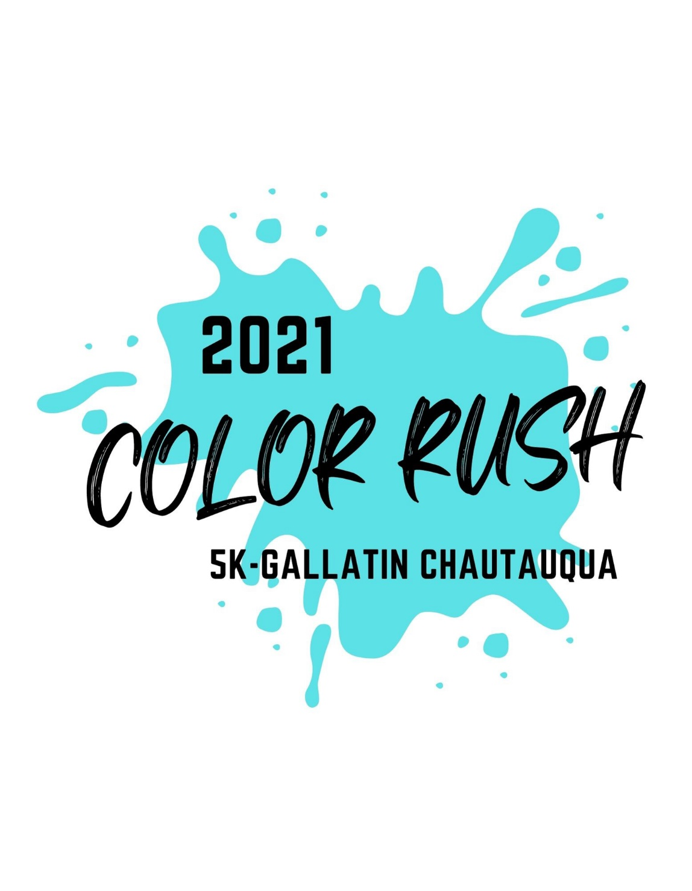



**Ways to Register**

**\*\*Race Participants will be sprayed with washable paint at several points during the race. You can walk, roll, or run your way through this event!\*\***

Race: 5K- 3.1-mile loop course starts and finishes on the South side of the intersection of Market & Grand Streets in Gallatin

Registration Time: Sign in from 6:30-7:00 am and race begins at 7:00 am

Registration & T Shirt Pick Up: SW Corner of Market and Grand Streets

Entry Fees: $25 registration fee for all ages; registration fee includes an event t-shirt; event t-shirts are provided for participants **registered by Aug 30th 2021**.

Awards: Medals will be awarded to the 1st, 2nd, & 3rd place runners in the **Men’s, Women’s & Children’s** (13 & under) divisions.

1. Print a registration form from our website at [www.accessii.org](http://www.accessii.org) and mail it in or drop it off at the Access II office
2. Contact us at 1-888-663-2423 or email us at [jadkins@accessii.org](mailto:jadkins@accessii.org) to have a registration form mailed to you.
3. Pick up a registration form from the Access II office, or partnering local business.

**Proceeds benefit Access II Independent Living Center**

5K Race-Sept. 18, 2021 in Gallatin, MO