The Circuit Writer
Volume 39 Issue 10

What a wonderful month we have had at Monterey United Methodist Church! We had an average attendance in September of 94! Sundays are my favorite day of the week because it is the day we all come together in one place! On September 2, we kicked off the month with worship celebrating Native American Appreciation. What Beautiful prayers and acts of worship we experienced! We followed up the next week by feeding 70 football players from Monterey High School. I don’t think it was coincidence that they subsequently won their fist game of the season! The next week, we began recruiting for committees for the 2019 year. I was so pleased that everyone stepped up to serve! I have never had an experience filling committee seats so easily! I am humbled and thankful for your commitment to our ministry in Monterey! We rounded out the month with group membership Sunday at which time we welcomed Cynthia Chamberlain, Pam Dove, Michael and Amanda Turner and their children Prudence, Phoebe, Piper, Cynthia, Sophie and Wyatt, as well as Micah Groover, and Carl “Buck” Bohannon. And the fellowship meal that followed – there are no words for how good you can cook!! What a wonderful way to celebrate the body of Christ!! We continued the celebration with a concert by The Jim Brady Trio and a wonderful night in communion with the whole community as we celebrated our faith!

I hope you have accepted the Psalm 19:14 Challenge. I look forward to hearing your stories! Please email your experience of Psalm 19:14, or your own personal go-to scripture to church@montereyumc.com so that we can share our experience of scripture as church family.

As we celebrate what God is doing in our church and community I look forward to October, to our mission trip to Red Bird Mission, Children's Sabbath, Laity Sunday, and Trunk or Treat!!

It is my honor to serve you! I will never stop giving thanks for you, remembering you in my prayers!
Denna

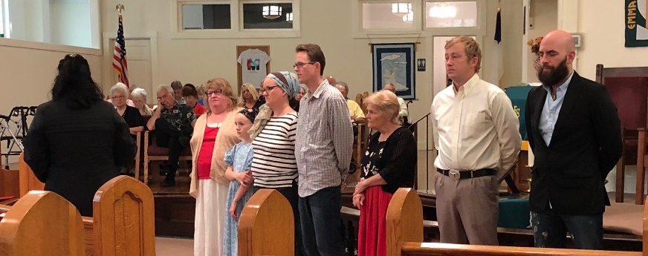

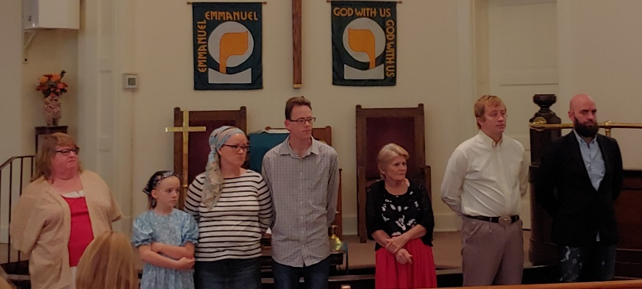

Monthly & Weekly Church Scheduling
Sunday School & Worship 9:45am & 11:00am
Youth Group Sundays 5:30pm – 7:00 pm
Monterey Hilltop Chorale Mondays at 6:00pm
Civitan Club 3rd Tuesday of each month at 6:00pm
Choir Rehearsal Wednesdays at 6:00pm
Cottage Ministry Friday & Saturday, 9am – Noon
Garden Club 2nd Tuesday of each month at 10:30am

October Worship Leaders
Liturgist Saundra Gilmore
Ushers Phillip & Sharon Choate
Acolytes Children of the Church

A Record of our faithfulness September 2018

SEPTEMBER FINANCIAL RESULTS (Operating Funds)
07/01/18 BEGINNING BALANCE $15,941.33
TITHES AND OFFERINGS $14,342.20
OPERATING EXPENSES ($18,281.63)
07/31/18 ENDING BALANCE $12,001.90

Upcoming Meetings & Events

Youth Ministry: Are you available to help with the youth? We want you! Contact Pastor Denna for more information.

Backpack Ministry: As you are shopping, can you purchase granola bars for the backpack ministry? Leave in the narthex for Judy Webster to pick-up.

Burks Elementary Team: Monterey UMC is an adopter of Burks Elementary. Would you like to be a reading partner? Stay tuned for ways to volunteer and help the students succeed.

Save The Date: Cookies and milk at Burks Elementary on Friday, October 26th .

Trunk or Treat: October 31st 6 – 8:30 pm. Please be here by 5pm to set up.

MONTEREY’S OCTOBER BIRTHDAYS

4 Blanche Hessell
7 Mary “Cissie” Davenport
12 Tommy Jones
13 Bob Cournoyer
16 Georgia Garrett
17 Johnny Looper
22 Pam Dunn
23 Jim Lifsey
26 Louise Vail

MONTEREY’S OCTOBER ANNIVERSARIES

6 Keelan & Marcy Milligan
12 David & Judy Webster
18 Lynn & Lee Driscoll
24 Jim & Mary Lifsey

MUMC Wednesdays

5:00pm Early Childhood Music Ministry - FREE music classes for children and a guardian.

An Arrow Pointing to Heaven - Bob Cournoyer will lead a 10-week study of the life and music of Rich Mullins, the forerunner of Contemporary Christian Music. This study will challenge the sensibilities of what it means to follow Jesus in today's world, and build upon his legacy of joy, compassion, brokenness, unblinking honesty, and the wonder of an Awesome God. Coming soon

The Cottage

The Cottage has been busy the last 3 months. About 350 people and 19 meals. We have contributed with rent and utilities for persons requesting help as well. Backpack continues as we have slated an additional food supplement for the neediest with Marcy’s help. Plans are to continue with mild and cookies for the honor roll students. Still assisting some of the Cottage ladies with doctors appointments as well. Trustees have approved the Cottage to be painted and mended around Oct. 1st. It is and remains a safe place of laughter, love and prayer.
Blessings, Deborah

Some Words of Understanding from the
United Methodist Church
In the information given to me explaining the responsibilities of SPRC, the following points were given. As MUMC is made up of people from all walks of life and several different denominations, these are for information to clarify any misunderstandings on the part of members who are unfamiliar with the structure and function of the church. Our hope is to offer instruction by having a class, “Methodism 101”, in the near future.
- Pastors are sent to a mission field; not a local church.
- Highly motivated places receive highly motivated pastors.
- The mission is primary, to make disciples of Jesus Christ and transform the world.
- People don’t need friendly churches; they need Friendships.

Please consider these points when you think of Monterey United Methodist Church. The mission field here is all of Monterey and the surrounding area it serves. We are viewed as very important in this area by our conference.

I don’t think I have to tell you how motivated Pastor Denna Hornby is. In the eyes of the conference we are seen as a highly motivated church in order to have received her appointment here.

In regards to our mission, I believe we have proven our focus through all the mission activities in which we are involved. This is summed up in the development of our more personal mission statement as printed on our Sunday bulletins.
We can be friendly to those who enter our doorway, but what people are seeking is true friendships. Simply shaking hands and saying we are glad to see them is not enough. We must be willing to share with them and include them in our
lives. Remember “Open doors, Open hearts, Open Minds”, the phrase that is included in the advertising of The United Methodist Church so people will know we are welcoming Christians.

With Christ as my Savior, love to you all,
Susie Cournoyer, Chairman
Staff/Parish Relations Committee

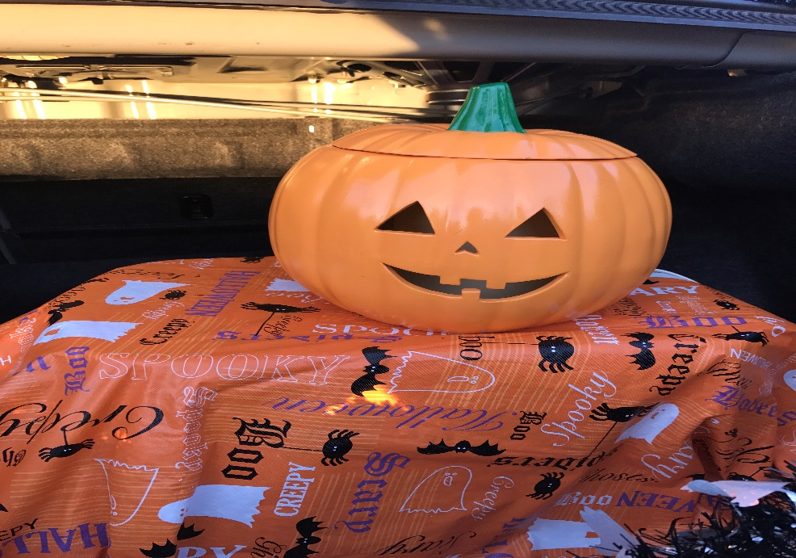

Trunk or Treat is October 31st
from 6:00 – 8:30 pm.
Don’t forget to bring your candy & treats. Bins are in the hallway!!!!
If you are helping this year, please be here by 5pm for set-up and to get your trunks ready!!!!

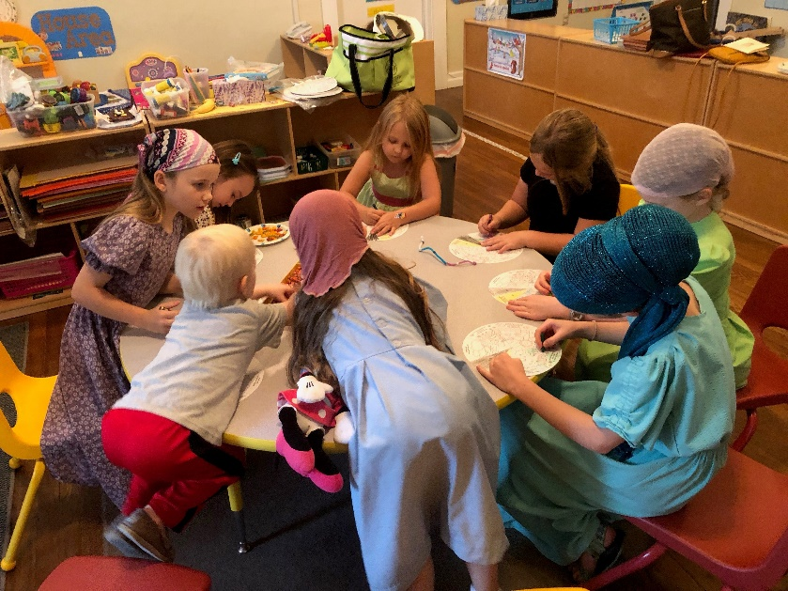

Our wonderful children enjoying Children’s Church!!

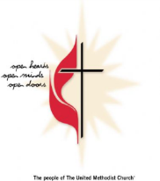
Monterey United Methodist Church
October 2018
Finally, brothers and sisters, pray for us, so that the word of the Lord may spread rapidly
and be glorified everywhere, just as it is among you… 2 Thessalonians 3:1
Sun | Mon | Tue | Wed | Thu | Fri | Sat
 | 1 | 2 | 3 | 4 | 5 | 6
 | 6:00 pm Monterey Hilltop Chorale Rehearsal |  | 5:00 Music for Children  6:00 pm Choir Practice  6:00 pm SPRC meeting |  | 9:00 am Cottage Ministry | 9:00 am Cottage Ministry  2:00 pm Service for the Blessing of Animals (lot beside church)
7 | 8 | 9 | 10 | 11 | 12 | 13
9:45 am Sunday School  11:00 am Worship Service  5:30 pm Youth Group | 6:00pm Monterey Hilltop Chorale Rehearsal | 10:30am Garden Club | 5:00 Music for Children  6:00 pm Choir Practice |  | 9:00 am Cottage Ministry | 9:00 am Cottage Ministry
14 | 15 | 16 | 17 | 18 | 19 | 20
9:45 am Sunday School  11:00 am Worship Service  5:30 pm Youth Group  CHILDRENS SABATH | 6:00 pm Monterey Hilltop Chorale Rehearsal  6:00 pm Charge Conference | 6:00 pm Civitan Club | 5:00 Music for Children  6:00 pm Choir Practice |  | 9:00 am Cottage Ministry | 9:00 am Cottage Ministry
21 | 22 | 23 | 24 | 25 | 26 | 27
9:45 am Sunday School  11:00 am Worship Service  5:30 pm Youth Group  3-5pm Listening Sessions at Cookeville 1st | 6:00pm Monterey Hilltop Chorale Rehearsal | 5:00 pm Finance Meeting | 5:00 Music for Children  6:00 pm Choir Practice |  | 9:00 am Cottage Ministry  Cookies & Milk – Burks Elementary | 9:00 am Cottage Ministry
28 | 29 | 30 | 31
9:45 am Sunday School  11:00 am Worship Service  5:30 pm Youth Group | 6:00pm Monterey Hilltop Chorale Rehearsal |  | 5:00 Music for Children  6:00 pm Choir Practice  5:00 pm Set up for Trunk or Treat  6pm – 830 pm Trunk or Treat

