
Baby Unit for 0 – 2 year old children
Day Nursery for 2 – 5 year old children
Before and after School Holiday Care for 5 – 16 year old children
Primary School Holiday Care for 5 – 16 year old children

SWIMMING POLICY
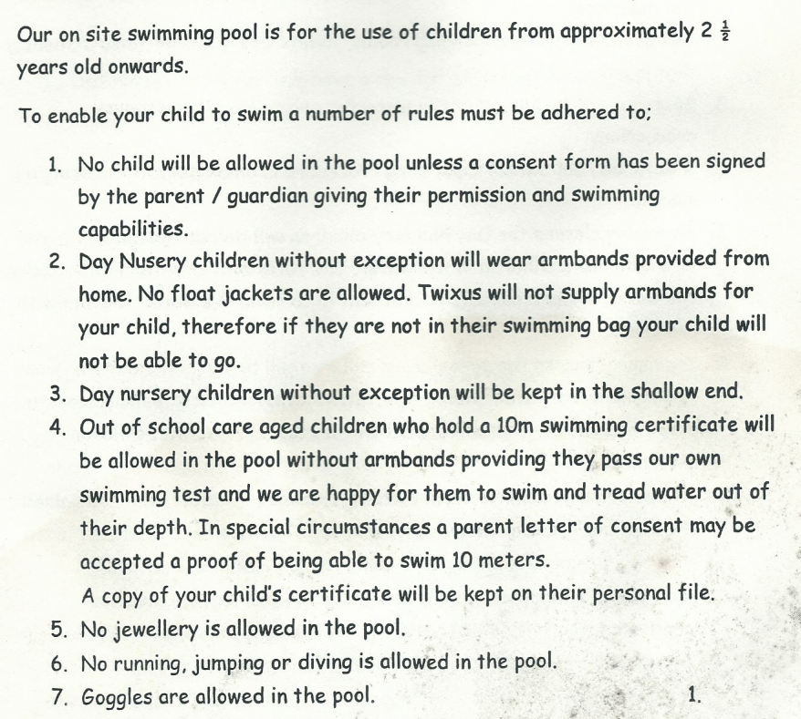
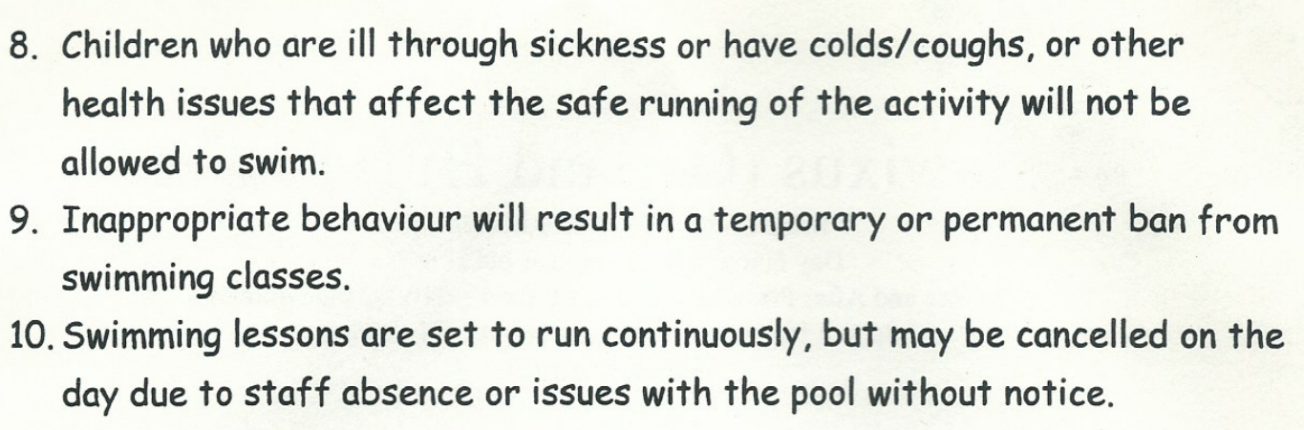

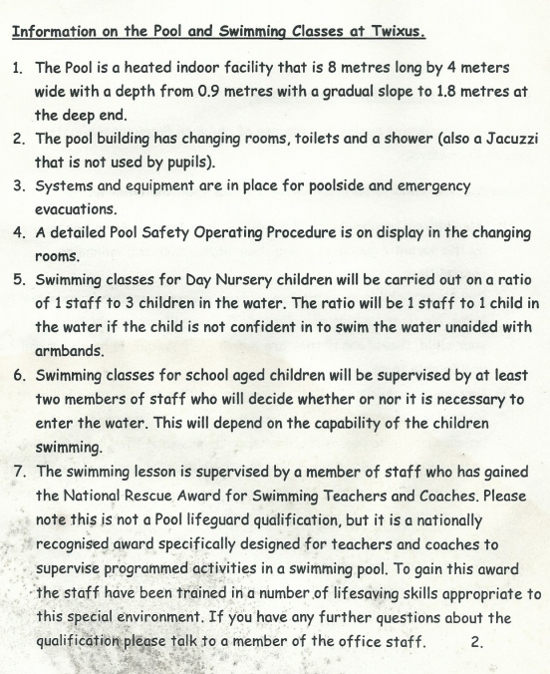

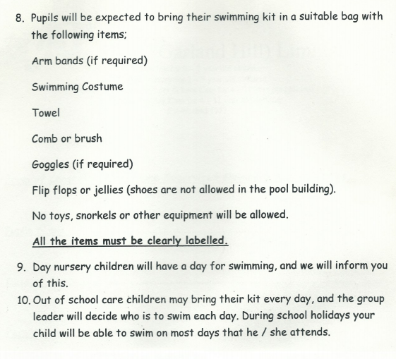
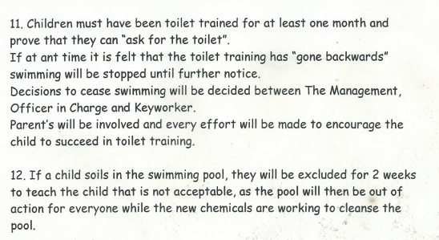

Acceptance and Application of Terms: The Management and Staff at the Twixus Childcare Centre has agreed (by signature) to uphold the legislative terms and working practices of this policy. This policy will be reviewed annually and/or when legislative terms or practical application requires amendments.

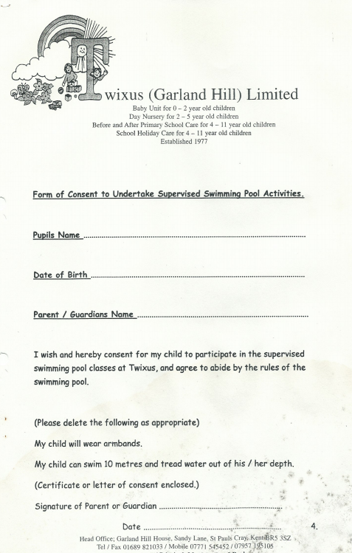


SWIMMING HEALTH AND SAFETY RECORD
SWIMMING SESSION DATE | NUMBER OF SWIMMERS | LIFESAFER INITIALS | POOLSIDE ADULT INITIALS | EQUIPTMENT AND RESOURCES SAFE | POOL SAFE | SIGNATURE OF ASSESSOR

NATIONAL RECUE AWARD FOR SWIMMING TEACHERS AND COACHES TERMLY SKILLS REVIEW
NAME | BEN BEAL | TERM

SKILL  (FIRST AID) | DATE OF REVIEW | SIGNED
1. Initial Assessment
On a live pupil, demonstrate the correct assessment and initial treatment of someone who seems to be unconscious following a rescue from the pool. Starting with the pupil lying face down, turn them onto their back and demonstrate how to open their airway

2. Action for Vomit
Demonstrate the action to be taken if a pupil shows signs of vomiting

3. Recovery Position
Demonstrate the action to be taken for an unconscious, breathing pupil, by placing in the recovery position

4. Adult CPR
Demonstrate on an approved adult manikin the correct assessment and sequence of action for a pupil who is not breathing and has no signs of a circulation, following a sudden collapse. This test will conclude after 2 minutes CPD has been demonstrated

5. Child CPR
Demonstrate on an approved child manikin the correct assessment and sequence of action for a pupil who is not breathing and has no signs of a circulation. This test will conclude after 2 minutes CPR has been demonstrated

6. Baby CPR
Demonstrate on an approved baby manikin the correct assessment and sequence of action for a baby who is not breathing and has no signs of a circulation. This test will conclude after 2 minutes CPD has been demonstrated
7. Poolside Rescue
Without entering the water, select an item of rescue equipment normally located at the poolside and rescue a conscious pupil simulating difficulty in the deepest part of the pool

8. Water Rescue
Enter the water safely and support. Help him/her to leave the water safely.

9. Stabilisation of Suspected Spinal Injury
Initiate the pool’s emergency procedures having identified a pupil who is floating face down in shallow water and who may have sustained an injury to the spine or neck. Effect the rescue of the pupil using a method suitable for a single rescuer. Stabilise the head in relation to the shoulders and back, turn the pupil into a face up position and secure them pending the arrival of additional trained rescuers and/or the emergency services

FOR REASONS OF HEALTH AND SAFETY WE DON’T BLOW UP ARMBANDS


PLEASE MAKE SURE THEY ARE FULLY INFLATED SO THAT YOUR CHILD CAN SWIM

THANKYOU

